bae urban economics

2016 Apartment Vacancy and Rental Rate Survey

Presented on behalf of the UC Davis Student Housing
Overview
The annual Apartment Vacancy and Rental Rate Survey collects data on vacancy and rental rates, as well as other characteristics, for rental units located within the City of Davis community. The objective of the survey is to provide information that will help inform planning decisions on campus, and throughout the broader Davis community. For example, survey results help campus officials to assess the current housing market conditions faced by UC Davis students, and to determine the likely feasibility of proposed housing projects. For the 2016 survey, UC Davis Student Housing partnered with BAE Urban Economics, a private real estate consulting firm located in downtown Davis, to administer the survey and report on the results.

The administration of the 2016 survey took place during the months of October and November, with follow-up outreach to non-responding property owners and managers in late November and early December. The timing of the survey reflects the desire to capture information on housing market characteristics during peak occupancy (e.g., after the final day to add or drop classes, when enrollment for the academic year has stabilized). This approach is consistent with that used in prior years, which facilitates longitudinal comparison. The survey is primarily administered as an online questionnaire, using the SurveyMonkey web survey hosting service. BAE mailed hard copy invitation letters to 132 apartment complexes, property management companies, and property owners. Email invitations were sent to 136 complexes, for whom electronic contact information was available. Each of these communications provided a brief description of the survey and its intended purpose, while directing participants to the online survey tool available at UCDavisApartmentSurvey.com.
They also informed participants that a paper copy of the survey was available upon request. On two separate occasions throughout the survey period, BAE mailed reminder postcards to non-respondents requesting their participation in the survey. At the end of the survey period, BAE also contacted non-respondents via telephone, to solicit participation, update contact information, and to ask why they had not yet responded. BAE used a secret shopper methodology to validate survey responses for a sample of the larger respondent complexes. The results of the secret shopper validation indicated that the survey responses generally corresponded with the information provided to individuals seeking rental accommodations.

2016 Survey Results
In 2015, BAE received responses for 143 unique apartment complexes and property management companies, representing 9,905 rental units. In 2016, a total of 142 apartment complexes and property management companies responded to the survey, representing 9,969 rental units. This represents a 0.7 percent decrease in the number of respondent complexes and a 0.6 percent increase in the number of rental units covered in the respondent pool.
Estimates from the American Community Survey (ACS) indicate that there were approximately 11,953 multifamily housing units, on average, on the UC Davis campus and in the City of

San Francisco | Sacramento | Los Angeles | Washington DC | New York City
1285 66th St. | 803 2nd St., Suite A | 706 South Hill St., Suite 1200 | 1400 I St. NW, Suite 350 | 49 West 27th St., Suite 10W
Emeryville, CA 94608 | Davis, CA 95616 | Los Angeles, CA 90014 | Washington, DC 20005 | New York, NY 10001
510.547.9380 | 530.750.2195 | 213.471.2666 | 202.588.8945 | 212.683.4486
www.bae1.com

Davis, between 2011 and 2015.1 This suggests that the units captured in the 2016 survey account for around 83 percent of the total multifamily housing stock in the Davis community.

Of the 2016 survey’s 142 respondents, 29 reported leasing units at below market rents (i.e., requiring an income eligibility test to qualify prospective tenants for reduced or subsidized rents). Seventeen of those respondents reported renting all of the units in the complex at below market rates, while the remaining 12 complexes rent some units at below market rates and some units at market rates. The remainder of this analysis excludes units rented at below market rents, as reported by respondents, but does include units rented at market rates in mixed-income properties that offer both market rate and below market rate, units. While all survey respondents reported total unit numbers, not all respondents provided detail regarding other unit characteristics, such as the number of beds leased under individual bed lease agreements. As a result, the unit and bed lease totals discussed below may not equal those reported above, in some cases.

Leasing “Beds” Versus Complete Apartment Units
One of the more complex dynamics of the local rental housing market is the practice of renting out units under multiple lease agreements. Under this type of arrangement, known as a “bed lease,” each bed, or bedroom, in an apartment is associated with a separate lease agreement. Each resident is, thereby, contractually responsible for only a portion of the total rent. This is compared to the more conventional approach, wherein each unit is rented under a single master lease and all of the tenants living in the unit are jointly responsible for the complete monthly rent. For the purposes of this survey, this arrangement is called a “unit lease.”

Unit Leases
Survey respondents provided unit size detail for 8,105 units that are rented under unit lease arrangements, which account for 89 percent of all reported market rate rental units. Note that the survey results reported below exclude units for which unit size detail was not reported.
Figure 1 illustrates the distribution of unit-leased apartments, by unit size. The majority of reported units had between one and three bedrooms. One-bedroom units accounted for 31 percent of the total, while two-bedroom units accounted for 45 percent. Three-bedroom units represented 14 percent. Four-bedroom apartments represented seven percent of reported units, while studio units represented slightly under three percent.

Table 1 provides more detailed unit totals, along with the number of vacant units, and the associated vacancy rate by unit size. Again, the results reflect only those survey responses that provided unit size and vacancy details. Per survey respondents, there were 15 vacant apartments available for lease on a unit-lease basis, which translates to a vacancy rate of 0.2 percent. By comparison, the 2015 and 2014 surveys presented vacancy rates of 0.2 percent and 0.3 percent, respectively. Broken down by unit type, the 2016 survey results indicated that the vacancy rate was highest among three-bedroom units at 0.4 percent. Two-bedroom and four-bedroom units had the next lowest vacancy rates, both registering a rate of 0.2 percent, while one-bedroom units reported a vacancy rate of 0.1 percent.

1 U.S. Census Bureau. 2011-2015 American Community Survey 5-Year Estimates, Table B25024. Retrieved from: http://factfinder2.census.gov/

Figure 1: Distribution of Unit Leases by Unit Size

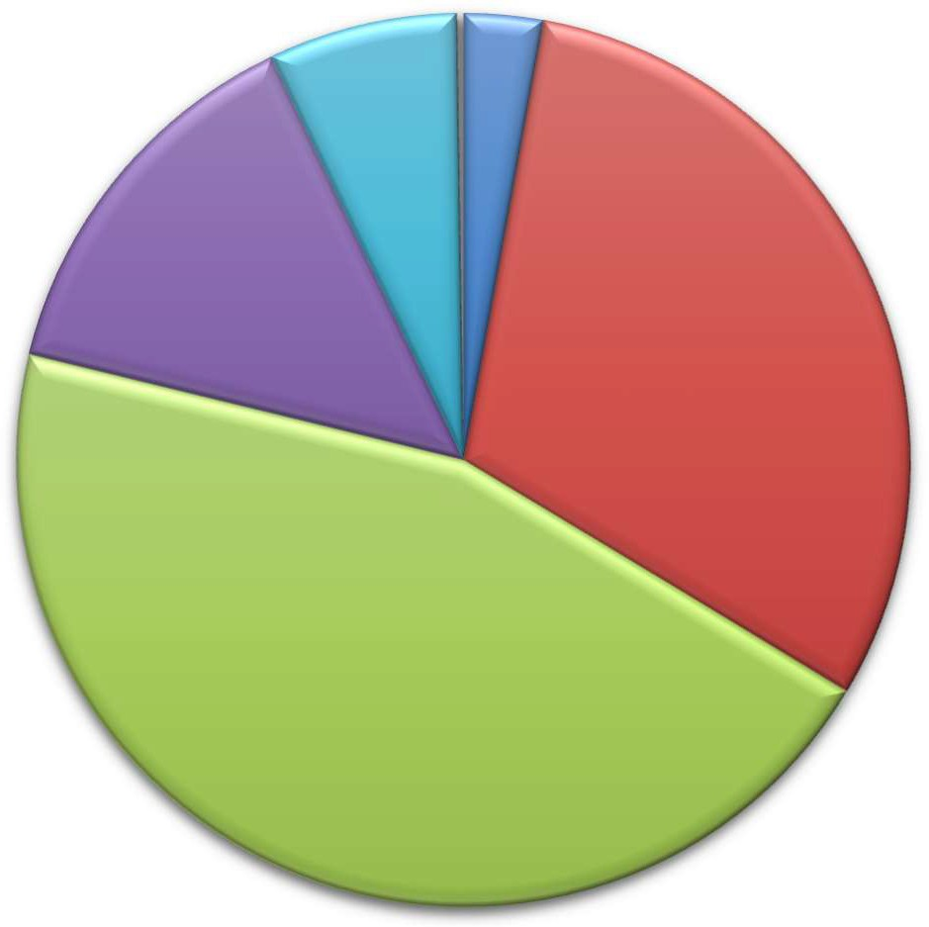
Studio
19, 0%
232, 3%
556, 7%
1,143, 14%
2,494, 31%
3,661, 45%
1 Bedroom
2 Bedroom
3 Bedroom
4 Bedroom
Other

Table 1: Vacancy Rate for Unit Leases by Unit Size
2016 Survey Results
 |  |  |  |  | Number of Vacant |  |  |  |  |  |  | 2015 |  | 2014
Units Reported (a) |  |  |  |  | Units Reported (b) |  |  |  | Vacancy |  |  | Vacancy |  | Vacancy
Unit Size |  | Number |  | Percent |  | Number |  | Percent |  | Rate (c) |  | Rate (c) |  | Rate (c)
Studio |  | 232 |  | 3% |  | 0 |  | 0% |  | 0.0% |  | 0.0% |  | 0.5%
1 Bedroom |  | 2,494 |  | 31% |  | 3 |  | 20% |  | 0.1% |  | 0.0% |  | 0.1%
2 Bedroom |  | 3,661 |  | 45% |  | 6 |  | 40% |  | 0.2% |  | 0.1% |  | 0.1%
3 Bedroom |  | 1,143 |  | 14% |  | 5 |  | 33% |  | 0.4% |  | 1.0% |  | 0.6%
4 Bedroom |  | 556 |  | 7% |  | 1 |  | 7% |  | 0.2% |  | 0.0% |  | 1.4%
Other |  | 19 |  | 0% |  | 0 |  | 0% |  | 0.0% |  | 0.0% |  | n.a.
Total, All Sizes |  | 8,105 |  | 100% |  | 15 |  | 100% |  | 0.2% |  | 0.2% |  | 0.3%

Notes:
- Includes the number of units, by unit type, reported by survey respondents as rented on a per unit basis (i.e., unit lease).
- Includes the number of units reported as vacant, by unit type, as reported by survey respondents. May exclude
some units in cases w here the survey respondent reported the total number of units, but did not report the associated number of vacant units.
- The vacancy rate for unit leases w as calculated based on the number of leased and vacant units only, as reported by survey respondents.

Sources: BAE, 2016.

Bed Leases
Of the 9,058 market rate apartment units reported by survey respondents, only 11 percent, around 950 units in total, were reportedly rented under bed lease arrangements. Figure 2 illustrates the distribution of bed leases and bed-leased units, by unit size, which are also reported in Table 2. Most of the bed-leased units, nearly 94 percent, had between two and four bedrooms. Four-bedroom units were by far the most common, accounting for 48 percent of the total. Two- and three-bedroom units accounted for 20 percent and 25 percent of all reported bed-leased units, respectively. Survey respondents reported a total of 3,253 leased beds. The following figures reflect the number of leased beds, as reported by respondents.
The distribution of leased beds, by unit size, reflects a similar overall distribution shown for bed-leased units. On average, bed-leased units typically contain one bed per bedroom; although some complexes allow multiple beds per bedroom. Sixty-three percent of the leased beds reported by respondents were located in four-bedroom units, while 24 percent were in three-bedroom units and 12 percent were in two-bedroom units. One-bedroom units that were reported as rented under bed lease agreements accounted for only two percent of the total.
Respondents reported 32 vacant bed lease spaces, for a vacancy rate among reported leasable beds of roughly 1.0 percent. According to survey respondents, all of the vacant bed leases are located in units with between two- and four-bedrooms. The reported vacancy rate for bed leases is notably lower than the rate identified through the 2015 survey, which reported that roughly 5.1 percent of the reported bed-leased spaces were vacant.

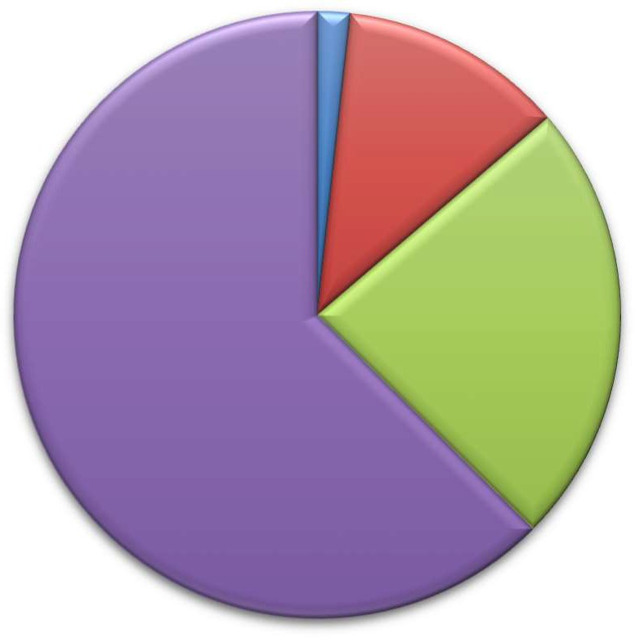
Figure 2: Distribution of Bed Leases by Unit Size
390, 12%
770, 24%
2,036, 63%

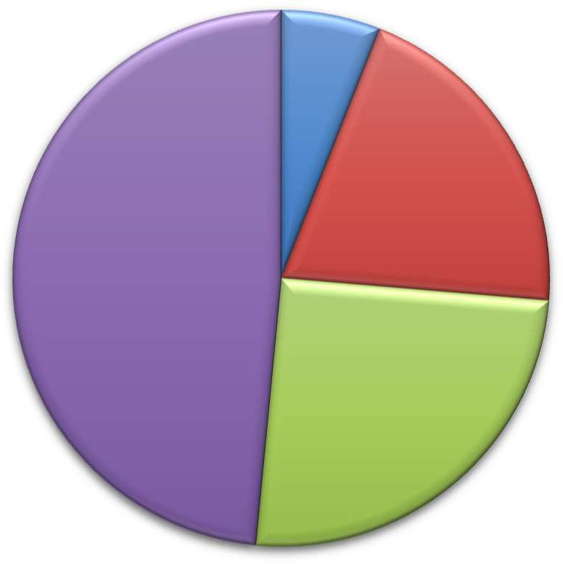
Units
194, 20%
462, 48%
240, 25%

57, 6%

Beds
57, 2%

1 Bedroom
2 Bedroom
3 Bedroom
4 Bedroom

Table 2: Vacancy Rate for Bed Leases by Unit Size
2016 Survey Results
Bed Leased Number of Number of Vacant |  |  |  |  |  |  |  |  |  |  |  |  |  |  |  | 2015 |  | 2014
Units Reported (a) Beds Reported (b) Beds Reported (c) |  |  |  |  |  |  |  |  |  |  |  |  | Vacancy |  |  | Vacancy |  | Vacancy
Unit Size |  | Number |  | Percent |  | Number |  | Percent |  | Number |  | Percent |  | Rate (d) |  | Rate (d) |  | Rate (d)
Studio |  | 0 |  | 0% |  | 0 |  | 0% |  | 0 |  | 0% |  | n.a. |  | n.a. |  | n.a.
1 Bedroom |  | 57 |  | 6% |  | 57 |  | 2% |  | 0 |  | 0% |  | 0.0% |  | 0.0% |  | 0.0%
2 Bedroom |  | 194 |  | 20% |  | 390 |  | 12% |  | 6 |  | 19% |  | 1.5% |  | 6.3% |  | 3.4%
3 Bedroom |  | 240 |  | 25% |  | 770 |  | 24% |  | 5 |  | 16% |  | 0.6% |  | 7.6% |  | 1.2%
4 Bedroom |  | 462 |  | 48% |  | 2,036 |  | 63% |  | 21 |  | 66% |  | 1.0% |  | 3.7% |  | 0.7%
Other |  | 0 |  | 0% |  | 0 |  | 0% |  | 0 |  | 0% |  | n.a. |  | 50.0% |  | n.a.
Total, All Sizes |  | 953 |  | 100% |  | 3,253 |  | 100% |  | 32 |  | 100% |  | 1.0% |  | 5.1% |  | 1.3%

Notes:
- Includes the number of units, by unit type, reported by survey respondents as rented on a per bed basis (i.e., bed lease).
- Includes the number of beds located w ithin bed leased units, by unit type, as reported by survey respondents. May exclude some beds in cases w here the survey respondent reported bed leased units, but did not report the associated number of leased.
- Includes the number of leasable beds reported as vacant, by unit type, as reported by survey respondents. May exclude
some beds in cases w here the survey respondent reported bed leased units, but did not report the associated number of leased or vacant beds.
- The vacancy rate for bed leases w as calculated based on the number of leased and vacant beds only, as reported by survey respondents.

Sources: BAE, 2016.

Blended Vacancy Rate
To estimate a citywide vacancy rate for all lease types, BAE implemented a new analytical method as part of the 2016 survey, which combines the unit lease and bed lease vacancy rates, to generate a “blended,” or combined, vacancy estimate.2 The results of the “blended” vacancy rate calculation for the 2016 survey are shown in Table 3. Given that unit-leased apartments account for 89 percent of the market rate rental inventory, the blended vacancy rate aligns more closely with the unit lease vacancy rate than the bed lease vacancy rate. The blended vacancy rate for all rental units is equal to 0.3 percent. For comparison purposes, BAE also calculated the blended vacancy rate using the 2015 survey response data, which resulted in a 2015 combined vacancy rate of 0.6 percent, which reflects somewhat higher vacancy among bed-leased units. Broken down by unit size, the 2016 survey identified the highest blended vacancy rate among four-bedroom units at 0.6 percent, followed by three-bedroom units at 0.5 percent. One- and two-bedroom units reported blended vacancy rates of just 0.1 percent and 0.2 percent, respectively, while there were no vacancies among studio and “Other” units.

2 To calculate the “blended” vacancy rate, BAE calculated the unit lease vacancy rate, then applied that rate to the total number of bed-leased units. The resulting “vacant unit equivalents” were then added to the total number of vacant unit-leased apartments to calculated the combined vacancy rate.

Table 3: Blended Vacancy Rate Summary

2016 Vacancy Rate
Unit Bed 2015 Blended
Unit Size |  | Lease (a) |  | Lease (b) |  | Blended (c) |  | Vacancy Rate (c)
Studio |  | 0.0% |  | n.a. |  | 0.0% |  | 0.0%
1 Bedroom |  | 0.1% |  | 0.0% |  | 0.1% |  | 0.0%
2 Bedroom |  | 0.2% |  | 1.5% |  | 0.2% |  | 0.3%
3 Bedroom |  | 0.4% |  | 0.6% |  | 0.5% |  | 2.1%
4 Bedroom |  | 0.2% |  | 1.0% |  | 0.6% |  | 1.5%
Other |  | 0.0% |  | n.a. |  | 0.0% |  | 2.3%
Total, All Sizes |  | 0.2% |  | 1.0% |  | 0.3% |  | 0.6%

Notes:
- Based on the number of units, by unit type, reported as rented on a per unit basis (i.e., unit lease).
- Based on the number of units, by unit type, reported as rented on a per bed basis (i.e., bed lease).
- Based on the number of units, by unit type, reported as rented on a per unit basis (i.e., unit lease), w ith vacant units leased on a per bed basis converted to "vacant unit equivalents."

Sources: BAE, 2016.

Rental Rates
All survey respondents reported static or increasing rents, relative to 2015. None of the respondent complexes reporting lowering rents in 2016 in order to fill vacancies.

Unit Leases
Table 4 illustrates the weighted average of the reported rental rates for apartments leased under unit lease arrangements. Note that the survey results reported here represent properties for which respondents reported both the total number of units, by type, and the corresponding rental rate information. The results exclude units for which no unit type or rental rate information was provided. Per survey respondents, the average rental rate for all units was $1,576 per month.3 This represents a 5.8 percent increase over 2015, when the average rental rate for unit-leased apartments was $1,489. Lease rates for four-bedroom units increased the least relative to 2015, at 1.5 percent, reflecting an average rental rate of
$2,627 per month in 2016. Three-bedroom units displayed the next lowest increase in average rental rates, at 2.4 percent, reflecting an average rental rate of $2,041 per month. The average rental rate for studio, one-, and two-bedroom units increased between six and eight percent, with rates equal to $972, $1,210, and $1,549, respectively.

3 Average rental rates were calculated based on the rental information provided by survey respondents. In cases where the respondent provided a range of prices, but no associated unit totals, BAE utilized the mid-point of the range as the assumed representative value. The reported values represent weighted averages, which reflect the reported rental rates and the total number of units, or beds, of each type.

Table 4: Rental Rates for Unit Leases, by Unit Size

2016 Survey Results 2015 2014
Weighted Weighted |  |  |  |  |  |  |  |  |  | Weighted
Unit Size |  | Minimum |  | Maximum |  | Average (a) |  | Average (a) |  | Average (a)
Studio |  | $603 |  | $1,420 |  | $972 |  | $916 |  | $900
1 Bedroom |  | $830 |  | $1,695 |  | $1,210 |  | $1,119 |  | $1,072
2 Bedroom |  | $950 |  | $2,145 |  | $1,549 |  | $1,462 |  | $1,373
3 Bedroom |  | $1,147 |  | $2,850 |  | $2,041 |  | $1,993 |  | $1,907
4 Bedroom |  | $1,229 |  | $3,413 |  | $2,627 |  | $2,587 |  | $2,442
Other |  | $2,295 |  | $3,700 |  | $3,233 |  | $2,297 |  | n.a.
Total, All Sizes |  | $603 |  | $3,700 |  | $1,576 |  | $1,489 |  | $1,414

Notes:
(a) Figures represent w eighted average rental rates and include only those complexes w here the respondent identified the number of units by type, the number of beds per unit, and associated rental rates.

Sources: BAE, 2016.

Bed Leases
Table 5 illustrates the weighted average of the reported rental rates for bed leases. Note that the reported survey results only include those responses that identified the total number of bed-leased units, by type, the total number of beds per unit, and the associated rental rate information. According to survey respondents, the average rental rate for a bed lease, in units of all sizes, was $875 per month.4 This represents an decrease of 3.3 percent over 2015, when the average monthly rental rate was $905. The average rental rate for bed leases in four-bedroom units decreased the most, at 5.3 percent, reflecting an average rental rate of
$796 per bed. The average rent for bed leases in three-bedroom units also decreased relative to 2015, reflecting a decrease of 3.0 percent, corresponding to an average rental rate of $874 per bed. By comparison, Bed leases in one- and two-bedroom units increased by 6.9 percent and 13.9 percent relative to 2015, respectively. This corresponds to average rental rates of
$1,977 and $1,126, respectively.5 Because the reported values represent weighted average rates, differences in pricing may reflect a variety of factors, including, but are not limited to, the number of beds leased per bedroom, planned renovations, and utility rates, as well as a variety of other factors.

4 See footnote 2.
5 According to the property managers representing complexes with one-bedroom bed-leased units, the one-bedroom apartments are intended for occupancy by a single individual and are priced accordingly. A second “registered guest” is permitted with approval, but is not permitted as a permanent occupant. Because these units are located in complexes that only offer bed lease arrangements, the suite of amenities associated with one-bedroom bed-leased units is similar to that offered with other bed-leased units. Due to differences in amenities associated with bed-leased units, compared to unit-leased apartments, the one-bedroom bed-leased units are reported along with the other bed-leased units.

Table 5: Average Rental Rate for Bed Leases, by Unit Size

2016 Survey Results 2015 2014
Weighted Weighted |  |  |  |  |  |  |  |  |  | Weighted
Unit Size |  | Minimum |  | Maximum |  | Average (a) |  | Average (a) |  | Average (a)
1 Bedroom (b) |  | (c) |  | (c) |  | $1,977 |  | $1,850 |  | $1,659
2 Bedroom |  | $625 |  | $1,161 |  | $1,126 |  | $988 |  | $940
3 Bedroom |  | $758 |  | $920 |  | $874 |  | $901 |  | $837
4 Bedroom |  | $668 |  | $865 |  | $796 |  | $841 |  | $765
Other |  | n.a. |  | n.a. |  | n.a. |  | $1,200 |  | n.a.
Total, All Sizes |  | $625 |  | $1,161 |  | $875 |  | $905 |  | $827

Notes:
- Figures represent w eighted average rental rates and include only those complexes w here the respondent identified the number of units by type, the number of beds per unit, and associated rental rates.
- One-bedroom bed-leased apartments are intended for occupancy by a single individual, but are located in complexes that only rent units under bed lease arrangements. These complexes offer a greater suite of amenities, compared to the average unit-leased complex, and are prices accordingly.
- Data are suppressed to prevent the disclosure of proprietary information.

Sources: BAE, 2016.

Utilities and Appliances
The 2016 survey incorporated additional questions regarding utilities and amenities that were made available to tenants at no additional charge (i.e., included in the monthly rental rate). Of the 119 respondents that offer unit-leased apartments, 74 percent reported that they include trash collection, 74 percent include sewer service, and 71 percent include water service. Only two percent included natural gas or propane, while three percent included cable or satellite television. However, 30 percent of unit leased properties include internet or Wi-Fi service as part of the monthly rent, while none of the respondent complexes included electricity. Of the nine respondents that offered bed-leased units, 89 percent reported that they include trash collection, while 79 percent also include water and sewer service, 33 percent include internet or Wi-Fi service, and 22 percent include electricity. Only 11 percent include natural gas and propane, and no complexes included cable or satellite television.

In addition to information regarding utilities, the survey also collected information on the appliances that are provided within each rental unit. Among respondents offering unit-leased apartments, 97 percent reported including a refrigerator, while 95 percent include a stove/oven, 58 percent include a dishwasher, and 49 percent include a microwave. Around 84 percent included air conditioning equipment. Among respondents offering bed-leased units, all complexes include a refrigerator, oven/stove, microwave, and dishwasher within each unit. In addition, roughly 89 percent reported including air conditioning equipment.

Figure 3: Percent of Respondents Including Utilities in Rent by Utility Type and Lease Type

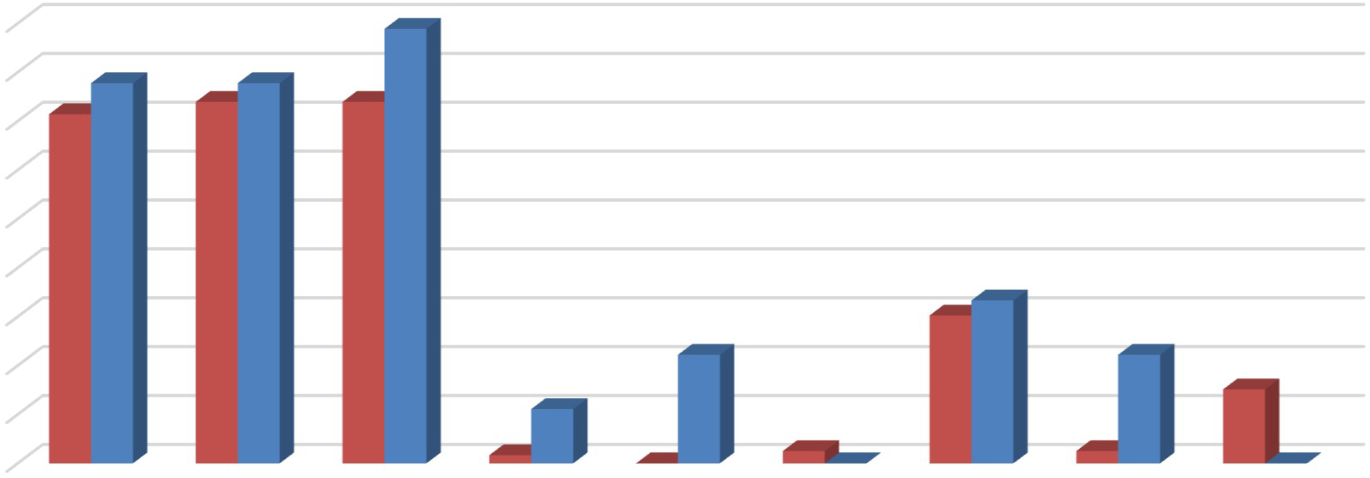
90%
89%
78%
78%
71%
74%
74%
30% 33%
22%
22%
11%
2%
15%
0%
3% 0%
3%
0%
80%
70%
60%
50%
40%
30%
20%
10%


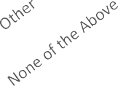
0%

Unit-Leases Bed-Leases

Figure 4: Percent of Respondents Including Appliances in Unit by Lease Type

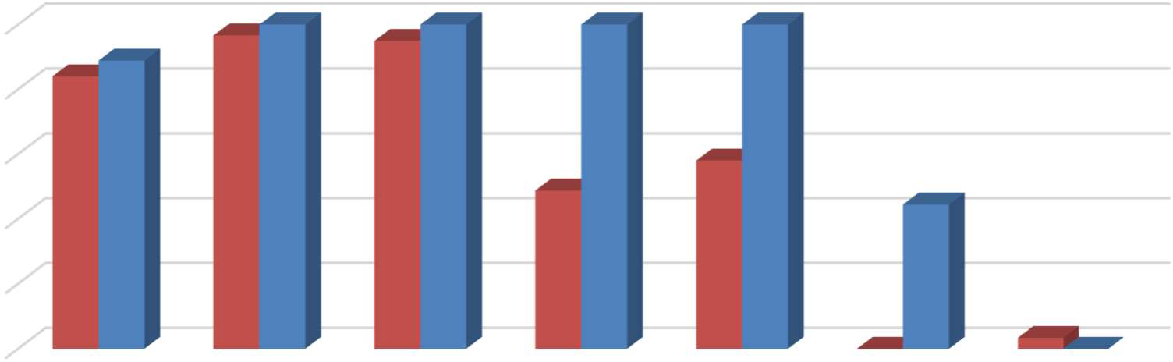
100%
97%100%
95%100%
100%
100%
84 89%
%
58%
49%
44%
0%
3% 0%
80%
60%
40%
20%
0%
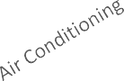



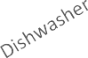


Unit-Leases Bed-Leases

The 2016 survey also questioned respondents regarding the various amenities offered onsite, such as gym or pool facilities, and some of the services provided by the property management staff, such as package service and organized social activities. Figure 5 illustrates the relative prevalence of these amenities, differentiating between complexes that offer unit leases versus bed leases. Overall, Respondents that offer unit leases generally tend to offer fewer amenities. For example, only 38 percent offer onsite gym facilities, while 41 percent offer a club house, 61 percent offer a pool and/or hot tub, and 52 percent offer a picnic or BBQ area. The most prevalent amenity offered by unit-lease complexes is an onsite laundry facility.
Respondents that offer bed leases were more likely to offer an assortment of onsite amenities, with most respondents offering multiple types of facilities and services. For example, all complexes that offer bed leases also offer a picnic or BBQ area and onsite laundry facility, while 89 percent offer onsite gym facilities, a pool and/or hot tub, and a club house.

Figure 5: Percent of Respondents Offering Select Amenities by Lease Type

100.0%
80.0%
60.0%
40.0%
20.0%
0.0%
100% 100%



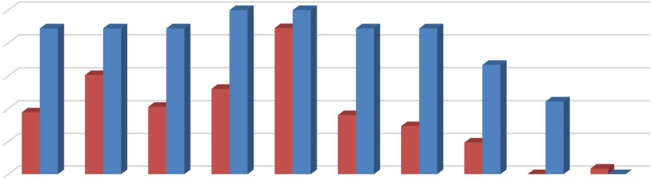


Unit-Leases Bed-Leases
89% 89% 89%
89%
89% 89%
61%
67%
52%
38%
41%
44%
36%
29%
19%
0%
3%0%

Furnished and Unfurnished Units
The majority of surveyed properties indicated that they did not offer furnished units in the 2015 leasing season. Figures 6 and 7, below, illustrate the number of respondents that offered furnishings, by unit size. A total of eight properties indicated that they offered furnished apartments under unit lease arrangements in 2016, which was unchanged from 2015. The most common units offered with furnishings under a unit lease arrangement are two-bedroom units. Only four respondents reported offering furnished bed-leased units, which represents a minor increase from 2015, when just three respondents indicated that they offered furnished bed-leased units. Similar to the responses received in 2015, the only furnished bed-leased units on offer were two-, three-, and four-bedroom units.

Figure 6: Number of Respondents Offering Furnished Unit Leases, by Unit Size

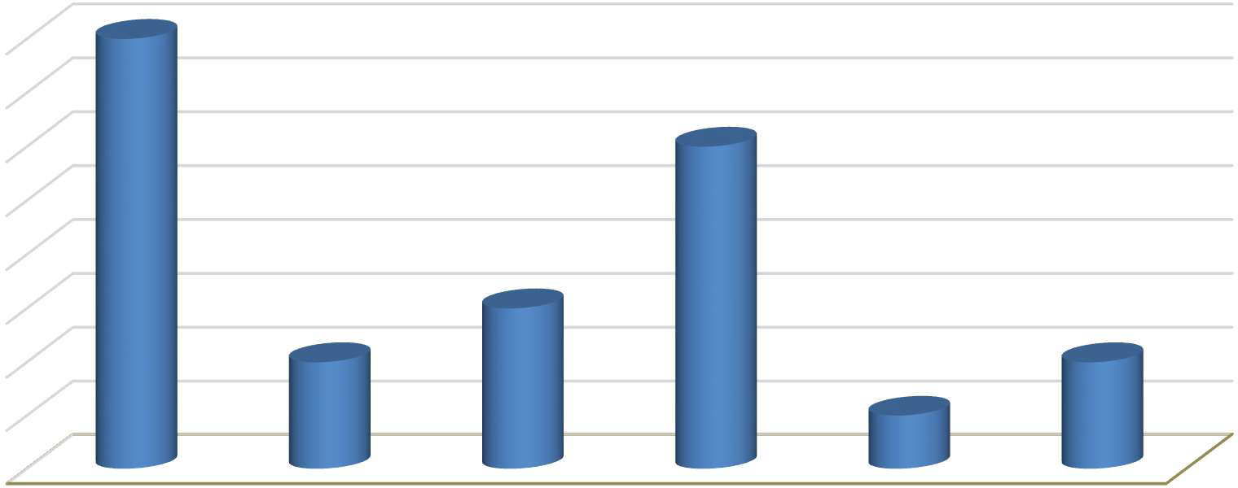
8
8
6
3
2
2
1
7
6
5
4
3
2
1
0
All Unit Sizes Studio 1 Bedroom 2 Bedroom 3 Bedroom 4 Bedroom

Figure 7: Number of Respondents Offering Furnished Bed Leases, by Unit Size

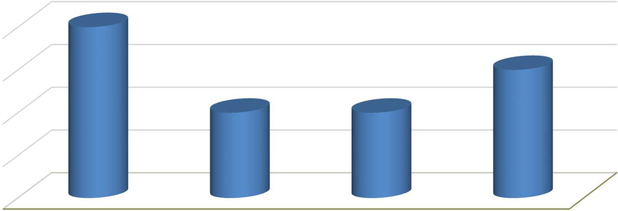
4
4
3
2
2

3

2

1

0
All Unit Sizes 2 Bedroom 3 Bedroom 4 Bedroom

Parking Availability
As in 2015, the 2016 survey included questions regarding parking availability. The survey requested that respondents identify the total number of automotive parking spaces, distinguishing between those reserved for use by tenants and those reserved for use by visitors. In total, 111 complexes responded to these survey questions. Approximately 93 percent of respondents reported offering assigned parking, which represented a total of 12,558 parking spaces. The remaining seven percent offered open parking (i.e., no assigned spaces), representing 773 parking spaces. Based on the number of housing units and parking spaces offered at each complex, respondent complexes average around 1.4 parking spaces per unit. Only eight complexes maintain a ratio of less than one space per unit. A total of 86 complexes maintained between one and two spaces per unit, while 17 complexes had more than two parking spaces per unit, with a maximum of 2.9 spaces.

In addition to questions regarding automobile parking availability, the 2016 survey included a question regarding the availability of various types of bicycle storage. Figure 8 illustrates the relative prevalence of a number of bicycle storage options, differentiating between complexes

that offer unit leases versus bed leases. The most common approach to bicycle storage is the provision of outdoor bicycle racks. Of the complexes that offered unit-leased apartments, 91 percent featured outdoor bicycle racks. This percentage was slightly lower than for complexes offering bed-leases, where all complexes reported offering outdoor bicycle racks. While relatively few complexes offer indoor or enclosed bicycle storage, complexes that offer bed leases were more likely to offer these amenities, compared to complexes that offer unit leases. Only one complex offered individual bicycle lockers onsite. A small number of complexes reported other types of bicycle storage options, including the option of storing bicycles in patio and balcony areas, as well as within private garages.

Figure 8: Percent of Respondents Offering Bicycle Storage by Storage Type and Lease Type

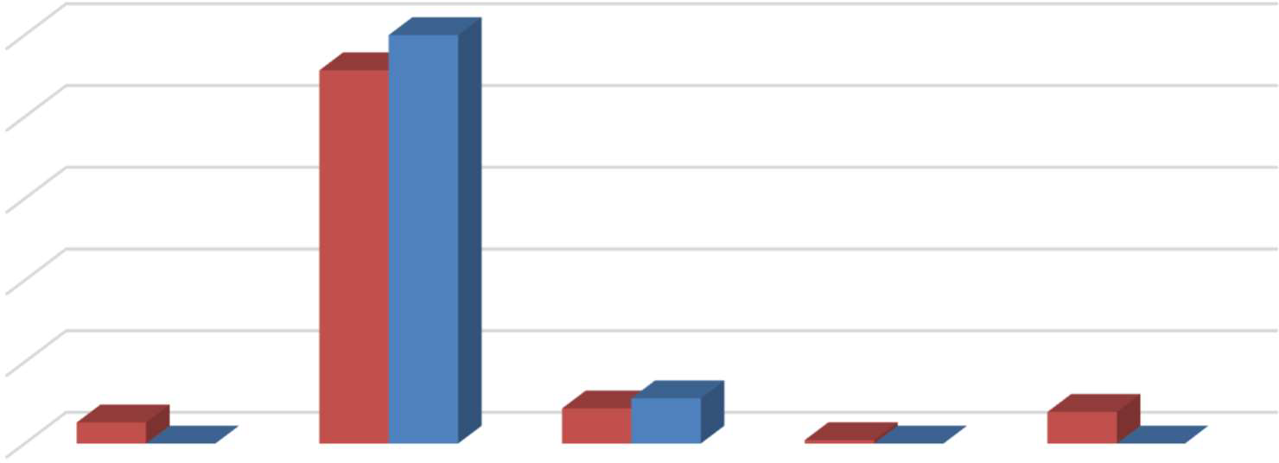
100%
100%
91%
5%
9%
11%
8%
0%
1% 0%
0%

80%

60%

40%

20%

0%

I do not offer bicycle parking

Outdoor bicycle racks

Indoor/enclosed storage

Individual bicycle lockers

Other

Unit-Leases Bed-Leases

Services and Incentives
For a variety of reasons, it is often in a property owner’s best interest to provide certain services and incentives to residents. This often helps to encourage resident attraction and retention. For properties that offer bed leases, a roommate matching program can often be an important tool for leasing up units. Under such a program, prospective residents fill out applications, stating their interests, and preferences in a roommate. The property manager then works to match roommates based on their estimated compatibility. In 2015, a total of 13 properties responded to the question inquiring whether the complex offers a roommate matching program for bed-leased units, with all but four indicating that they do provide a matching service. In 2016, a total of nine properties responded to the question, with six indicating that they offered both bed-leased units and a roommate matching program. For the 2015 survey, 117 properties responded to the question inquiring whether the complex offers roommate matching for unit-leased apartments, with only six properties indicating that they offered a matching service. For the 2016 survey, 117 properties responded to this question, with only five indicating that they offer a matching program for unit-leased apartments.

Nine apartment complexes reported offering other incentives and move-in specials in the 2016 leasing season to help fill vacancies and attract new residents. Two respondents offered some form of free or reduced price rent. An additional two respondents reported

offering reduced move-in deposits and/or waived application fees. Three respondents reported other incentives, including various gift card and television giveaways, and early move-out specials.6 Two complexes stated that they offered move-in specials, but did not specify the incentives offered. Note that most of the complexes that reported providing incentives offered more than one type during the 2016 leasing season.

Planned Renovations
Thirty-nine respondents, around 31 percent, reported having plans to undertake renovations within the next 12 months. Most of those that reported planned renovations conduct periodic updates, as units turn over. Other common upgrades, in order of frequency, include upgraded flooring and countertops, followed by appliances and windows. Three complexes indicated that they were undertaking exterior upgrades, including exterior paint and landscaping. Some properties also indicated that they were in the process, or planned on, renovating offices, study rooms, fitness centers, laundry rooms, and pool facilities.

6 With an early move-out special, the complex offers incentives, such as the ability to break a lease agreement without being held liable for the remaining lease term. This is beneficial to the property manager in those cases, for example, where they have limited resources or staff available to prepare units for re-leasing (e.g., to conduct repairs and improvements) when all units turn over within a relatively narrow window of time.

