bae urban economics

2017 Apartment Vacancy and Rental Rate Survey

Presented on behalf of UC Davis Student Housing and Dining Services

Overview
The annual Apartment Vacancy and Rental Rate Survey collects information on the characteristics of rental units located within the Davis community. The objective of the survey is to provide information that will help inform planning decisions on campus and throughout the broader Davis community. For example, survey results help campus officials to assess the current housing market conditions faced by UC Davis students and faculty and determine the feasibility of proposed housing projects. Similar surveys have been conducted on an annual, or biennial basis, since at least 1975, documenting long-term historical trends. Since 2013, the survey has been administered in partnership with BAE Urban Economics, a private real estate consulting firm with offices in downtown Davis.

2017 Survey Results
In 2017, a total of 138 apartment complexes and property management companies responded to the survey, representing 10,188 rental units. This represents a 2.8 percent decrease in the number of respondent complexes compared to 2016, but a 2.2 percent increase in the number of rental units covered in the respondent pool.1 Estimates from the American Community Survey (ACS) indicate that there were approximately 11,579 multifamily housing units, on average, on the UC Davis campus and in the City of Davis between 2012 and 2016.2 This indicates that the units captured in the 2017 survey account for approximately 88 percent of the Davis area multifamily housing stock.

Of the 2017 survey’s 138 respondents, 28 reported leasing units at below market rents (i.e., requiring an income eligibility test to qualify prospective tenants for reduced or subsidized rents). Eighteen of those respondents reported renting all of the units in the complex at below market rates, while the remaining 10 complexes rent some units at below market rates and some units at market rates. The remainder of this analysis excludes units rented at below market rents, as reported by respondents, but does include units rented at market rates in mixed-income complexes.

While all survey respondents reported total unit numbers, not all respondents provided detail regarding other unit characteristics, such as the number of beds leased under individual bed lease agreements. As a result, the unit and bed lease totals discussed elsewhere in this report may not equal those reported above, in some cases.

1 BAE received responses from 142 unique apartment complexes and property management companies as part of the 2016 survey, representing 9,969 rental units.
2 U.S. Census Bureau. 2012-2016 American Community Survey 5-Year Estimates, Table B25024. Retrieved from: http://factfinder.census.gov/
San Francisco | Sacramento | Los Angeles | Washington DC | New York City
2600 10th St., Suite 300 | 803 2nd St., Suite A | 448 South Hill St., Suite 701 | 1400 I St. NW, Suite 350 | 49 West 27th St., Suite 10W
Berkeley, CA 94710 | Davis, CA 95616 | Los Angeles, CA 90013 | Washington, DC 20005 | New York, NY 10001
510.547.9380 | 530.750.2195 | 213.471.2666 | 202.588.8945 | 212.683.4486

www.bae1.com

Leasing “Beds” Versus Complete Apartment Units
One of the more complex dynamics of the local rental housing market is the practice of renting out individual apartment units to multiple tenants using multiple lease agreements. Under this type of arrangement, known as a “bed lease,” each bed or bedroom in an apartment is associated with a separate lease agreement. This is compared to the more conventional approach, whereby each unit is rented under a single lease and all of the tenants living in the unit sign the lease and are jointly responsible for the complete monthly rent for the entire unit. For the purposes of this survey, this latter arrangement is called a “unit lease.”

Unit Leases
Survey respondents provided unit size detail for 8,122 units that are rented under unit lease arrangements, which account for 87 percent of all reported market rate rental units. Note that the survey results reported below exclude units for which unit size detail was not reported.
Figure 1 illustrates the distribution of unit-leased apartments, by unit size. The majority of reported units had between one and three bedrooms. One-bedroom units accounted for 32 percent of the total, while two-bedroom units accounted for 46 percent, and three-bedroom units represented 13 percent. Four-bedroom apartments represented six percent of reported units, while studio units represented two percent. Reflecting the stable nature of the Davis area housing stock, this distribution is roughly comparable to the results of the 2016 survey.

Figure 1: Distribution of Unit Leases by Unit Size











Studio
21, 0%
197, 2%
455, 6%
1,090, 13%
2,614, 32%
3,745, 46%
1 Bedroom
2 Bedroom
3 Bedroom
4 Bedroom
Other

Table 1 provides more detailed unit totals, along with the number of vacant units, and the associated vacancy rate by unit size. Again, the results reflect only those survey responses that provided unit size and vacancy details. Per survey respondents, there were 13 vacant apartments available for lease on a unit-lease basis. This translates to a vacancy rate of 0.2 percent, which is roughly comparable to the vacancy rate documented through both the 2016

and 2015 surveys. Broken down by unit type, the 2017 survey results indicated that the vacancy rate was highest among two-bedroom units at 0.2 percent. One-bedroom and three-bedroom units had the next highest vacancy rates at only 0.1 percent. There were no vacancies among studio and four-bedroom apartments.

Table 1: Vacancy Rate for Unit Leases by Unit Size

2017 Survey Results
 |  |  |  |  | Number of Vacant |  |  |  |  |  |  | 2016 |  | 2015
Units Reported (a) |  |  |  |  | Units Reported (b) |  |  |  | Vacancy |  |  | Vacancy |  | Vacancy
Unit Size |  | Number |  | Percent |  | Number |  | Percent |  | Rate (c) |  | Rate (c) |  | Rate (c)
Studio |  | 197 |  | 2% |  | 0 |  | 0% |  | 0.0% |  | 0.0% |  | 0.0%
1 Bedroom |  | 2,614 |  | 32% |  | 3 |  | 23% |  | 0.1% |  | 0.1% |  | 0.0%
2 Bedroom |  | 3,745 |  | 46% |  | 9 |  | 69% |  | 0.2% |  | 0.2% |  | 0.1%
3 Bedroom |  | 1,090 |  | 13% |  | 1 |  | 8% |  | 0.1% |  | 0.4% |  | 1.0%
4 Bedroom |  | 455 |  | 6% |  | 0 |  | 0% |  | 0.0% |  | 0.2% |  | 0.0%
Other |  | 21 |  | 0% |  | 0 |  | 0% |  | 0.0% |  | 0.0% |  | 0.0%
Total, All Sizes |  | 8,122 |  | 100% |  | 13 |  | 100% |  | 0.2% |  | 0.2% |  | 0.2%

Notes:
- Includes the number of units, by unit type, reported by survey respondents as rented on a per unit basis (i.e., unit lease).
- Includes the number of units reported as vacant, by unit type, as reported by survey respondents. May exclude
some units in cases w here the survey respondent reported the total number of units, but did not report the associated number of vacant units.
- The vacancy rate for unit leases w as calculated based on the number of leased and vacant units only, as reported by survey respondents.

Sources: BAE, 2017.

Bed Leases
Of the 9,348 market rate apartment units reported by survey respondents, 1,226 units (13 percent) were reportedly rented under bed lease arrangements. This represents an increase from 950 units in 2016. Figure 2 illustrates the distribution of bed leases and bed-leased units, by unit size, which are also reported in Table 2. Most of the bed-leased units, nearly 94 percent, had between two and four bedrooms. Four-bedroom units were by far the most common, accounting for 51 percent of the total. Two- and three-bedroom units accounted for 21 percent and 23 percent of all reported bed-leased units, respectively.

Survey respondents reported a total of 4,504 leased beds, which represents an increase of more than 1,250 beds since 2016. The following figures reflect the number of leased beds, as reported by respondents. The distribution of leased beds, by unit size, reflects a distribution similar to that shown for bed-leased units. As shown in Figure 2, 67 percent of the leased beds reported by respondents were located in four-bedroom units, while 20 percent were in three-bedroom units and 12 percent were in two-bedroom units. One-bedroom units that were reported as rented under bed lease agreements accounted for only two percent of the total.






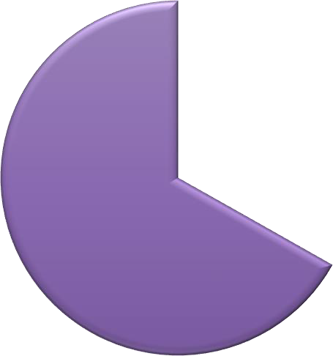
Figure 2: Distribution of Bed Leases by Unit Size
Beds
83, 2%








Units
70, 6%
252, 21%
625, 51%
279, 23%
 | 526, 12% | 1 Bedroom
3,010, 67% | 885, 20% | 2 Bedroom  3 Bedroom  4 Bedroom

Figure 3 reports the average number of beds per unit, by unit size. This generally illustrates the relatively low incidence of double-occupancy bedrooms among bed-leased units. For example, there are an average of 1.2 beds per one-bedroom bed-leased apartment, 2.1 beds per two-bedroom bed-leased apartment, and 3.2 beds per three-bedroom bed-leased apartment.
Four-bedroom bed-leased apartments have a higher prevalence of “double-ups,” with an
average of 4.8 beds per unit.3

Figure 3: Average Number of Beds Per Bed-Leased Unit

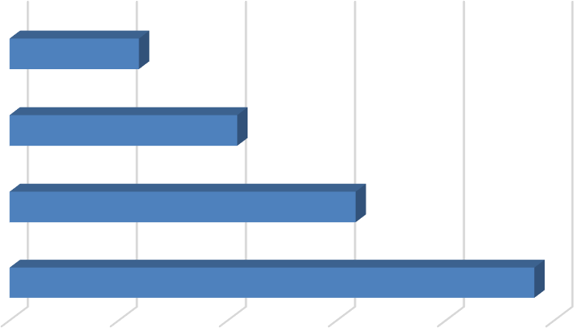
  - Bedroom
1.2

  - Bedroom
Unit Size
2.1

  - Bedroom
3.2

  - Bedroom
4.8

- 1.0 2.0 3.0 4.0 5.0
Beds Per Unit

3 This generally reflects an average of one double-occupancy bedroom per four-bedroom unit.

As documented in Table 2, respondents reported 74 vacant bed lease spaces, for a vacancy rate among reported leasable beds of 1.6 percent. This represents a modest increase from 32 vacant beds in 2016, when the vacancy rate was 1.0 percent. Vacancies were spread among all unit sizes, with the majority (i.e., 50 units) concentrated in units with four-bedrooms.

Table 2: Vacancy Rate for Bed Leases by Unit Size

2017 Survey Results
Bed Leased |  |  |  |  | Number of |  |  |  | Number of Vacant |  |  |  |  |  |  | 2016 |  | 2015
Units Reported (a) |  |  |  |  | Beds Reported (b) |  |  |  | Beds Reported (c) |  |  |  | Vacancy |  |  | Vacancy |  | Vacancy
Unit Size |  | Number |  | Percent |  | Number |  | Percent |  | Number |  | Percent |  | Rate (d) |  | Rate (d) |  | Rate (d)
Studio |  | 0 |  | 0% |  | 0 |  | 0% |  | 0 |  | 0% |  | n.a. |  | n.a. |  | n.a.
1 Bedroom |  | 70 |  | 6% |  | 83 |  | 2% |  | 1 |  | 1% |  | 1.2% |  | 0.0% |  | 0.0%
2 Bedroom |  | 252 |  | 21% |  | 526 |  | 12% |  | 8 |  | 11% |  | 1.5% |  | 1.5% |  | 6.3%
3 Bedroom |  | 279 |  | 23% |  | 885 |  | 20% |  | 15 |  | 20% |  | 1.7% |  | 0.6% |  | 7.6%
4 Bedroom |  | 625 |  | 51% |  | 3,010 |  | 67% |  | 50 |  | 68% |  | 1.7% |  | 1.0% |  | 3.7%
Other |  | 0 |  | 0% |  | 0 |  | 0% |  | 0 |  | 0% |  | n.a. |  | n.a. |  | 50.0%
Total, All Sizes |  | 1,226 |  | 100% |  | 4,504 |  | 100% |  | 74 |  | 100% |  | 1.6% |  | 1.0% |  | 5.1%

Notes:
- Includes the number of units, by unit type, reported by survey respondents as rented on a per bed basis (i.e., bed lease).
- Includes the number of beds located w ithin bed leased units, by unit type, as reported by survey respondents. May exclude some beds in cases w here the survey respondent reported bed leased units, but did not report the associated number of leased.
- Includes the number of leasable beds reported as vacant, by unit type, as reported by survey respondents. May exclude some beds in cases w here the survey respondent reported bed leased units, but did not report the associated number of leased or vacant beds.
- The vacancy rate for bed leases w as calculated based on the number of leased and vacant beds only, as reported by survey respondents.

Sources: BAE, 2017.

Blended Vacancy Rate
To estimate a citywide vacancy rate for all lease types, BAE combined the unit lease and bed lease vacancy rates, to generate a combined or “blended” vacancy estimate.4 The results of the “blended” vacancy rate calculation for the 2017 survey are shown in Table 3. Given that unit-leased apartments account for 87 percent of the reported market rate rental inventory, the blended vacancy rate aligns more closely with the unit lease vacancy rate than the bed lease vacancy rate, but is drawn upward due to the addition of the higher bed lease vacancy rate. The blended vacancy rate for all rental units equals to 0.4 percent. For comparison purposes, BAE also calculated a blended vacancy rate of 0.3 percent in 2016 and 0.6 percent in 2015.

4 To calculate the “blended” vacancy rate, BAE calculated the unit lease vacancy rate, then applied that rate to the total number of bed-leased units. The resulting “vacant unit equivalents” were then added to the total number of vacant unit-leased apartments to calculate the combined vacancy rate.

Table 3: Blended Vacancy Rate Summary

2017 Vacancy Rate
Unit Bed 2016 Blended 2015 Blended
Unit Size |  | Lease (a) |  | Lease (b) |  | Blended (c) |  | Vacancy Rate (c) |  | Vacancy Rate (c)
Studio |  | 0.0% |  | n.a. |  | 0.0% |  | 0.0% |  | 0.0%
1 Bedroom |  | 0.1% |  | 1.2% |  | 0.1% |  | 0.1% |  | 0.0%
2 Bedroom |  | 0.2% |  | 1.5% |  | 0.3% |  | 0.2% |  | 0.3%
3 Bedroom |  | 0.1% |  | 1.7% |  | 0.4% |  | 0.5% |  | 2.1%
4 Bedroom |  | 0.0% |  | 1.7% |  | 1.0% |  | 0.6% |  | 1.5%
Other |  | 0.0% |  | n.a. |  | 0.0% |  | 0.0% |  | 2.3%
Total, All Sizes |  | 0.2% |  | 1.6% |  | 0.4% |  | 0.3% |  | 0.6%

Notes:
- Based on the number of units, by unit type, reported as rented on a per unit basis (i.e., unit lease).
- Based on the number of units, by unit type, reported as rented on a per bed basis (i.e., bed lease).
- Based on the number of units, by unit type, reported as rented on a per unit basis (i.e., unit lease), w ith vacant units leased on a per bed basis converted to "vacant unit equivalents."

Sources: BAE, 2017.

Rental Rates
All survey respondents reported static or increasing rents, relative to 2016. None of the respondent complexes reported lowering rents in 2017 in order to fill vacancies.

Unit Leases
Table 4 reports the range and weighted average of the reported rental rates for apartments leased under unit lease arrangements. Note that the survey results reported here represent properties for which respondents reported both the total number of units, by type, and the corresponding rental rate information. The results exclude survey responses with no unit type or rental rate information. Based on this information, the average rental rate for all units was
$1,673 per month.5 This represents a 6.2 percent increase over 2016, when the average rental rate for unit-leased apartments was $1,576.

5 In cases where the respondent provided a range of prices for a given unit type, but no corresponding unit totals, BAE utilized the mid-point of the range as the assumed representative value. The reported values represent weighted averages, which reflect the reported rental rates and the total number of units or beds.

Table 4: Rental Rates for Unit Leases, by Unit Size

2017 Survey Results 2016 2015
Weighted Weighted |  |  |  |  |  |  |  |  |  | Weighted
Unit Size |  | Minimum |  | Maximum |  | Average (a) |  | Average (a) |  | Average (a)
Studio |  | $468 |  | $1,600 |  | $1,035 |  | $972 |  | $916
1 Bedroom |  | $625 |  | $1,725 |  | $1,270 |  | $1,210 |  | $1,119
2 Bedroom |  | $789 |  | $2,600 |  | $1,660 |  | $1,549 |  | $1,462
3 Bedroom |  | $804 |  | $2,860 |  | $2,270 |  | $2,041 |  | $1,993
4 Bedroom |  | $2,035 |  | $3,950 |  | $2,858 |  | $2,627 |  | $2,587
Other |  | $2,495 |  | $3,995 |  | $3,511 |  | $3,233 |  | $2,297
Total, All Sizes |  | $468 |  | $3,995 |  | $1,673 |  | $1,576 |  | $1,489

Notes:
(a) Figures represent w eighted average rental rates and include only those complexes w here the respondent identified the number of units by type, the number of beds per unit, and associated rental rates.

Sources: BAE, 2017.

Bed Leases
Table 5 illustrates the weighted average of the reported rental rates for bed leases. Note that the reported survey results only include those responses that identified the total number of bed-leased units, by type, the total number of beds per unit, and the associated rental rate information. According to survey respondents, the weighted average rental rate for a bed lease, in units of all sizes, was $892 per month.6 This represents an increase of 1.9 percent over 2016, when the average monthly rental rate was $875.

Table 5: Average Rental Rate for Bed Leases, by Unit Size

2017 Survey Results 2016 2015
Weighted Weighted Weighted
Unit Size |  | Minimum |  | Maximum |  | Average (a) |  | Average (a) |  | Average (a)
1 Bedroom (b) |  | (c) |  | (c) |  | $1,614 |  | $1,977 |  | $1,850
2 Bedroom |  | $475 |  | $1,255 |  | $1,147 |  | $1,126 |  | $988
3 Bedroom |  | $420 |  | $1,055 |  | $898 |  | $874 |  | $901
4 Bedroom |  | $475 |  | $1,055 |  | $826 |  | $796 |  | $841
Other |  | n.a. |  | n.a. |  | n.a. |  | n.a. |  | $1,200
Total, All Sizes |  | $420 |  | (c) |  | $892 |  | $875 |  | $905

Notes:
- Figures represent w eighted average rental rates and include only those complexes w here the respondent identified the number of units by type, the number of beds per unit, and associated rental rates.
- One-bedroom bed-leased apartments are intended for occupancy by a single individual, but are located in complexes that only rent units under bed lease arrangements. These complexes offer a greater suite of amenities, compared to the average unit-leased complex, and are prices accordingly.
- Data are suppressed to prevent the disclosure of proprietary information.

Sources: BAE, 2017.

6 See footnote 5.

Utilities, Appliances, and Amenities
The 2017 survey incorporated additional questions regarding utilities and amenities that were made available to tenants at no additional charge (i.e., included in the monthly rental rate). Of the 117 respondents that offer unit-leased apartments, 79 percent reported that they include trash collection, while 76 percent include sewer service, and 72 percent include water service. Meanwhile, 27 percent offer internet or Wi-Fi at no additional charge. Of the nine respondents that offered bed-leased units, 78 percent reported that they include trash collection and sewer service, 56 percent include water service, and 44 percent include internet or Wi-Fi service.
Twenty two percent include electricity at no additional charge for bed-leased units.

Figure 4: Percent of Respondents Including Utilities in Rent by Utility Type and Lease Type

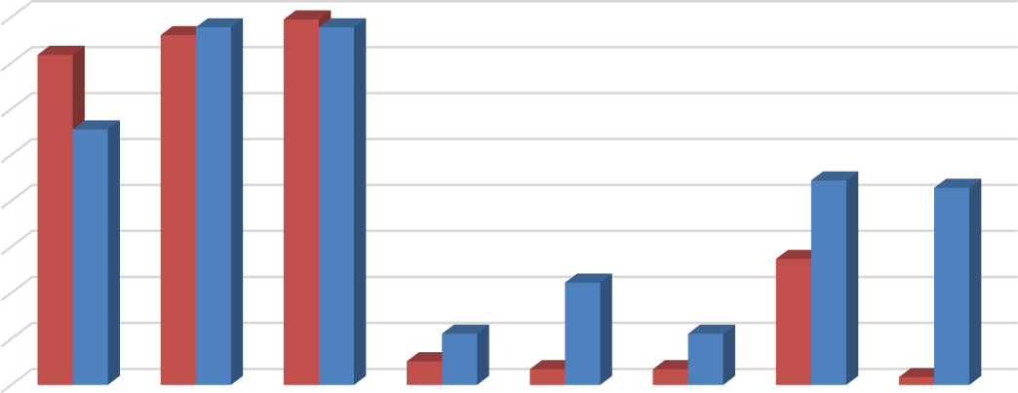
80%
76%78%
79% 78%
72%
56%
44%
43%
27%
22%
11%
5%
3%
11%
3%
2%
70%
60%
50%
40%
30%
20%
10%





0%

Unit-Leases Bed-Leases

In addition to information regarding utilities, the survey also collected information on the appliances that are provided within each rental unit. Among respondents offering unit-leased apartments, 98 percent reported including a refrigerator, while 97 percent include a stove/oven, 93 percent include air conditioning, 62 percent include a dishwasher, and 47 percent include a microwave. Of the 15 percent that reported offering other appliances, most reported in-unit laundry facilities. Among respondents offering bed-leased units, all complexes include a refrigerator and air conditioning, while 78 percent include an oven/stove and a microwave. Sixty-seven percent of the complexes that offer bed-leases provide dishwashers, while 33 percent offer other appliances, typically including in-unit laundry facilities.

Figure 5: Percent of Respondents Including Appliances in Unit by Lease Type

100%
90%
80%
70%
60%
50%
40%
30%
20%
10%
0%

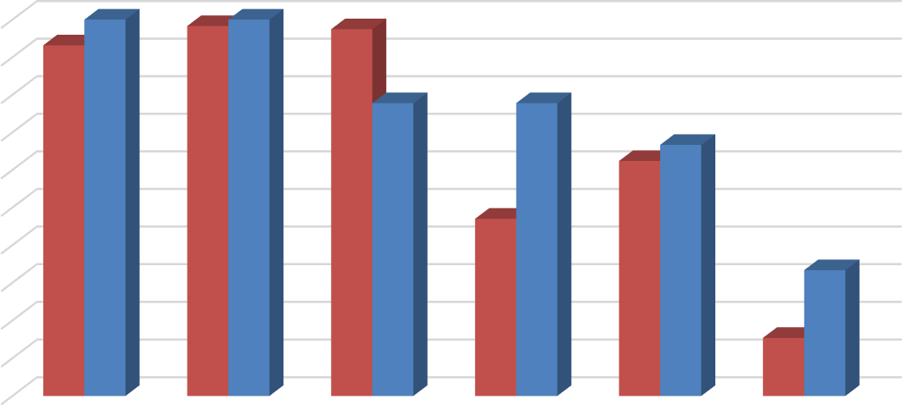
Air Conditioning
100%
98% 100%
93%
97%
78%
78%
62%
67%
47%
33%
15%

Refrigerator Stove/Oven Microwave Dishwasher Other

Unit-Leases Bed-Leases

The 2017 survey also questioned respondents regarding the amenities offered onsite, such as gym or pool facilities, and some of the services provided by the property management staff, such as package service and organized social activities. Figure 6 illustrates the prevalence of these amenities, differentiating between complexes that offer unit leases versus bed leases. Overall, respondents that offer unit leases generally tend to offer fewer amenities. For example, 40 percent offer onsite gym facilities, while 38 percent offer a club house, 66 percent offer a pool and/or hot tub, and 56 percent offer a picnic or BBQ area. The most prevalent amenity offered by unit-lease complexes is an onsite laundry facility. Respondents that offer bed leases were more likely to offer an assortment of onsite amenities, with most respondents offering multiple types of equipment, facilities, and services. For example, all complexes that offer bed leases also offer a picnic or BBQ area and planned social activities, while 89 percent offer onsite gym facilities, a pool and/or hot tub, and a club house.

Figure 6: Percent of Respondents Offering Select Amenities by Lease Type

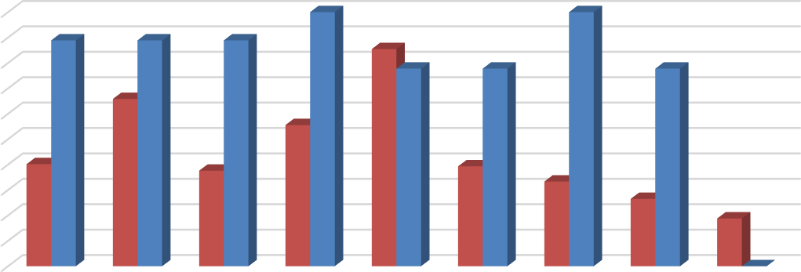
100%
89%
89%
89%
85%
78%
78%
78%
66%
56%
33%
26%
19%
0%
90%
80%
70%
60%
100%
100%

50% 40% | 38% | 39%
40%
30%
20%
10%
0%
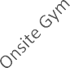




Unit-Leases Bed-Leases

Furnished and Unfurnished Units
Most of the surveyed properties indicated that they did not offer furnished units in the 2017 leasing season. Figures 7 and 8 illustrate the number of respondents that offered furnishings, by unit size. A total of only six properties indicated that they offered furnished apartments under unit lease arrangements in the 2017 leasing season. The most common units offered with furnishings under a unit lease arrangement are two-bedroom units. Only five respondents reported offering furnished bed-leased units.

Figure 7: Number of Respondents Offering Furnished Unit Leases, by Unit Size

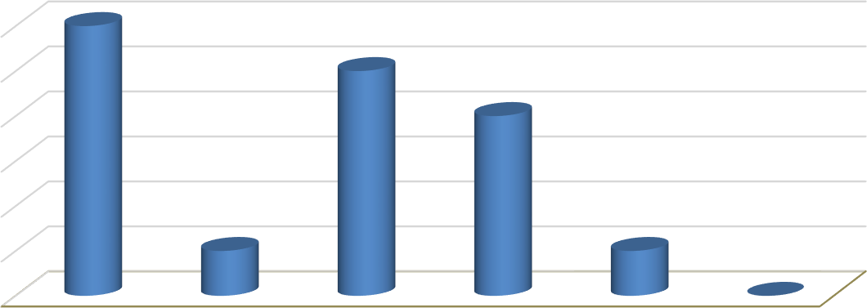
6
6
5
4
1
1
0
5
4
3
2
1
0
All Unit Sizes Studio 1 Bedroom 2 Bedroom 3 Bedroom 4 Bedroom

Figure 8: Number of Respondents Offering Furnished Bed Leases, by Unit Size

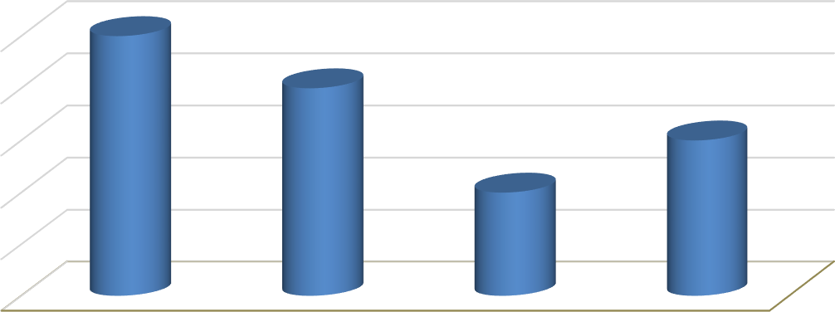
5
5
4
3
2

4

3

2

1

0
All Unit Sizes 2 Bedroom 3 Bedroom 4 Bedroom

Parking Availability
As in prior years, the 2017 survey included questions regarding parking availability. The survey requested that respondents identify the total number of automotive parking spaces, distinguishing between those reserved for use by tenants and those reserved for use by visitors. In total, 120 complexes responded to these survey questions. Based on the number of housing units and parking spaces offered at each complex, respondent complexes average around 1.13 parking spaces per unit. Twenty-six percent of the complexes that responded to these questions indicate that they offer fewer than one parking space per unit, while 63 percent offer one to two spaces per unit. Only 12 percent offer more than two parking spaces per unit, including guest parking spaces.

Figure 9: Number of Parking Spaces Per Unit





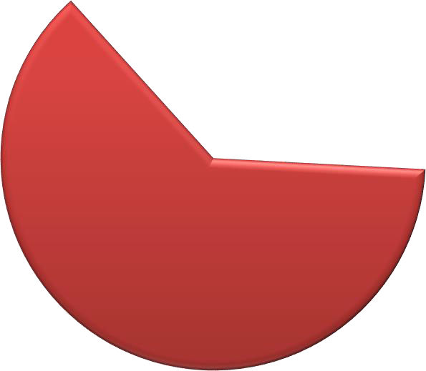

Less than 1 space per unit
14, 12%
31, 26%
75, 62%
Between 1-2 space per unit
More than 2 space per Unit

Active Leasing Period
As a new question for the 2017 survey, BAE asked respondents to identify the date when they began accepting applications for the fall 2017 rental season, as well as when they stopped.

Only three respondents indicated they began accepting applications for the fall 2017 rental season in December or November of the prior year. Thirty eight percent of respondents began accepting applications in January of 2017, while 14 percent began accepting applications in February and 24 percent began accepting applications in March. The remaining 18 percent did not begin accepting applications until later in 2017.

The duration of the lease-up period varied significantly depending on the property in question. While only one complex completed its leasing process by January of 2017, 25 percent completed the leasing process by the end of March 2017. Another 27 percent of survey respondents completed the leasing process in April and May, while 39 percent completed the leasing process during the period extending from the beginning of June to the end of August.7 There were seven complexes that did not complete the leasing process until September and two that did not complete the process until October and November.

Services and Incentives
For a variety of reasons, it is often in a property owner’s best interest to provide certain services and incentives to residents. This often promotes resident attraction and retention. For properties that offer bed leases, a roommate matching program can often be an important tool. Under such a program, prospective residents fill out applications, stating their interests, and preferences in a roommate. The prevalence of roommate matching programs remains unchanged from the 2016 survey, with a total of nine properties offering such services, including six properties that manage apartments that are leased on a per bed basis. Only six apartment complexes reported offering other incentives and move-in specials in the 2017 leasing season to help fill vacancies and attract new residents. These primarily included a mix of free or discounted rent, as well as gift cards and raffle entries provided upon signing.

Planned Renovations
Forty-two respondents reported having plans to undertake renovations within the next 12 months. Most of those that reported planned renovations conduct periodic updates, as units turn over. Other common in-unit upgrades include new flooring and countertops, updated appliances, and window replacement. Other exterior upgrades typically include new paint or siding, landscaping, and common area improvements. Some properties also indicated that they planned on renovating common areas, like club houses and laundry rooms.

7 Anecdotal evidence indicates that most rental housing complexes in the Davis area structure their leases on a 12-month basis extending from September 1st through August 31st.

