bae urban economics

2018 Apartment Vacancy and Rental Rate Survey

Presented on behalf of UC Davis Student Housing and Dining Services

Overview
The annual Apartment Vacancy and Rental Rate Survey collects information on the characteristics of rental units located within the Davis community. The objective of the survey is to provide information that will help inform planning decisions on campus and throughout the broader Davis area. For example, survey results help campus officials to assess the current housing market conditions faced by UC Davis students, faculty, and staff. The survey results also help the university to assess the likely feasibility of proposed housing projects.
Similar surveys have been conducted on an annual, or biennial basis, since at least 1975. Since 2013, the survey has been administered in partnership with BAE Urban Economics (BAE), a private real estate consulting firm with an office in Downtown Davis.
2018 Survey Results
In 2018, a total of 109 apartment complexes and property management companies responded to the survey, covering 8,658 rental units. This represents a 21 percent decrease in the number of respondent complexes compared to 2017, and a 15 percent decrease in the number of rental units covered in the respondent pool.1 More than half of the observed decrease in the response rate is driven by the absence of responses from one of the area’s large below market rate (i.e., affordable) housing property managers, which declined to participate recognizing that the survey is focused on market rate housing projects. According to estimates from the American Community Survey (ACS) there were approximately 11,349 multifamily housing units, on average, on the UC Davis campus and in the City of Davis between 2013 and 2017.2 This indicates that the units captured in the 2018 survey account for approximately 76 percent of the Davis area multifamily housing stock.

Of the 2018 survey’s 109 respondents, 11 reported leasing units at below market rents (i.e., requiring an income eligibility test to qualify prospective tenants for reduced or subsidized rents). Two of those respondents reported renting all of the units in the complex at below market rates, while the remaining nine complexes rent some units at below market rates and some units at market rates. The remainder of this analysis excludes units rented at below market rents, as reported by respondents, but does include units rented at market rates in mixed-income complexes.

1 BAE received responses from 138 unique apartment complexes and property management companies as part of the 2017 survey, representing 10,188 rental units.
2 U.S. Census Bureau. 2013-2017 American Community Survey 5-Year Estimates, Table B25024. Retrieved from: http://factfinder.census.gov/

San Francisco | Sacramento | Los Angeles | Washington DC | New York City
2600 10th St., Suite 300 | 803 2nd St., Suite A | 448 South Hill St., Suite 701 | 700 Pennsylvania Ave. SE, 2nd Floor | 215 Park Ave. S, 6th Floor
Berkeley, CA 94710 | Davis, CA 95616 | Los Angeles, CA 90013 | Washington, DC 20003 | New York, NY 10003
510.547.9380 | 530.750.2195 | 213.471.2666 | 202.588.8945 | 212.683.4486
www.bae1.com

While all survey respondents reported the total unit numbers, not all respondents provided detail regarding other unit characteristics, such as the number of beds leased under individual bed lease agreements. As a result, the unit and bed lease totals discussed elsewhere in this report may not equal those reported above, in some cases.

Leasing “Beds” Versus Complete Apartment Units
One of the increasingly common and complex dynamics of the local rental housing market is the practice of renting out individual apartment units to multiple tenants using multiple lease agreements. Under this type of arrangement, known as a “bed lease,” each bed or bedroom in an apartment is associated with a separate lease agreement. Each resident is, thereby, contractually responsible for only a portion of the total rent. This is compared to the more conventional approach, whereby each unit is rented under a single lease and all of the tenants living in the unit sign the lease and are jointly responsible for the complete monthly rent. For the purposes of this survey, this arrangement is called a “unit lease.”

Unit Leases
Survey respondents provided unit size detail for 7,073 units that are rented under unit lease arrangements, which account for 85 percent of all reported market rate rental units. Note that the survey results reported below exclude units for which unit size detail was not reported.
Figure 1 illustrates the distribution of unit-leased apartments, by unit size. The majority of reported units had between one and three bedrooms. One-bedroom units accounted for 31 percent of the total, while two-bedroom units accounted for 45 percent and three-bedroom units represented 14 percent. Four-bedroom apartments represented seven percent of reported units, while studio units represented three percent. Respondents also reported 20 units categorized as “other” unit types, generally including five or more bedrooms. This distribution is roughly comparable to the results of the 2017 survey.

Figure 1: Distribution of Unit Leases by Unit Size











20, 0% 201, 3%
483, 7%
984, 14%
2,182, 31%
3,203, 45%

Studio
1 Bedroom
2 Bedroom
3 Bedroom
4 Bedroom Other

Figure 2 summarizes the average number of occupants in unit-leased apartments by type.
This information is based on a new survey question that was introduced for the first time in the 2018 survey. As reported below, most unit types have at least one double occupancy bedroom on average. For example, the average occupancy for a one-bedroom unit is 1.6 persons, while two-bedroom units average 3.2 residents, three-bedroom units average 4.4 residents, and four-bedroom units average 5.7 residents. By comparison, most studio units are single-occupancy.

Figure 2: Average Number of Occupants in Unit-Leased Apartments by Type

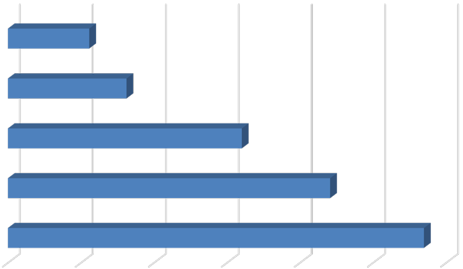
Studio
1.1
1.6
3.2
4.4
5.7

- Bedroom

- Bedroom

- Bedroom

- Bedroom

0.0 1.0 2.0 3.0 4.0 5.0 6.0

Table 1 below provides detailed unit totals, along with the number of vacant units, and the associated vacancy rate by unit size. Again, the results reflect only those survey responses that provided unit size and vacancy details. Per the survey respondents, there were 30 vacant apartments available for lease on a unit-lease basis. This translates to a vacancy rate of 0.4 percent, which is slightly higher than was reported in other recent surveys, though still indicative of a tight rental market. Broken down by unit type, the 2018 survey results show that the vacancy rate was highest among two-bedroom and four-bedroom units, which both had vacancy rates of 0.6 percent. Three-bedroom and two-bedroom units account for the remaining vacant units, with vacancy rates of 0.3 percent and 0.2 percent, respectively. There were no vacancies reported among studio units or “other” units.3

3 Units included in the “other” category generally include those with five or more bedrooms.

Table 1: Vacancy Rate for Unit Leases by Unit Size

2018 Survey Results
 |  |  |  |  | Number of Vacant |  |  |  |  |  |  | 2017 |  | 2016
Units Reported (a) |  |  |  |  | Units Reported (b) |  |  |  | Vacancy |  |  | Vacancy |  | Vacancy
Unit Size |  | Number |  | Percent |  | Number |  | Percent |  | Rate (c) |  | Rate (c) |  | Rate (c)
Studio |  | 201 |  | 3% |  | 0 |  | 0% |  | 0.0% |  | 0.0% |  | 0.0%
1 Bedroom |  | 2,182 |  | 31% |  | 5 |  | 17% |  | 0.2% |  | 0.1% |  | 0.0%
2 Bedroom |  | 3,203 |  | 45% |  | 19 |  | 63% |  | 0.6% |  | 0.2% |  | 0.1%
3 Bedroom |  | 984 |  | 14% |  | 3 |  | 10% |  | 0.3% |  | 0.1% |  | 1.0%
4 Bedroom |  | 483 |  | 7% |  | 3 |  | 10% |  | 0.6% |  | 0.0% |  | 0.0%
Other |  | 20 |  | 0% |  | 0 |  | 0% |  | 0.0% |  | 0.0% |  | 0.0%
Total, All Sizes |  | 7,073 |  | 100% |  | 30 |  | 100% |  | 0.4% |  | 0.2% |  | 0.2%

Notes:
- Includes the number of units, by unit type, reported by respondents as rented on a per unit basis (i.e., unit lease).
- Includes the number of units reported as vacant, by unit type, as reported by survey respondents. May exclude some units in cases where the survey respondent reported the total number of units but did not report the associated number of vacant units.
- The vacancy rate for unit leased apartments was calculated based on the number of leased and vacant units only, as reported by survey respondents.
Sources: BAE, 2018.

Bed Leases
Of the 8,277 market rate apartment units reported by survey respondents, 1,204 units (15 percent) were reportedly rented under bed lease arrangements. This generally aligns with the survey response from 2017, which contained 1,226 bed-leased units. Figure 3 illustrates the distribution of bed leases and bed-leased units, by unit size, which are also reported in Table
2. Most of the bed-leased units, nearly 84 percent, had between two and four bedrooms. Four-bedroom units were the most common, accounting for 39 percent of the total. Two- and three-bedroom units accounted for 26 percent and 18 percent of all reported bed-leased units, respectively, while one-bedroom units accounted for the remaining 16 percent.

Survey respondents reported a total of 3,955 leased beds, which represents only a slight decrease relative to the 2017 responses, despite the fact that more complexes reported using a bed-leasing structure in the 2018 survey. The distribution of leased beds, by unit size, reflects a distribution similar to that shown for bed-leased units. As shown in Figure 3, 55 percent of the leased beds reported by respondents were in four-bedroom units, while 19 percent were in two-bedroom units and 18 percent were in three-bedroom units. One- bedroom units that were reported as rented under bed lease agreements accounted for eight percent of the total.

Figure 3: Distribution of Bed Leases by Unit Size
















Beds
Units
194, 16%
471, 39%
318, 26%
221, 18%
744, 19%
2,161, 55%
719, 18%

331, 8%

1 Bedroom

2 Bedroom

3 Bedroom

4 Bedroom

Figure 4 reports the average number of beds per unit, by unit size. This generally illustrates the relatively low incidence of double-occupancy bedrooms among bed-leased units, though the number of double-occupancy rooms appears to be increasing. For example, there are an average of 1.7 beds per one-bedroom bed-leased apartment, 2.3 beds per two-bedroom bed- leased apartment, 3.3 beds per three-bedroom bed-leased apartment, and 4.6 beds per four- bedroom.4

Figure 4: Average Number of Beds Per Bed-Leased Unit

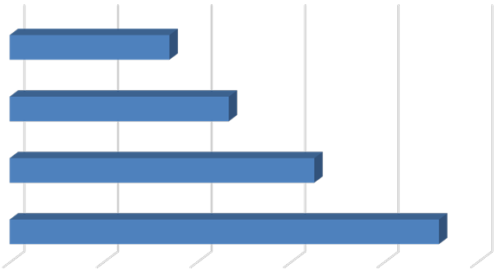
- Bedroom
1.7
2.3
3.3
4.6

- Bedroom

- Bedroom

- Bedroom

- 1.0 2.0 3.0 4.0 5.0

4 This generally reflects an average of one double-occupancy bedroom per unit.

As documented in Table 2, respondents reported just 28 vacant bed lease spaces, for a vacancy rate among reported leasable beds of 0.7 percent. This represents a decrease from the 74 vacant beds reported in 2017, when the vacancy rate was 1.6 percent. Anecdotal information suggests that the decrease is a result of a change in management practices, whereby properties used to intentionally maintain higher vacancy rates in order to accommodate new arrivals. Property managers are now maintaining a lower operating vacancy rates.

Table 2: Vacancy Rate for Bed Leases by Unit Size

2018 Survey Results
Bed Leased |  |  |  |  | Number of |  |  |  | Number of Vacant |  |  |  |  |  |  | 2017 |  | 2016
Units Reported (a) |  |  |  |  | Beds Reported (b) |  |  |  | Beds Reported (c) |  |  |  | Vacancy |  |  | Vacancy |  | Vacancy
Unit Size |  | Number |  | Percent |  | Number |  | Percent |  | Number |  | Percent |  | Rate (d) |  | Rate (d) |  | Rate (d)
Studio |  | 0 |  | 0% |  | 0 |  | 0% |  | 0 |  | 0% |  | n.a. |  | n.a. |  | n.a.
1 Bedroom |  | 194 |  | 16% |  | 331 |  | 8% |  | 0 |  | 0% |  | 0.0% |  | 1.2% |  | 0.0%
2 Bedroom |  | 318 |  | 26% |  | 744 |  | 19% |  | 8 |  | 29% |  | 1.1% |  | 1.5% |  | 1.5%
3 Bedroom |  | 221 |  | 18% |  | 719 |  | 18% |  | 3 |  | 11% |  | 0.4% |  | 1.7% |  | 0.6%
4 Bedroom |  | 471 |  | 39% |  | 2,161 |  | 55% |  | 17 |  | 61% |  | 0.8% |  | 1.7% |  | 1.0%
Other |  | 0 |  | 0% |  | 0 |  | 0% |  | 0 |  | 0% |  | n.a. |  | n.a. |  | n.a.
Total, All Sizes |  | 1,204 |  | 100% |  | 3,955 |  | 100% |  | 28 |  | 100% |  | 0.7% |  | 1.6% |  | 1.0%

Notes:
- Includes the number of units, by unit type, reported by respondents as rented on a per bed basis (i.e., bed lease).
- Includes the number of beds located within bed leased units, by unit type, as reported by survey respondents. May exclude some beds in cases where the survey respondent reported bed leased units but did not report the associated number of leased.
- Includes the number of leasable beds reported as vacant, by unit type, as reported by survey respondents. May exclude some beds in cases where the survey respondent reported bed leased units but did not report the associated number of leased or vacant beds.
- The vacancy rate for bed leases was calculated based on the number of leased and vacant beds only, as reported by survey respondents.

Sources: BAE, 2018.

Blended Vacancy Rate
To estimate a citywide vacancy rate for all lease types, BAE combined the unit lease and bed lease vacancy rates, to generate a combined or “blended” vacancy estimate.5 The results of the “blended” vacancy rate calculation for the 2018 survey are shown in Table 3. Given that unit-leased apartments account for 85 percent of the reported market rate rental inventory, the blended vacancy rate aligns more closely with the unit lease vacancy rate than the bed lease vacancy rate, but is drawn upward due to the addition of the higher bed lease vacancy rate. The blended vacancy rate for all rental units equals to 0.5 percent, which is roughly in

5 To calculate the “blended” vacancy rate, BAE calculated the unit lease vacancy rate, then applied that rate to the total number of bed-leased units. The resulting “vacant unit equivalents” were then added to the total number of vacant unit-leased apartments to calculate the combined vacancy rate.

line with the 2016 and 2017 blended rates of 0.6 percent and 0.3 percent, respectively. Nevertheless, the overall vacancy rate remains extremely low.

Table 3: Blended Vacancy Rate Summary

2018 Vacancy Rate
Unit Bed 2017 Blended 2016 Blended
Unit Size |  | Lease (a) |  | Lease (b) |  | Blended (c) |  | Vacancy Rate (c) |  | Vacancy Rate (c)
Studio |  | 0.0% |  | n.a. |  | 0.0% |  | 0.0% |  | 0.0%
1 Bedroom |  | 0.2% |  | 0.0% |  | 0.2% |  | 0.1% |  | 0.0%
2 Bedroom |  | 0.6% |  | 1.1% |  | 0.6% |  | 0.2% |  | 0.3%
3 Bedroom |  | 0.3% |  | 0.4% |  | 0.3% |  | 0.5% |  | 2.1%
4 Bedroom |  | 0.6% |  | 0.8% |  | 0.7% |  | 0.6% |  | 1.5%
Other |  | 0.0% |  | n.a. |  | 0.0% |  | 0.0% |  | 2.3%
Total, All Sizes |  | 0.4% |  | 0.7% |  | 0.5% |  | 0.3% |  | 0.6%

Notes:
- Based on the number of units, by unit type, reported as rented on a per unit basis (i.e., unit lease).
- Based on the number of units, by unit type, reported as rented on a per bed basis (i.e., bed lease).
- Based on the number of units, by unit type, reported as rented on a per unit basis (i.e., unit lease), with vacant units leased on a per bed basis converted to "vacant unit equivalents."

Sources: BAE, 2018.

Rental Rates
Most respondents reported static or increasing rents, relative to 2017. Four of the respondent complexes reported lowering rents in 2018 in order to fill vacancies, though two of the complexes indicated the reductions were just on a portion of their units. This is the first time since 2014 that any complex reported reduced rents in order to help fill vacancies.

Unit Leases
Table 4 reports the range and weighted average of the reported rental rates for apartments leased under unit lease arrangements. Note that the survey results reported here represent properties for which respondents reported both the total number of units, by type, and the corresponding rental rate information. The results exclude survey responses with no unit type or rental rate information. Based on this information, the average rental rate for all units was
$1,815 per month.6 This represents an 8.5 percent increase over 2017.

Bed Leases
Table 5, on the following page, illustrates the weighted average of the reported rental rates for individual bed leases. Note that the reported survey results only include those responses that identified the total number of bed-leased units, by type, the total number of beds per unit, and the associated rental rate information. According to survey respondents, the weighted

6 In cases where the respondent provided a range of prices for a given unit type, but no corresponding unit totals, BAE utilized the mid-point of the range as the assumed representative value. The reported values represent weighted averages, which reflect the reported rental rates and the total number of units or beds.

average rental rate for a bed lease, in units of all sizes, was $954 per month.7 This represents an increase of 6.9 percent over 2017 when the average monthly rental rate was $892.

Table 4: Rental Rates for Unit Leases, by Unit Size

2018 Survey Results 2017 2016
Weighted Weighted |  |  |  |  |  |  |  |  |  | Weighted
Unit Size |  | Minimum |  | Maximum |  | Average (a) |  | Average (a) |  | Average (a)
Studio |  | $633 |  | $1,557 |  | $1,096 |  | $1,035 |  | $972
1 Bedroom |  | $865 |  | $2,600 |  | $1,367 |  | $1,270 |  | $1,210
2 Bedroom |  | $1,025 |  | $3,350 |  | $1,785 |  | $1,660 |  | $1,549
3 Bedroom |  | $1,494 |  | $3,235 |  | $2,416 |  | $2,270 |  | $2,041
4 Bedroom |  | $2,200 |  | $4,095 |  | $2,992 |  | $2,858 |  | $2,627
Other |  | $3,870 |  | $4,595 |  | $4,336 |  | $3,511 |  | $3,233
Total, All Sizes |  | $633 |  | $4,595 |  | $1,815 |  | $1,673 |  | $1,576

Note:
(a) Figures represent weighted average rental rates and include only those complexes where the respondent identified the number of units by type, the number of beds per unit, and associated rental rates.

Sources: BAE, 2018.

Table 5: Average Rental Rate for Bed Leases, by Unit Size

2018 Survey Results 2017 2016
Weighted Weighted Weighted
Unit Size |  | Minimum |  | Maximum |  | Average (a) |  | Average (a) |  | Average (a)
1 Bedroom (b) |  | $740 |  | $2,135 |  | $980 |  | $1,614 |  | $1,977
2 Bedroom |  | $700 |  | $1,287 |  | $1,024 |  | $1,147 |  | $1,126
3 Bedroom |  | $770 |  | $1,135 |  | $1,022 |  | $898 |  | $874
4 Bedroom |  | $638 |  | $1,103 |  | $903 |  | $826 |  | $796
Other |  | n.a. |  | n.a. |  | n.a. |  | n.a. |  | n.a.
Total, All Sizes |  | $638 |  | $2,135 |  | $954 |  | $892 |  | $875

Notes:
- Figures represent weighted average rental rates and include only those complexes where the respondent identified the number of units by type, the number of beds per unit, and associated rental rates.
- One-bedroom bed-leased apartments are in complexes that only rent units under bed lease arrangements. These complexes offer a greater suite of amenities, compared to the average unit-leased complex, and are priced accordingly.
Sources: BAE, 2018.

Blended Rental Rate
To estimate the average Citywide rental rate for an entire unit, either under a unit-lease or bed- lease agreement, BAE combined the rental rates for unit leases and calculated the unit-

7 See footnote 5.

equivalent rental rate for units rented under bed lease arrangements.8 Table 6 provides a summary of these average rental rates. As seen in the table, unit-equivalent bed-lease rental rates are generally higher than the average unit lease rents (e.g., ranging from 22 to 38 percent higher depending on the unit type). Across all unit types, the average rental rate for an apartment unit in Davis is $2,006. BAE used the same method to calculate the blended rental rate for the 2017. This comparison indicates that the blended 2018 rental rate reflects an increase of 6.5 percent over the blended 2017 average of $1,883.

Table 6: Blended Rental Rate Summary

2018 Rental Rate
Unit Size |  | Unit  Lease |  | Bed  Lease (a) |  | Blended (b) |  | 2017 Blended  Rental Rate (b) |  | 2016 Blended  Rental Rate (b)
Studio |  | $1,096 |  | n.a. |  | $1,096 |  | $1,035 |  | $972
1 Bedroom |  | $1,367 |  | $1,673 |  | $1,392 |  | $1,287 |  | $1,227
2 Bedroom |  | $1,785 |  | $2,395 |  | $1,840 |  | $1,706 |  | $1,585
3 Bedroom |  | $2,416 |  | $3,324 |  | $2,582 |  | $2,388 |  | $2,173
4 Bedroom |  | $2,992 |  | $4,141 |  | $3,559 |  | $3,506 |  | $3,027
Other |  | $4,336 |  | n.a. |  | $4,336 |  | $3,511 |  | $3,233
Total, All Sizes |  | $1,815 |  | $3,132 |  | $2,006 |  | $1,883 |  | $1,724

Notes:
- Based on the number of beds and the weighted average bed-lease rental rate, by unit type.
- Based on the weighted average unit lease rate and unit lease rate equivalent (for bed-leased units), by unit type.

Sources: BAE, 2018.

Utilities, Appliances, and Amenities
The 2018 survey incorporated additional questions regarding utilities and amenities that were made available to tenants at no additional charge (i.e., included in the monthly rental rate). Of the 109 respondents that offer unit-leased apartments, 74 percent reported that they include trash collection, while 73 percent include sewer service, and 69 percent include water service. Meanwhile, 28 percent offer internet or Wi-Fi at no additional charge. Of the nine respondents that offered bed-leased units, 67 percent reported that they include water service, trash collection, sewer service, and 44 percent include internet or Wi-Fi service. Eleven percent include electricity at no additional charge for bed-leased units.

8 To calculate the “blended” rental rate, BAE calculated the a “unit lease equivalent” for bed leased units. This is equal to the weighted average bed-lease rate multiplied by the number of beds per unit, by unit type. This value was then used to calculate a weighted average rental rate for all units.

Figure 5: Percent of Respondents Including Utilities in Rent by Utility Type and Lease Type

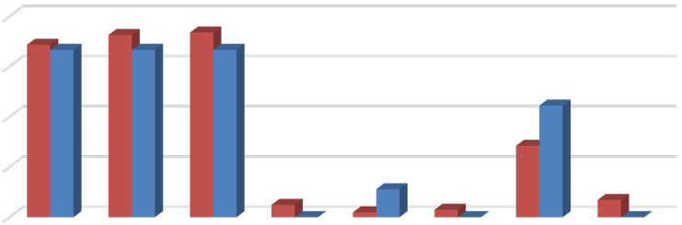
80%
69% 67% 73% 67% 74%
67%
44%
28%
11%
5%
0%
2%
3%
7%
0%
0%

60%

40%

20%






0%
Unit-Leases Bed-Leases

In addition to information regarding utilities, the survey also collected information on the appliances that are provided within each rental unit. Among respondents offering unit-leased apartments, 99 percent reported including a stove/oven, while 98 percent include a refrigerator, 94 percent include air conditioning, 70 percent include a dishwasher, and 49 percent include a microwave. Of the 15 percent that reported offering other appliances, most reported in-unit laundry facilities. Among respondents offering bed-leased units, all complexes include a refrigerator, while 89 percent include an air conditioning unit and oven/stove.
Seventy-eight percent of the complexes with bed-leases provide dishwashers and microwaves.

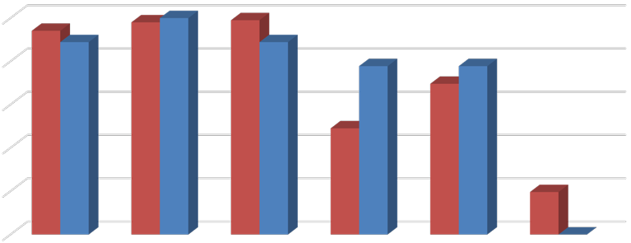
Figure 6: Percent of Respondents Including Appliances in Unit by Lease Type
94%
98% 100%
99%
89% 89%
78%
78%
70%
49%
20%
0%

100%

80%

60%

40%

20%

0%
Air Conditioning

Refrigerator Stove/Oven Microwave Dishwasher Other Unit-Leases Bed-Leases

The 2018 survey also questioned respondents regarding the amenities offered onsite, such as gym or pool facilities, and some of the services provided by the property management staff, such as package service and organized social activities. Figure 7 illustrates the prevalence of these amenities, differentiating between complexes that offer unit leases versus bed leases. Overall, Respondents that offer unit leases generally tend to offer fewer amenities. For example, 41 percent offer onsite gym facilities, while 38 percent offer a club house, 60 percent offer a pool and/or hot tub, and 56 percent offer a picnic or BBQ area. The most prevalent amenity offered by unit-lease complexes is an onsite laundry facility. Respondents that offer bed leases were more likely to offer an assortment of onsite amenities, with most respondents offering multiple types of equipment, facilities, and services. For example, all complexes that offer bed leases also offer a picnic or BBQ area and planned social activities, while 89 percent offer a pool and/or hot tub, 78 percent offer onsite gym facilities, and 67 percent offer a club house, package service, and a business center. Of the respondents who offered other additional services, most offer study lounges and on-site printing centers.

Figure 7: Percent of Respondents Offering Select Amenities by Lease Type

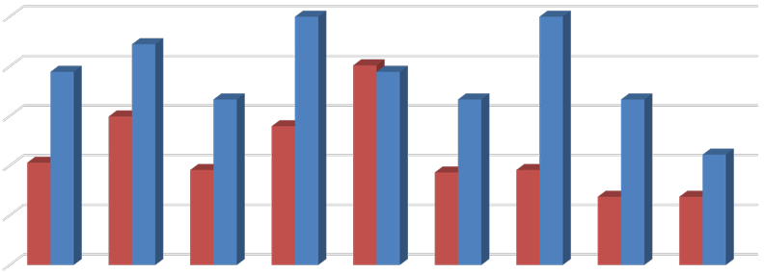
100%
100%
100%
89%
78%
80% 78%
67% 67%
67%
60%
56%
41%
38%
44%
37%
38%
27% 27%

80%

60%

40%

20%

0%





Unit-Leases Bed-Leases

Furnished and Unfurnished Units
Most of the surveyed properties indicated that they did not offer furnished units in the 2018 leasing season. Figures 8 and 9 illustrate the number of respondents that offered furnishings, by unit size. A total of only six properties indicated that they offered furnished apartments under unit lease arrangements in the 2018 leasing season. The most common units offered with furnishings under a unit lease arrangement are two-bedroom units. Five of the nine bed- lease complexes reported offering furnished bed-leased units.

Figure 8: Number of Respondents Offering Furnished Unit Leases, by Unit Size

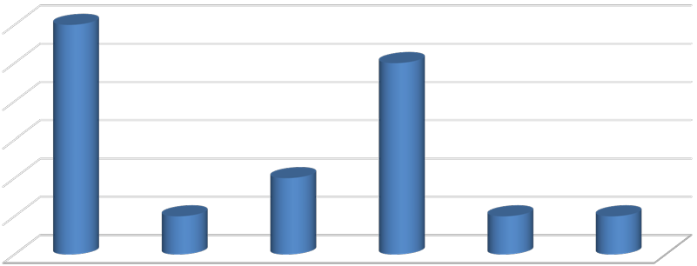
6
6
5
2
1
1
1
5
4
3
2
1
0
All Unit Sizes Studio 1 Bedroom 2 Bedroom 3 Bedroom 4 Bedroom

Figure 9: Number of Respondents Offering Furnished Bed Leases, by Unit Size

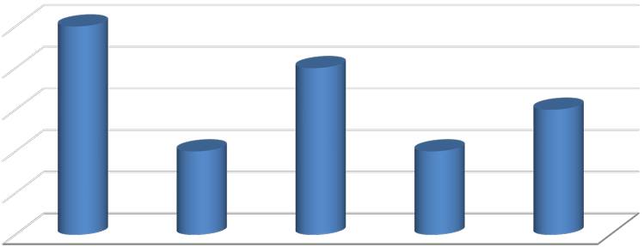
5
5
4
3
2
2

4

3

2

1

0
All Unit Sizes 1 Bedroom 2 Bedroom 3 Bedroom 4 Bedroom

Parking Availability
As in prior years, the 2018 survey included questions regarding parking availability. The survey requested that respondents identify the total number of automotive parking spaces, distinguishing between those reserved for use by tenants and those reserved for use by visitors. In total, 93 complexes responded to these survey questions. Based on the number of housing units and parking spaces offered at each complex, respondent complexes average around 1.6 parking spaces per unit. Only seven percent of the complexes that responded to these questions indicate that they offer fewer than one parking space per unit, while 73 percent offer one to two spaces per unit. The remaining 20 percent offer more than two parking spaces per unit, including guest parking spaces.

Figure 10: Number of Parking Spaces Per Unit





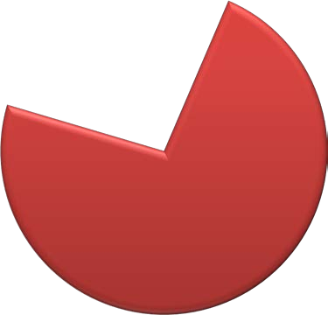

Less than 1 space per unit Between 1-2 space per unit More than 2 space per Unit
6, 7%
19, 20%
68, 73%

Charges for Parking
The 2018 survey also asked respondents if tenants are required to pay extra for a parking space, or if parking is included in the monthly rental charge. Of the 103 complexes offering unit-leases, only 14 percent charge separately for parking. However, an additional nine percent do charge for any additional parking spaces beyond the number initially allocated to each unit. The remaining 78 percent of complexes do not charge additional fees for parking. For bed-lease complexes, however, 89 percent of respondents charge separately for parking spaces, with an average cost of roughly $35 per month.

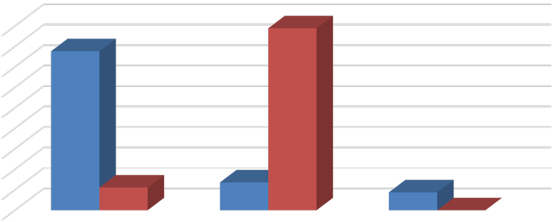
Figure 11: Parking Charges by Lease Type
89%
78%
11%
14%
9%
0%

90%
80%
70%
60%
50%
40%
30%
20%
10%
0%

No, we do not charge for parking

Yes, we charge separately for parking
Unit-Lease Bed-Lease

Yes, but only for extra spaces

Active Leasing Period
Similar to the 2017 survey, the 2018 survey asked respondents to identify the date when they began accepting applications for the fall 2018 rental season, as well as when they stopped.

Only four respondents indicated they began accepting applications for the fall 2018 rental season in December or November of the prior year. Twenty three percent of respondents began accepting applications in January of 2018, while 27 percent began accepting applications in February and 17 percent began accepting applications in March. The remaining 18 percent did not begin accepting applications until later in 2018.

The duration of the lease-up period varied significantly depending on the property. As seen in Figure 12, roughly 17 percent of respondents opened and closed their leasing period within the same month, while 39 percent maintained an open leasing period of one to three months. Twenty two percent of respondents took between three and six months to finish lease-up, while 23 percent took more than six months to lease up, including seven complexes that are still actively seeking tenants.

Figure 12: Leasing Period Duration

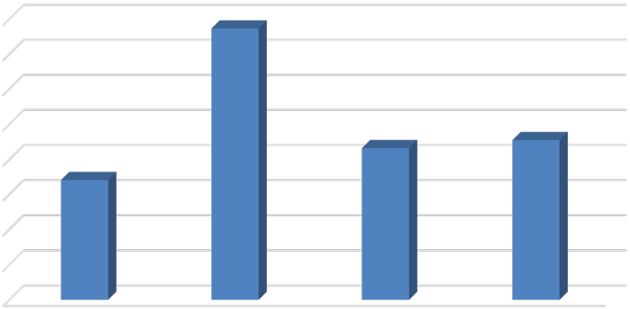
40%
39%
22%
23%
17%
35%
30%
25%
20%
15%
10%
5%
0%
Less than 1 Month 1-3 months 3-6 months 6 months or more

Services and Incentives
For a variety of reasons, it is often in a property owner’s best interest to provide certain services and incentives to residents. This often promotes resident attraction and retention. For properties that offer bed leases, a roommate matching program can often be an important tool. Under such a program, prospective residents fill out applications, stating their interests, and preferences in a roommate. The prevalence of roommate matching programs is roughly

unchanged from the 2017 survey period, with a total of ten properties offering such services, including eight properties that manage apartments that are leased on a per bed basis. Only 11 apartment complexes reported offering other incentives and move-in specials in the 2018 leasing season to help fill vacancies and attract new residents. These primarily included a mix of free or discounted rent, as well as gift cards and raffle entries provided upon signing.

Planned Renovations
Thirty-eight respondents reported having plans to undertake renovations within the next 12 months. Most of those that reported planned renovations conduct periodic updates, as units turn over. Other common in-unit upgrades include new flooring and countertops, updated appliances, and window replacement. Other exterior upgrades typically include new paint or siding, landscaping, and common area improvements. Some properties also indicated that they planned on renovating common areas, like club houses and laundry rooms.

