bae urban economics

2019 Apartment Vacancy and Rental Rate Survey

Presented on behalf of UC Davis Student Housing and Dining Services

Overview
The annual Apartment Vacancy and Rental Rate Survey collects information on the characteristics of rental apartment units in the Davis community. The objective of the survey is to provide information that will help inform planning decisions on campus and throughout the broader Davis area. For example, survey results help campus officials assess the current housing market conditions faced by UC Davis students, faculty, and staff. The survey results also help the university to assess the likely feasibility of proposed campus housing projects. Similar surveys have been conducted on an annual, or biennial basis, since at least 1975.
Since 2013, the survey has been administered in partnership with BAE Urban Economics (BAE), a private real estate consulting firm with an office in Downtown Davis.
2019 Survey Results
In 2019, a total of 122 apartment complexes and property management companies responded to the survey. These properties include a total of 9,007 rental units. This represents a 12 percent increase in the number of respondent complexes compared to 2018, and a four percent increase in the number of rental units covered in the response pool.1 According to estimates from the American Community Survey (ACS) there were approximately 11,833 multifamily housing units, on average, on the UC Davis campus and in the City of Davis between 2014 and 2018.23 This indicates that the units captured in the 2019 survey account for approximately 76 percent of the Davis area multifamily housing stock.

Of the 2019 survey’s 122 respondents, 13 reported leasing units at below market rents (i.e., requiring an income eligibility test to qualify prospective tenants for reduced or subsidized rents). Four of those respondents reported renting all of the units in the complex at below market rates, while the remaining nine complexes rent some units at below market rates and some units at market rates. Of the 13 complexes that reported renting units at below market rates, ten reported the income eligibility standards that they use to screen prospective tenants. Of those, three reported leasing to households earning up to 80 percent of area

1 BAE received responses from 109 unique apartment complexes and property management companies as part of the 2018 survey, representing 8,658 rental units.
2 Includes the City of Davis and the Census Block Groups 1 and 2 in Census Tract 105.1 in Yolo County, California.
3 U.S. Census Bureau. 2014-2018 American Community Survey 5-Year Estimates, Table B25024. Retrieved from: http://data.census.gov/

San Francisco | Sacramento | Los Angeles | Washington DC | New York City
2600 10th St., Suite 300 | 803 2nd St., Suite A | 448 South Hill St., Suite 701 | 700 Pennsylvania Ave. SE, 2nd Floor | 234 5th Ave.
Berkeley, CA 94710 | Davis, CA 95616 | Los Angeles, CA 90013 | Washington, DC 20003 | New York, NY 10001
510.547.9380 | 530.750.2195 | 213.471.2666 | 202.588.8945 | 212.683.4486
www.bae1.com

median income (AMI) and four reported leasing to households earning up to 60 percent of AMI. The remaining three complexes lease to households earning up to 50 percent of AMI. This is consistent with the 2018 results, which found that the majority of below market rate units in the community were rented to households earning between 60 and 80 percent of AMI. The remainder of this analysis excludes units rented at below market rents, as reported by respondents, but does include units rented at market rates in mixed-income complexes.

While all survey respondents reported the total unit numbers, not all respondents provided complete information regarding other unit characteristics, such as the mix of units by size or amenities provided on-site. Additionally, the sum total of all unit sizes may not equal the reported total unit count due to inconsistent reporting of managers’ units. As a result, the unit-and bed lease totals discussed elsewhere in this report may not equal those reported above, in some cases.

Leasing “Beds” Versus Complete Apartment Units
One of the increasingly common and complex dynamics of the local rental housing market is the practice of renting out individual apartment units to multiple tenants using multiple lease agreements. Under this type of arrangement, known as a “bed lease,” each bed or bedroom in an apartment is associated with a separate lease agreement. Each resident is thereby contractually responsible for only a portion of the total rent. This is compared to the more conventional approach, in which each unit is rented under a single lease, and all of the tenants living in the unit sign the lease and are jointly responsible for the complete monthly rent payment. For the purposes of this survey, this arrangement is called a “unit lease.”

Unit Leases
Survey respondents provided unit size detail for 7,207 units that are rented under unit lease arrangements, which account for about 85 percent of all reported market-rate rental units. Note that the survey results reported below exclude units for which unit size detail was not provided. Figure 1 illustrates the distribution of unit-leased apartments, by unit size. The majority of reported units had between one and three bedrooms. One-bedroom units accounted for 31 percent of the total, while two-bedroom units accounted for 45 percent and three-bedroom units represented 15 percent. Four-bedroom apartments represented six percent of reported units, while studio units represented three percent. Respondents also reported 18 units categorized as “other” unit types, generally including five or more bedrooms. This distribution is roughly comparable to the results of the 2018 survey.

Figure 1: Distribution of Unit Leases by Unit Size






416; 6% 18; 0%
1,062; 15%
2,273; 31%
3,253; 45%
185; 3%

Studio
1 Bedroom
2 Bedroom
3 Bedroom
4 Bedroom
Other

Figure 2 summarizes the average number of occupants in unit-leased apartments by unit size. As reported below, most units have at least one double occupancy bedroom, on average. For example, the average occupancy for a one-bedroom unit is 1.7 persons, while two-bedroom units average 3.1 residents, three-bedroom units average 4.5 residents, and four-bedroom units average 5.8 residents. Occupancy in studio units is most typically a single person, with an average occupancy factor of 1.1 residents.

Figure 2: Average Number of Occupants in Unit-Leased Apartments by Type

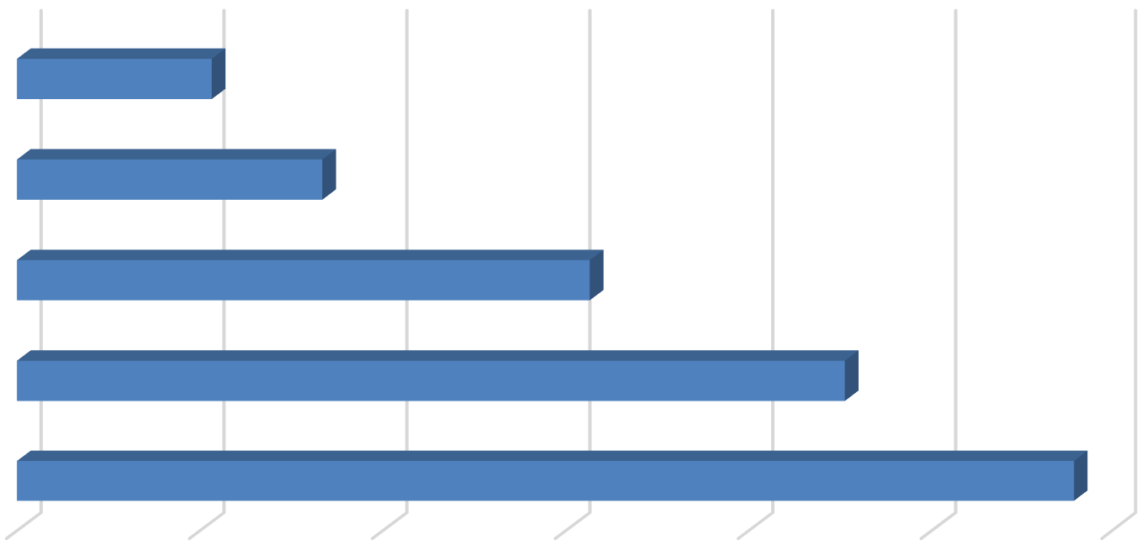
Studio
1.1
1.7
3.1
4.5
5.8

- Bedroom

- Bedroom

- Bedroom

- Bedroom

0.0 1.0 2.0 3.0 4.0 5.0 6.0

Table 1, below, provides detailed unit totals, along with the number of vacant units, and the associated vacancy rate by unit size. Again, the results reflect only those survey responses

that provided unit size and vacancy details. Per the survey respondents, there were 40 vacant apartments available for lease on a unit-lease basis during the survey period. This translates to a vacancy rate of 0.6 percent. This is 0.2 percentage points higher than was reported in the 2018 survey. Broken down by unit type, the 2019 survey results show that the vacancy rate was the highest among the one-bedroom and two-bedroom units, which had vacancy rates of
1.0 percent and 0.5 percent, respectively. The comparatively high vacancy rate among one-bedroom units is driven by vacancies at a small number of properties that have recently undergone renovations, where units were not available until after the fall lease-up period.

Table 1: Vacancy Rate for Unit Leases by Unit Size

2019 Survey Results
 |  |  |  |  | Number of Vacant |  |  |  |  |  |  | 2018 |  | 2017
Units Reported (a) |  |  |  |  | Units Reported (b) |  |  |  | Vacancy |  |  | Vacancy |  | Vacancy
Unit Size |  | Number |  | Percent |  | Number |  | Percent |  | Rate (c) |  | Rate (c) |  | Rate (c)
Studio |  | 185 |  | 2.6% |  | 0 |  | 0.0% |  | 0.0% |  | 0.0% |  | 0.0%
1 Bedroom |  | 2,273 |  | 31.5% |  | 23 |  | 57.5% |  | 1.0% |  | 0.2% |  | 0.1%
2 Bedroom |  | 3,253 |  | 45.1% |  | 17 |  | 42.5% |  | 0.5% |  | 0.6% |  | 0.2%
3 Bedroom |  | 1,062 |  | 14.7% |  | 0 |  | 0.0% |  | 0.0% |  | 0.3% |  | 0.1%
4 Bedroom |  | 416 |  | 5.8% |  | 0 |  | 0.0% |  | 0.0% |  | 0.6% |  | 0.0%
Other |  | 18 |  | 0.2% |  | 0 |  | 0.0% |  | 0.0% |  | 0.0% |  | 0.0%
Total, All Sizes |  | 7,207 |  | 100% |  | 40 |  | 100% |  | 0.6% |  | 0.4% |  | 0.2%

Notes:
- Includes the number of units, by unit type, reported by respondents as rented on a per unit basis (i.e., unit lease).
- Includes the number of units reported as vacant, by unit type, as reported by survey respondents. May exclude some units in cases where the survey respondent reported the total number of units but did not report the associated number of vacant units.
- The vacancy rate for unit-leased apartments was calculated based on the number of leased and vacant units only, as reported by survey respondents.

Sources: BAE, 2019.

Bed Leases
Of the 8,475 market-rate apartment units reported by survey respondents, 1,266 units (15 percent) were reportedly rented under bed lease arrangements. This generally aligns with the 2018 survey findings, which identified 1,204 bed-leased units. Figure 3 illustrates the distribution of bed leases and bed-leased units, by unit size, which are also reported in Table
2. Most of the bed-leased units, nearly 85 percent, had between two and four bedrooms. Four-bedroom units were the most common, accounting for 42 percent of the total. Two- and three-bedroom units accounted for 25 percent and 18 percent of all reported bed-leased units, respectively. One-bedroom units accounted for the remaining 15 percent.

Survey respondents reported a total of 4,194 leased beds, which represents a minor increase from 2018. The distribution of leased beds, by unit size, reflects a distribution similar to that shown for bed-leased units. As shown in Figure 3, 58 percent of the leased beds were in four-bedroom units, while 16 percent were in two-bedroom units, and 20 percent were in three-

bedroom units. One-bedroom units that were reported as rented under bed lease agreements accounted for six percent of the total.

Figure 3: Distribution of Leased Beds and Associated Units by Unit Size
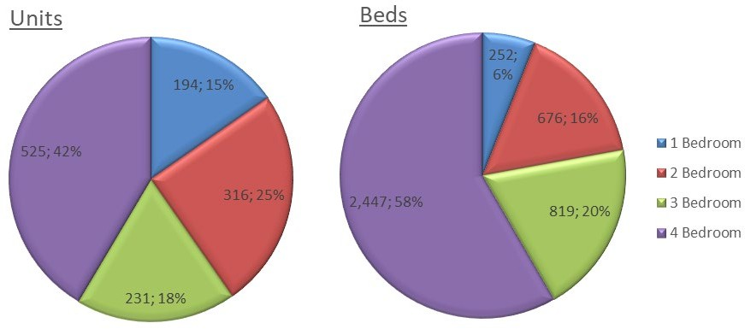

Figure 4 reports the average number of beds per unit, by unit size. This generally illustrates the relatively low incidence of double-occupancy bedrooms among bed-leased units. Doubled-up bedrooms are generally more prevalent within larger three-and four-bedroom units.
Compared to 2018, the data indicate a minor decrease in the prevalence of double-ups among one-bedroom units and a minor increase in the prevalence of double-ups in three- and four-bedroom units.

Figure 4: Average Number of Beds Per Bed-Leased Unit

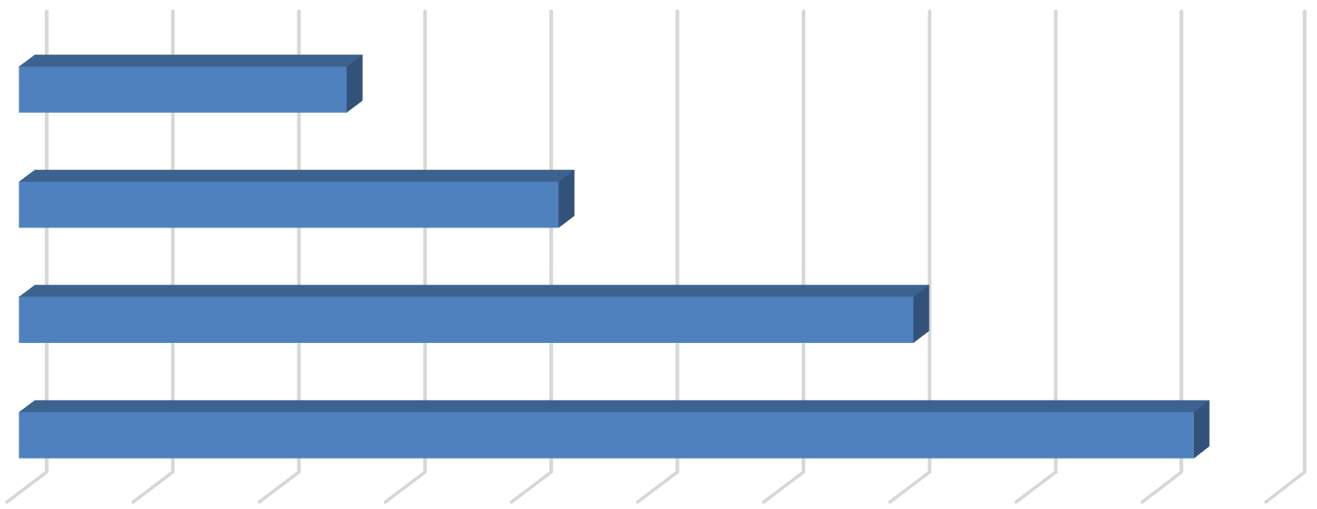
- Bedroom
1.3
2.1
3.5
4.7

- Bedroom

- Bedroom

- Bedroom

0.0 0.5 1.0 1.5 2.0 2.5 3.0 3.5 4.0 4.5 5.0

As documented in Table 2, respondents reported 141 vacant beds in 2019. This equals a vacancy rate of 3.4 percent, which represents a significant increase from 0.7 percent and 28

vacant beds in 2018. The increase in the vacancy rate is largely due to vacancies at a small number of properties, where units were not available until after the typical fall lease-up period.

Table 2: Vacancy Rate for Bed Leases by Unit Size

2019 Survey Results
Bed Leased |  |  |  |  | Number of |  |  |  | Number of Vacant |  |  |  |  |  |  | 2018 |  | 2017
Units Reported (a) |  |  |  |  | Beds Reported (b) |  |  |  | Beds Reported (c) |  |  |  | Vacancy |  |  | Vacancy |  | Vacancy
Unit Size |  | Number |  | Percent |  | Number |  | Percent |  | Number |  | Percent |  | Rate (d) |  | Rate (d) |  | Rate (d)
Studio |  | (e) |  | (e) |  | (e) |  | (e) |  | (e) |  | (e) |  | (e) |  | n.a. |  | n.a.
1 Bedroom |  | 194 |  | 15.3% |  | 252 |  | 6.0% |  | 11 |  | 7.8% |  | 4.4% |  | 0.0% |  | 1.2%
2 Bedroom |  | 316 |  | 25.0% |  | 676 |  | 16.1% |  | 19 |  | 13.5% |  | 2.8% |  | 1.1% |  | 1.5%
3 Bedroom |  | 231 |  | 18.2% |  | 819 |  | 19.5% |  | 27 |  | 19.1% |  | 3.3% |  | 0.4% |  | 1.7%
4 Bedroom |  | 525 |  | 41.5% |  | 2,447 |  | 58.3% |  | 84 |  | 59.6% |  | 3.4% |  | 0.8% |  | 1.7%
Other |  | (e) |  | (e) |  | (e) |  | (e) |  | (e) |  | (e) |  | (e) |  | n.a. |  | n.a.
Total, All Sizes |  | 1,266 |  | 100% |  | 4,194 |  | 100% |  | 141 |  | 100% |  | 3.4% |  | 0.7% |  | 1.6%

Notes:
- Includes the number of units, by unit type, reported by respondents as rented on a per bed basis (i.e., bed lease).
- Includes the number of beds located within bed-leased units, by unit type, as reported by survey respondents. May exclude some beds in cases where the survey respondent reported bed-leased units but did not report the associated number of leased.
- Includes the number of leasable beds reported as vacant, by unit type, as reported by survey respondents. May exclude some beds in cases where the survey respondent reported bed-leased units but did not report the associated number of leased or vacant beds.
- The vacancy rate for bed leases was calculated based on the number of leased and vacant beds only, as reported by survey respondents.
- Data are suppressed to prevent the disclosure of proprietary information.

Sources: BAE, 2019.

Blended Vacancy Rate
When UC Davis began collecting rent and vacancy information in the 1970s, the majority of the available properties used roughly the same leasing structure (i.e., unit leasing). In recent years, the market has shifted with a small but increasing share of units leased under bed-lease arrangements. Recognizing these changes in the market, the survey tool and report were updated to provide break outs for units leased by the bed. In order to facilitate comparison with prior years, BAE developed a method for calculating “blended” vacancy and rental rate figures that combine information for unit-leased and bed-leased properties.

To estimate a citywide vacancy rate for all lease types, BAE combined the unit lease and bed lease vacancy rates, to generate a combined, or “blended,” vacancy estimate.4 The results of the blended vacancy rate calculation for the 2019 survey are shown in Table 3. Given that

4 To calculate the “blended” vacancy rate, BAE calculated the bed lease vacancy rate on a per bed basis, then applied that rate to the total number of bed-leased units. The resulting “vacant unit equivalents” were then added to the total number of vacant unit-leased apartments to calculate the combined vacancy rate.

unit-leased apartments account for 85 percent of the reported market-rate rental inventory, the blended vacancy rate aligns more closely with the unit lease vacancy rate but is drawn upward due to the higher bed lease vacancy rate. The blended vacancy rate for all rental units is 1.0 percent. This vacancy rate is higher than the 2017 and 2018 blended rates of 0.4 percent and 0.5 percent, respectively.

Table 3: Blended Vacancy Rate Summary

2019 Vacancy Rate
Unit Size |  | Unit  Lease (a) |  | Bed  Lease (b) |  | Blended (c) |  | 2018 Blended  Vacancy Rate (c) |  | 2017 Blended  Vacancy Rate (c)
Studio |  | 0.0% |  | (d) |  | (d) |  | 0.0% |  | 0.0%
1 Bedroom |  | 1.0% |  | 4.4% |  | 1.3% |  | 0.2% |  | 0.1%
2 Bedroom |  | 0.5% |  | 2.8% |  | 0.7% |  | 0.6% |  | 0.3%
3 Bedroom |  | 0.0% |  | 3.3% |  | 0.6% |  | 0.3% |  | 0.4%
4 Bedroom |  | 0.0% |  | 3.4% |  | 2.0% |  | 0.7% |  | 1.0%
Other |  | 0.0% |  | (d) |  | (d) |  | 0.0% |  | 0.0%
Total, All Sizes |  | 0.6% |  | 3.4% |  | 1.0% |  | 0.5% |  | 0.4%

Notes:
- Based on the number of units, by unit type, reported as rented on a per unit basis (i.e., unit lease).
- Based on the number of units, by unit type, reported as rented on a per bed basis (i.e., bed lease).
- Based on the number of units, by unit type, reported as rented on a per unit basis (i.e., unit lease), with vacant units leased on a per bed basis converted to "vacant unit equivalents."
- Data are suppressed to prevent the disclosure of proprietary information.

Sources: BAE, 2019.

Rental Rates
Most respondents reported static or increasing rents, relative to 2018. Five of the respondent complexes reported lowering rents in 2019 in order to fill vacancies. This is a slight increase from 2018, when only four complexes reported reducing rents. Generally, complexes lowered rents by only two percent or less. One complex indicated a reduction in the rent on only one unit, while another reduced rents but is now charging an additional offsetting “utility coverage” fee.

Unit Leases
Table 4 reports the range and weighted average of the reported rental rates for apartments leased under unit lease arrangements. Note that the survey results reported here represent properties for which respondents reported both the total number of units, by type, and the corresponding rental rate information. Based on this information, the average rental rate for

all units was $1,901 per month.5 This represents a 4.7 percent increase over 2018, when the average rental rate for unit-leased apartments was $1,815; though the increase is notably smaller than the 8.5 percent increase experienced between 2017 and 2018.

Table 4: Rental Rates for Unit Leases by Unit Size

2019 Survey Results 2018 2017
Weighted Weighted |  |  |  |  |  |  |  |  |  | Weighted
Unit Size |  | Minimum |  | Maximum |  | Average (a) |  | Average (a) |  | Average (a)
Studio |  | $668 |  | $1,875 |  | $1,180 |  | $1,096 |  | $1,035
1 Bedroom |  | $900 |  | $2,600 |  | $1,430 |  | $1,367 |  | $1,270
2 Bedroom |  | $1,060 |  | $3,450 |  | $1,893 |  | $1,785 |  | $1,660
3 Bedroom |  | $1,480 |  | $3,555 |  | $2,529 |  | $2,416 |  | $2,270
4 Bedroom |  | $2,225 |  | $4,325 |  | $3,210 |  | $2,992 |  | $2,858
Other |  | $3,995 |  | $4,825 |  | $4,548 |  | $4,336 |  | $3,511
Total, All Sizes |  | $668 |  | $4,825 |  | $1,901 |  | $1,815 |  | $1,673

Note:
(a) Weighted averages include complexes where the number of units, the number of beds, and rental rates are reported.
Sources: BAE, 2019.

Bed Leases
Table 5 illustrates the weighted average of the reported rental rates for individual bed leases. Note that the reported survey results only include those responses that identified the total number of bed-leased units, by type, the total number of beds per unit, and the associated rental rate information. According to the survey respondents, the weighted average rental rate for a bed lease, in units of all sizes, was $1,003 per month.6 This represents an increase of
5.1 percent over 2018, when the average monthly bed lease rate was $954.

5 In cases where the respondent provided a range of prices for a given unit type, but no corresponding unit totals, BAE applied the mid-point of the range. The reported values represent weighted averages, which reflect the reported rental rates and the total number of units and/or beds.
6 See footnote 5.

Table 5: Average Rental Rate for Bed Leases by Unit Size

 |  | 2019 |  | 2018 |  | 2017
 |  | Weighted |  | Weighted |  | Weighted
Unit Size |  | Average (a) |  | Average (a) |  | Average (a)
Studio (b) |  | (c) |  | n.a. |  | n.a.
1 Bedroom (b) |  | $1,344 |  | $980 |  | $1,614
2 Bedroom |  | $1,077 |  | $1,024 |  | $1,147
3 Bedroom |  | $1,033 |  | $1,022 |  | $898
4 Bedroom |  | $937 |  | $903 |  | $826
Other |  | (c) |  | n.a. |  | n.a.
Total, All Sizes |  | $1,003 |  | $954 |  | $892

Notes:
- Weighted averages include complexes where the number of units, the number of beds, and rental rates are reported.
- One-bedroom bed-leased apartments offer a greater suite of amenities, compared to the average unit-leased complex.
- Data are suppressed to prevent the disclosure of proprietary information.
Sources: BAE, 2019.

Blended Rental Rate
To estimate the average citywide rental rate for an entire unit, either under a unit lease or bed lease agreement, BAE combined the rental rates for unit leases and calculated the unit equivalent rental rate for units rented under bed lease arrangements.7 As reported in Table 6, unit equivalent bed lease rental rates are generally higher than the average unit lease rents (e.g., ranging from 22 to 45 percent higher depending on the unit type). Across all unit types, the average rental rate is $2,117. This represents a 5.5 percent increase over 2018.

Table 6: Blended Rental Rate Summary

2019 Survey Results
Unit Size |  | Unit  Lease |  | Bed  Lease (a) |  | Blended (b) |  | 2018 Blended  Rental Rate (b) |  | 2017 Blended  Rental Rate (b)
Studio |  | $1,180 |  | (c) |  | (c) |  | $1,096 |  | $1,035
1 Bedroom |  | $1,430 |  | $1,746 |  | $1,455 |  | $1,392 |  | $1,287
2 Bedroom |  | $1,893 |  | $2,303 |  | $1,929 |  | $1,840 |  | $1,706
3 Bedroom |  | $2,529 |  | $3,661 |  | $2,731 |  | $2,582 |  | $2,388
4 Bedroom |  | $3,210 |  | $4,368 |  | $3,856 |  | $3,559 |  | $3,506
Other |  | $4,548 |  | (c) |  | (c) |  | n.a. |  | n.a.
Total, All Sizes |  | $1,901 |  | $3,322 |  | $2,117 |  | $2,006 |  | $1,883

Notes:
- Based on the number of beds and the weighted average bed lease rental rate, by unit type.
- Based on the weighted average unit lease rate and unit lease equivalent rate (for bed-leased units), by unit type.
- Data are suppressed to prevent the disclosure of proprietary information.
Sources: BAE, 2019.

7 To calculate the “blended” rental rate, BAE calculated a “unit lease equivalent” for bed-leased units, or the weighted average bed lease rate multiplied by the number of beds per unit.

Additional Recurring Charges
Prior survey efforts identified an increasing prevalence of complexes charging tenants separately for amenities and services that have historically been included in rent. For example, some complexes have started charging a recurring monthly fee for water, sewer, and garbage service, or for the use of certain on-site amenities. In the past, these charges were included as part of rent. In many cases, these newly itemized charges are mandatory, but are considered to be separate from rent. To account for this, and to identify other optional charges, the 2019 survey added a question asking respondents to more clearly identify additional monthly charges that are not included in the monthly rent amount paid by tenants.

Additional Unit Lease Charges
A total of 45 unit lease complexes indicated they levy additional mandatory charges in addition to rent. These are most typically associated with utility usage and parking. Among the 31 complexes that charge a separate utility fee, seven of them charged roughly $20 per person, and two charged roughly $25 per bedroom, regardless of the number of occupants. A total of 13 complexes charge separately for parking. Six respondents reported charged parking fees on a monthly basis, with an average cost of $30 per month. The complexes that charged parking annually reported charging an average of $90 for a parking permit. Some examples of other additional charges include monthly pet fees and “city service fees.”

Additional Bed Lease Charges
Similar to the unit lease complexes, bed lease complexes most commonly reported additional utility usage and parking charges. Of the seven bed lease complexes, only one charges a flat utility fee, with the other six charging for the utilities on a pass-through basis8. Six of the complexes charged for parking, typically at around $30 per month; though there is some slight variation between the amount charged for covered versus uncovered spaces. Some examples of other charges for bed-leasing tenants include common area and furniture rental fees.

Utilities, Appliances, and Amenities
As in prior years, the 2019 survey included questions regarding the utilities, appliances, and amenities that are provided to tenants at no additional charge (i.e., included in the monthly rental rate). As shown in Figure 5, an average of 60 to 70 percent of respondent complexes include water, sewer, and trash collection in rent. Approximately 55 percent of bed lease complexes report offering internet and Wi-Fi, as do 30 percent of unit lease complexes.

8 Properties that charge utility fees on a pass-through basis independently meter utility usage by unit and pass on the utility charge to tenants (e.g., Ratio Utility Billing System, or RUBS).

Figure 5: Percent of Respondents Including Utilities in Rent by Utility Type and Lease Type

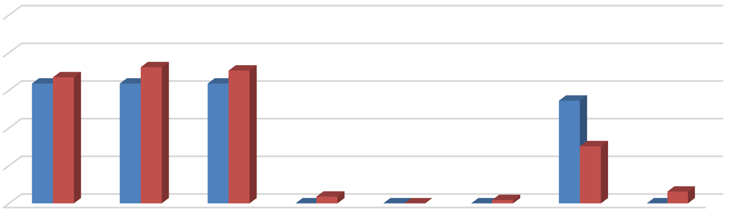
100%
64% 67%
72%
64%
71%
64%
55%
30%
0%
4%
0% 0% 0%
2%
6%
0%
80%
60%
40%
20%





0%
Bed Leases Unit Leases
Figure 6 illustrates the types of appliances and other amenities that are provided. Nearly all respondent complexes include a refrigerator, stove/oven, and air conditioning in the unit at no extra charge. Around 75 percent of unit lease properties and 82 percent of bed lease properties include a dishwasher, while 54 percent of unit lease properties and 73 percent of bed lease properties include a microwave. Only between 20 and 30 percent of respondent complexes report offering in-unit laundry facilities (including a washer and dryer).

Figure 6: Percent of Respondents Including Appliances in Unit by Lease Type

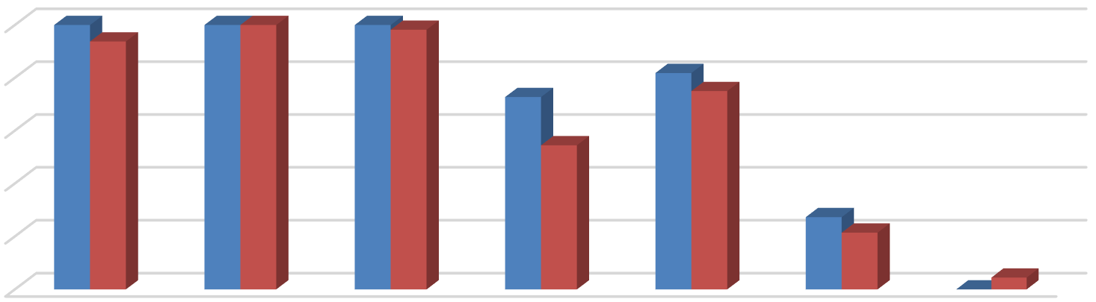
100%
100%
94%
100% 100% 100%
98%
82%
73%
75%
54%
27% 21%
0%4%
80%
60%
40%
20%
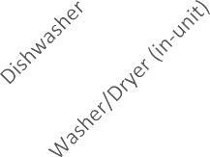
0%
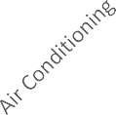




Bed Leases Unit Leases

The 2019 survey also questioned respondents regarding the amenities offered on-site, such as gym or pool facilities, and some of the services provided by the property management staff, such as package service and organized social activities. Figure 7 illustrates the prevalence of

these amenities, differentiating between complexes that offer unit leases versus bed leases. Overall, respondents that offer unit leases generally tend to offer fewer amenities. For example, 58 percent offer a pool and/or hot tub, while 49 percent offer a picnic or BBQ area, and 37 percent offer on-site gym facilities and club houses. The most prevalent amenity offered by unit lease complexes is an on-site laundry facility. Respondents that offer bed leases were more likely to offer an assortment of on-site amenities, with most respondents offering multiple types of equipment, facilities, and services. For example, all complexes that offer bed leases also offer a picnic or BBQ area, while 73 percent offer a pool and/or hot tub, 64 percent offer on-site laundry and planned social activities, 55 percent have a package service, and 45 percent offer an on-site gym and a club house. Of the respondents who offered other additional services, most offer study lounges and on-site printing centers.

Figure 7: Percent of Respondents Offering Select Amenities by Lease Type
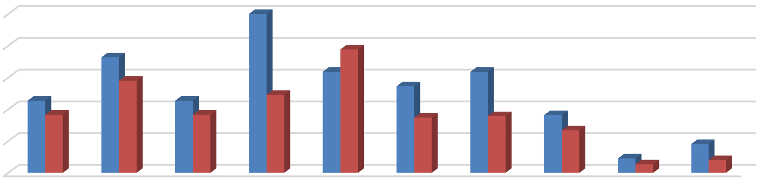
100%
100%  80%  60% | 45%  37% | 73%  58% | 45%  37% | 49% | 78%  64% | 55%  35% | 64%  36% 36%
40% |  |  |  |  |  |  | 27% |  | 18%
20% |  |  |  |  |  |  |  | 9%5% | 8%
0%



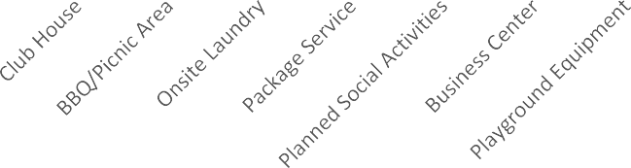
Bed Leases Unit Leases

Furnished and Unfurnished Units
Most of the surveyed properties indicated that they did not offer furnished units in the 2019 leasing season. Figures 8 and 9 illustrate the number of respondents that offered furnishings, by unit size. A total of only four properties indicated that they offered furnished apartments under unit lease arrangements in the 2019 leasing season. The most common units offered with furnishings under a unit lease arrangement are one- and two-bedroom units. Five of the 11 bed lease complexes reported offering furnished bed-leased units.

Figure 8: Number of Respondents Offering Furnished Unit Leases by Unit Size

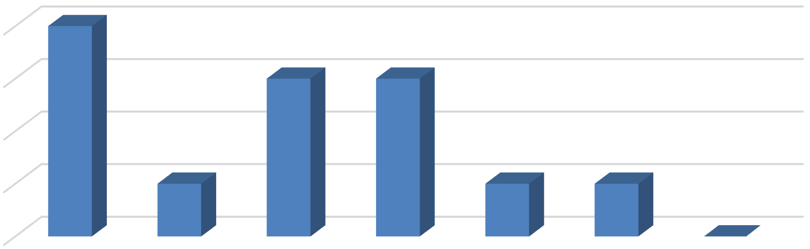
4
4
3
3
1
1
1
0

3

2

1

0
All Unit Sizes

Studio 1 Bedroom 2 Bedroom 3 Bedroom 4 Bedroom Other

Figure 9: Number of Respondents Offering Furnished Bed Leases by Unit Size

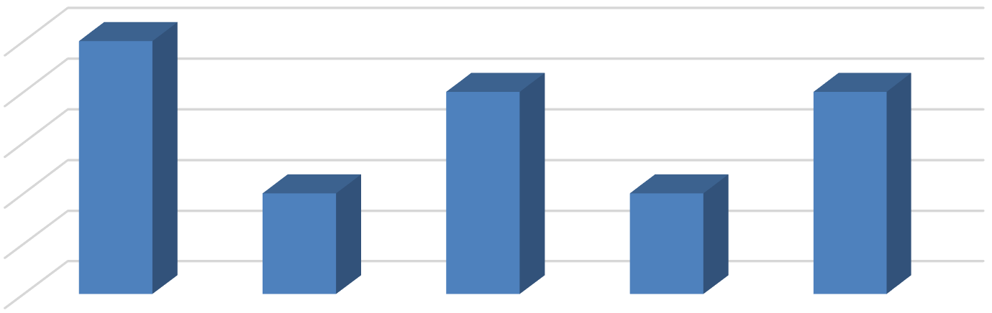
5
5
4
4
2
2
4
3
2
1
0
All Unit Sizes 1 Bedroom 2 Bedroom 3 Bedroom 4 Bedroom

Parking Availability
As in prior years, the 2019 survey included questions regarding parking availability. The survey requested that respondents identify the total number of auto parking spaces, distinguishing between those reserved for use by tenants and those reserved for use by visitors. In total, 96 complexes responded to these survey questions. Based on the number of housing units and parking spaces offered at each complex, respondent complexes average around 1.5 parking spaces per unit. Seventy-seven percent of the complexes that responded to these questions indicate that they offer one to two spaces per unit, while 17 percent indicate that they offer more than two spaces per unit. Only six percent of respondents indicated that they offer fewer than one space per unit on average.

Figure 10: Number of Parking Spaces Per Unit


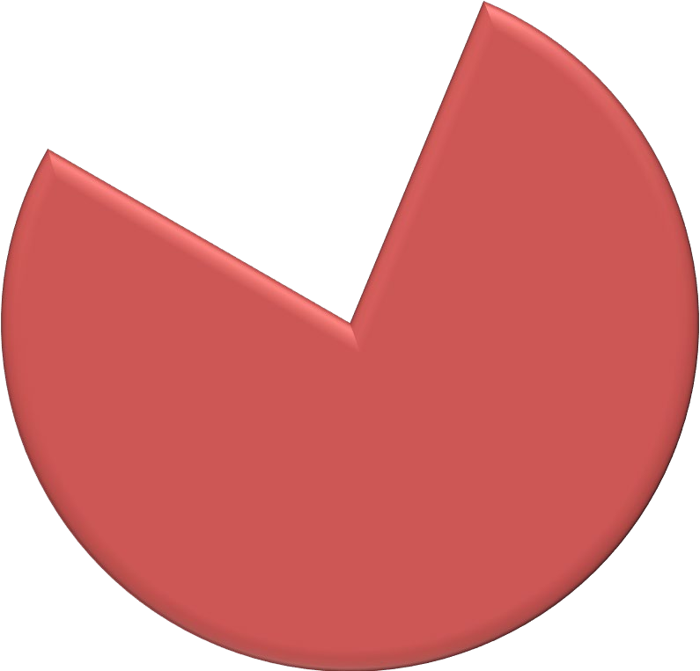

Less than 1 space per unit
6, 6%
16, 17%
74, 77%
Between 1-2 space per unit
More than 2 space per unit

Services and Incentives
For a variety of reasons, it is often in a property owner’s best interest to provide certain services and incentives to residents. This often promotes resident attraction and retention. For properties that offer bed leases, a roommate matching program can often be an important tool. Under such a program, prospective residents fill out applications, stating their interests, and preferences for a roommate. The prevalence of roommate matching programs is roughly unchanged from the 2018 survey period, with a total of ten properties offering such services, including seven properties that manage apartments that are leased on a per bed basis. Only 13 apartment complexes reported offering other incentives and move-in specials in the 2019 leasing season to help fill vacancies and attract new residents, which is comparable to prior years. Common incentives and specials included free or discounted rent, waived application fees, gift cards, and raffles, among other giveaways.

Planned Renovations
Thirty-two respondents reported having plans to undertake renovations within the next 12 months. Most of those that reported planned renovations conduct periodic updates as units turn over. Other common in-unit upgrades include new flooring and countertops, updated appliances and cabinetry, and window replacement. Other exterior upgrades typically include new paint or siding, landscaping, and common area improvements.

