bae urban economics

2020 Apartment Vacancy and Rental Rate Survey

Presented on behalf of UC Davis Student Housing and Dining Services

Overview
The annual Apartment Vacancy and Rental Rate Survey collects information on the characteristics of rental apartment units in the Davis community. Similar surveys have been conducted on an annual, or biennial basis, since at least 1975. Since 2013, the survey has been administered in partnership with BAE Urban Economics (BAE), a private real estate consulting firm with an office in Downtown Davis. The objective of the survey is to provide information that will help inform planning decisions on campus and throughout the broader Davis area. For example, survey results help campus officials assess the current housing market conditions faced by UC Davis students, faculty, and staff. The survey results also help the university to assess the likely feasibility of proposed campus housing projects.

Recognizing that many properties have been both directly and indirectly impacted by the ongoing Coronavirus pandemic, the 2020 Apartment Vacancy and Rental Rate Survey was revised to collect information regarding the ways in which rental properties in the Davis community are being impacted (i.e., increases in vacancy and unoccupied units, revenue losses, etc.). Nonetheless, the survey still asks many of the same questions asked in prior years to ensure consistency and to allow for analysis of long-term trends. Other questions have been removed to streamline the survey tool and make it easier to complete.

2020 Survey Results
In 2020, a total of 114 apartment complexes and property management companies responded to the survey. These properties represent a total of 8,938 rental units. While the majority of these totals reflect unit leases, the survey recorded a total of nine properties that lease a total of 1,352 units on a per-bed basis with a total inventory of 4,300 leasable beds. This is a six percent decrease in the number of respondent complexes compared to 2019, and a one percent decrease in the number of rental units covered in the response pool.1
According to estimates from the American Community Survey (ACS) there were approximately 11,975 multifamily housing units, on average, on the UC Davis campus and in the City of Davis between 2015 and 2019.23 This indicates that the units captured in the 2020 survey account for approximately 75 percent of the Davis area multifamily housing stock.

1 BAE received responses from 122 unique apartment complexes and property management companies as part of the 2019 survey, representing 9,007 rental units.
2 Includes the City of Davis and the Census Block Groups 1 and 2 in Census Tract 105.1 in Yolo County, California.
3 U.S. Census Bureau. 2015-2019 American Community Survey 5-Year Estimates, Table B25024. Retrieved from: http://data.census.gov/

San Francisco | Sacramento | Los Angeles | Washington DC | New York City
2560 9th St., Suite 211 | 803 2nd St., Suite A | 448 South Hill St., Suite 701 | 1140 3rd St. NE, 2nd Floor | 234 5th Ave.
Berkeley, CA 94710 | Davis, CA 95616 | Los Angeles, CA 90013 | Washington, DC 20002 | New York, NY 10001
510.547.9380 | 530.750.2195 | 213.471.2666 | 202.588.8945 | 212.683.4486
www.bae1.com

Of the 2020 survey’s 114 respondents, 13 reported leasing units at below market rents (i.e., requiring an income eligibility test to qualify prospective tenants for reduced or subsidized rents). Three of those respondents reported renting all of the units in the complex at below market rates, while the remaining ten complexes rent some units at below market rates and some units at market rates. Of the 13 complexes that reported renting units at below market rates, only three reported the income eligibility standards that they use to screen prospective tenants. The 2020 survey results for complexes with below market rate units are generally consistent with the 2019 results, which found that the majority of below market rate units in the community were rented to households earning between 50 and 80 percent of AMI. The remainder of this analysis excludes units rented at below market rents, as reported by respondents, but does include units rented at market rates in mixed-income complexes.

While all survey respondents reported the total unit numbers, not all respondents provided complete information regarding other unit characteristics, such as the mix of units by size or amenities provided on-site. Additionally, the sum total of all unit sizes may not equal the reported total unit count due to inconsistent reporting of managers’ units and other similar factors. As a result, the unit and bed lease totals discussed elsewhere in this report may not equal those reported above, in some cases.

Impact of the Coronavirus Pandemic
To better understand the impact of the ongoing Coronavirus pandemic on the Davis rental housing market, the 2020 survey included new questions addressing impacts to Davis area rental properties, including changes in vacancy and rental rates, changes to property management practices, and the prevalence of Paycheck Protection Program (PPP) loans.

Roughly 75 percent of responding complexes reported some direct impact from the Coronavirus pandemic. The most common reported impact was an increase in vacancy relative to prior years. A total of 44 properties representing 4,739 units identified a marked increase in vacancy as a result of the pandemic, though additional properties were also likely impacted, as evidenced by the vacancy data discussed below. The second most commonly referenced impact was an increase in the number of broken leases. A total of 85 properties provided detail regarding the number of broken leases, with 325 broken unit leases and 83 broken bed leases, representing approximately six percent of the total unit and/or bed inventory at those properties. Another 39 properties identified a total of 182 unit-leased apartments and 53 bed-leased units that were fully leased but never occupied, which represents roughly four percent of the total inventory at those properties. Other impacts identified by respondents also include institution of COVID safety protocols that align with State and Federal guidelines, such as reduced staffing levels and limitations on office hours, as well as reducing or adjusting access to onsite amenities like fitness centers, pools and spas, and shared laundry facilities.

To address potential reductions in revenue, 21 complexes reported applying for the Federal PPP loans, 16 of which were reportedly funded. These 16 properties include a total of around 750 units. Complexes that reported receiving loans were smaller, with an average of roughly 45 units, compared to a citywide average of 75 units per complex. Note, however, that the property managers responding to the survey on behalf of larger corporate owned properties may not have had knowledge of, or authorization to share information regarding, PPP loans.

Leasing “Beds” Versus Complete Apartment Units
One of the increasingly common and complex dynamics of the local rental housing market is the practice of renting out individual apartment units to multiple tenants using multiple lease agreements. Under this type of arrangement, known as a “bed lease,” each bed or bedroom in an apartment is associated with a separate lease agreement. Each resident is thereby contractually responsible for only a portion of the total rent. This is compared to the more conventional approach, in which each unit is rented under a single lease, and all of the tenants living in the unit sign the lease and are jointly responsible for the complete monthly rent payment. For the purposes of this survey, this arrangement is called a “unit lease.”

Unit Leases
Survey respondents provided unit size detail for 6,797 units that are rented under unit lease arrangements, which account for about 83 percent of all reported market-rate rental units. Note that the survey results reported below exclude units for which unit size detail was not provided. Figure 1 illustrates the distribution of unit-leased apartments, by unit size. The majority of reported units had between one and three bedrooms. One-bedroom units accounted for 31 percent of the total, while two-bedroom units accounted for 47 percent and three-bedroom units represented 15 percent. Apartments with four or more bedrooms represented five percent of reported units, while studio units represented just three percent. This distribution is roughly comparable to the results of the 2019 survey.










Figure 1: Distribution of Unit Leases by Unit Size
364;

173; 3%

991; 15%
5% Studio
1 Bedroom

2,086; 31%
2 Bedroom

3 Bedroom

3,183; 47%
4+ Bedroom

Source: BAE, 2020.

Figure 2 summarizes the average number of occupants in unit-leased apartments by unit size. As reported below, most units have at least one double occupancy bedroom, on average. For example, the average occupancy for a one-bedroom unit is 1.4 persons, while two-bedroom units average 2.8 residents, three-bedroom units average 4.2 residents, and four-bedroom units average 5.4 residents. Occupancy in studio units is most typically a single person, with an average occupancy factor of 1.1 residents. The data indicate that average number of persons per unit decreased slightly across all unit types between 2019 and 2020.

Figure 2: Average Number of Occupants in Unit-Leased Apartments by Type

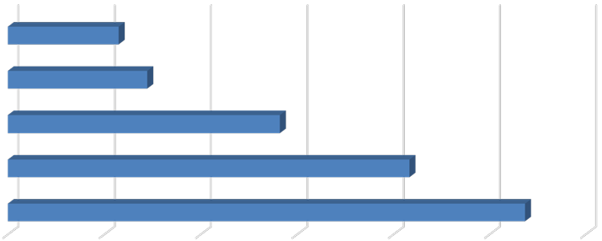
Studio
1.1
1.4
2.8
4.2
5.4

- Bedroom

- Bedroom

- Bedroom

4+ Bedroom

0.0 1.0 2.0 3.0 4.0 5.0 6.0
Source: BAE, 2020.

Table 1, below, provides detailed unit totals, along with the number of vacant units, and the associated vacancy rate by unit size. Again, the results reflect only those survey responses that provided unit size and vacancy details. Per the survey respondents, there were 570 vacant apartments available for lease on a unit-lease basis during the survey period, which is up from only 40 units in 2019. This translates to a vacancy rate of 8.4 percent. This vacancy rate is significantly higher than the rate observed during prior survey periods, which have historically averaged below one percent.

Broken down by unit type, the 2020 survey results show that the vacancy rate was the highest among two-bedroom and three-bedroom units, which had vacancy rates of 10.8 percent and
12.3 percent, respectively. The vacancy rate for units with four or more units was 8.0 percent, followed by one-bedroom units and studio units at 3.6 percent and 0.6 percent, respectively.

Table 1: Vacancy Rate for Unit Leases by Unit Size

2020 Survey Results
 |  |  |  |  | Number of Vacant |  |  |  |  |  |  | 2019 |  | 2018
Units Reported (a) |  |  |  |  | Units Reported (b) |  |  |  | Vacancy |  |  | Vacancy |  | Vacancy
Unit Size |  | Number |  | Percent |  | Number |  | Percent |  | Rate (c) |  | Rate (c) |  | Rate (c)
Studio |  | 173 |  | 3% |  | 1 |  | 0% |  | 0.6% |  | 0.0% |  | 0.0%
1 Bedroom |  | 2,086 |  | 31% |  | 75 |  | 13% |  | 3.6% |  | 1.0% |  | 0.2%
2 Bedroom |  | 3,183 |  | 47% |  | 343 |  | 60% |  | 10.8% |  | 0.5% |  | 0.6%
3 Bedroom |  | 991 |  | 15% |  | 122 |  | 21% |  | 12.3% |  | 0.0% |  | 0.3%
4+ Bedroom |  | 364 |  | 5% |  | 29 |  | 5% |  | 8.0% |  | 0.0% |  | 0.6%
Total, All Sizes |  | 6,797 |  | 100% |  | 570 |  | 100% |  | 8.4% |  | 0.6% |  | 0.4%

Notes:
- Includes the number of units, by unit type, reported by respondents as rented on a per unit basis (i.e., unit lease).
- Includes the number of units reported as vacant, by unit type, as reported by survey respondents. May exclude some units in cases where the survey respondent reported the total number of units but did not report the associated number of vacant units.
- The vacancy rate for unit-leased apartments was calculated based on the number of leased and vacant units only, as reported by survey respondents.
Source: BAE, 2020.

Bed Leases
Of the 8,149 market-rate apartment units reported by survey respondents, 1,352 units (17 percent) were reportedly rented under bed lease arrangements. This generally aligns with the 2019 survey findings, which identified 1,266 bed-leased units. Figure 3 illustrates the distribution of bed leases and bed-leased units, by unit size, which are also reported in Table
2. Most of the bed-leased units, nearly 85 percent, had between two and four bedrooms. Four-bedroom units were the most common, accounting for 36 percent of the total. Two- and three-bedroom units accounted for 28 percent and 20 percent of all reported bed-leased units, respectively. Studio and one-bedroom units accounted for the remaining 16 percent.

Survey respondents reported a total of 4,300 leasable beds, which represents an increase of just over 100 beds from 2019. The distribution of leasable beds, by unit size, reflects a distribution similar to that shown for bed-leased units. As shown in Figure 3, 54 percent of the leased beds were in four-bedroom units, while 21 percent were in two-bedroom units, and 18 percent were in three-bedroom units. Studio and one-bedroom units that were reported as rented under bed lease agreements accounted for seven percent of the total.

Figure 3: Distribution of Leasable Beds and Associated Units by Unit Size









Units
212; 16%
493; 36%
381; 28%
266; 20%
Beds









280; 7%

Studio & 1 Bedroom
2 Bedroom
3 Bedroom
4+ Bedroom

2,331; 54%

794; 18%
895; 21%

Source: BAE, 2020.

Figure 4 reports the average number of beds per unit, by unit size. This generally illustrates the relatively low incidence of double-occupancy bedrooms among bed-leased units. Double- occupancy bedrooms are generally more prevalent within larger three-and four-bedroom units. Compared to 2019, the data indicate a minor decrease in the prevalence of double-ups among three-bedroom units and a minor increase in the prevalence of double-ups in two- and four-bedroom units. This may reflect an adjustment in response to the pandemic, since double-occupancy bedrooms may in some cases represent an increased health risk.

Figure 4: Average Number of Beds Per Bed-Leased Unit

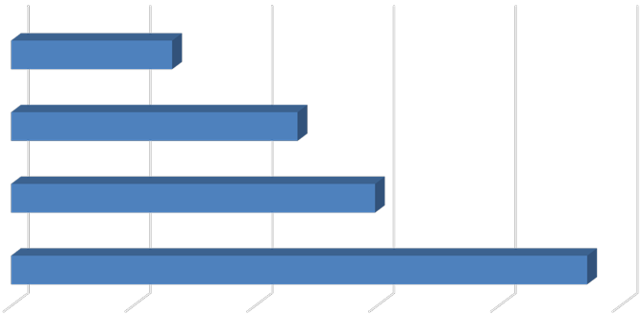
Studio & 1 Bedroom
1.3
2.3
3.0
4.7

- Bedroom

- Bedroom

4+ Bedroom

0.0 1.0 2.0 3.0 4.0 5.0
Source: BAE, 2020.

As documented in Table 2, respondents reported 1,283 vacant beds in 2020. This equals a vacancy rate of 29.8 percent. This indicates that nearly one-third of all leasable beds were vacant, where the historical average vacancy rate for bed-leases is under five percent. The increase in vacancy is likely a direct impact of the ongoing pandemic.

Table 2: Vacancy Rate for Bed Leases by Unit Size

2020 Survey Results
Bed Leased |  |  |  |  | Number of |  |  |  | Number of Vacant |  |  |  |  |  |  | 2019 |  | 2018
Units Reported (a) |  |  |  |  | Beds Reported (b) |  |  |  | Beds Reported (c) |  |  |  | Vacancy |  |  | Vacancy |  | Vacancy
Unit Size |  | Number |  | Percent |  | Number |  | Percent |  | Number |  | Percent |  | Rate (d) |  | Rate (d) |  | Rate (d)
Studio & 1 Bedroom |  | 212 |  | 16% |  | 280 |  | 7% |  | 112 |  | 9% |  | 40.0% |  | 4.4% |  | 0.0%
2 Bedroom |  | 381 |  | 28% |  | 895 |  | 21% |  | 348 |  | 27% |  | 38.9% |  | 2.8% |  | 1.1%
3 Bedroom |  | 266 |  | 20% |  | 794 |  | 18% |  | 271 |  | 21% |  | 34.1% |  | 3.3% |  | 0.4%
4+ Bedroom |  | 493 |  | 36% |  | 2,331 |  | 54% |  | 552 |  | 43% |  | 23.7% |  | 3.4% |  | 0.8%
Total, All Sizes |  | 1,352 |  | 100% |  | 4,300 |  | 100% |  | 1,283 |  | 100% |  | 29.8% |  | 3.4% |  | 0.7%

Notes:
- Includes the number of units, by unit type, reported by respondents as rented on a per bed basis (i.e., bed lease).
- Includes the number of beds located within bed-leased units, by unit type, as reported by survey respondents. May exclude some beds in cases where the survey respondent reported bed-leased units but did not report the associated number of leased.
- Includes the number of leasable beds reported as vacant, by unit type, as reported by survey respondents. May exclude some beds in cases where the survey respondent reported bed-leased units but did not report the associated number of leased or vacant beds.
- The vacancy rate for bed leases was calculated based on the number of leased and vacant beds only, as reported by survey respondents.
Source: BAE, 2020.

Blended Vacancy Rate
To estimate a community-wide vacancy rate for all lease types, BAE combined the unit lease and bed lease vacancy rates, to generate a combined, or “blended,” vacancy estimate.4 The results of the blended vacancy rate calculation for the 2020 survey are shown in Table 3.
Given that unit-leased apartments account for 83 percent of the reported market-rate rental inventory, the blended vacancy rate aligns more closely with the unit lease vacancy rate but is drawn upward due to the addition of the much higher bed lease vacancy rate. The blended vacancy rate for all rental units is 12.2 percent. This vacancy rate is significantly higher than the 2018 and 2019 blended rates of 0.5 percent and 1.0 percent, respectively. As previously noted, the increase in the vacancy rate was likely driven by the ongoing Coronavirus pandemic.

4 To calculate the “blended” vacancy rate, BAE calculated the bed lease vacancy rate on a per bed basis, then applied that rate to the total number of bed-leased units. The resulting “vacant unit equivalents” were then added to the total number of vacant unit-leased apartments to calculate the combined vacancy rate.

Table 3: Blended Vacancy Rate Summary

2020 Vacancy Rate
Unit Size |  | Unit  Lease (a) |  | Bed  Lease (b) |  | Blended (c) |  | 2019 Blended  Vacancy Rate (c) |  | 2018 Blended  Vacancy Rate (c)
Studio & 1 Bedroom |  | 3.4% |  | 40.0% |  | 5.7% |  | 1.3% |  | 0.2%
2 Bedroom |  | 10.8% |  | 38.9% |  | 13.7% |  | 0.7% |  | 0.6%
3 Bedroom |  | 12.3% |  | 34.1% |  | 16.9% |  | 0.6% |  | 0.3%
4+ Bedroom |  | 8.0% |  | 23.7% |  | 17.1% |  | 2.0% |  | 0.7%
Total, All Sizes |  | 8.4% |  | 29.8% |  | 12.2% |  | 1.0% |  | 0.5%

Notes:
- Based on the number of units, by unit type, reported as rented on a per unit basis (i.e., unit lease).
- Based on the number of units, by unit type, reported as rented on a per bed basis (i.e., bed lease).
- Based on the number of units, by unit type, reported as rented on a per unit basis (i.e., unit lease), with vacant units leased on a per bed basis converted to "vacant unit equivalents."

Source: BAE, 2020.

Rental Rates
Contrary to prior survey responses, over one-third of respondents reported decreasing rental rates. By comparison, only five percent of respondents in 2019 had decreased their asking rents in order to fill vacancies. Generally, complexes lowered rents by between three and 15 percent, with an average rent reduction of around ten percent.

Unit Leases
Table 4 reports the range and weighted average of the reported rental rates for apartments leased under unit lease arrangements. Note that the survey results reported here represent properties for which respondents reported both the total number of units, by type, and the corresponding rental rate information. Based on this information, the average rental rate for all units was $1,943 per month.5 This represents a 2.2 percent increase over 2019, when the average rental rate for unit-leased apartments was $1,901. This increase, however, is notably lower than the 4.7 percent rent increase recorded between 2018 and 2019, and well below the 8.5 percent rental rate increase observed between 2017 and 2018.

5 In cases where the respondent provided a range of prices for a given unit type, but no corresponding unit totals, BAE applied the mid-point of the range. The reported values represent weighted averages, which reflect the reported rental rates and the total number of units and/or beds.

Table 4: Rental Rates for Unit Leases by Unit Size
2020 Survey Results 2019 2018
Weighted Weighted |  |  |  |  |  |  |  |  |  | Weighted
Unit Size |  | Minimum |  | Maximum |  | Average (a) |  | Average (a) |  | Average (a)
Studio |  | $800 |  | $1,675 |  | $1,229 |  | $1,180 |  | $1,096
1 Bedroom |  | $940 |  | $1,960 |  | $1,498 |  | $1,430 |  | $1,367
2 Bedroom |  | $1,075 |  | $2,545 |  | $1,909 |  | $1,893 |  | $1,785
3 Bedroom |  | $1,775 |  | $3,375 |  | $2,610 |  | $2,529 |  | $2,416
4+ Bedroom |  | $2,275 |  | $4,995 |  | $3,392 |  | $3,210 |  | $2,992
Total, All Sizes |  | $800 |  | $4,995 |  | $1,943 |  | $1,901 |  | $1,815

Note:
(a) Figures represent weighted average rental rates and include only those complexes where the respondent identified the number of units by type, the number of beds per unit, and associated rental rates.
Source: BAE, 2020.

Bed Leases
Table 5 illustrates the weighted average of the reported rental rates for individual bed leases. Note that the reported survey results only include those responses that identified the total number of bed-leased units, by type, the total number of beds per unit, and the associated rental rate information. According to the survey respondents, the weighted average rental rate for a bed lease, in units of all sizes, was $1,050 per month.6 This represents an increase of
4.7 percent over 2019, when the average monthly bed lease rate was $1,003.

Table 5: Average Rental Rate for Bed Leases by Unit Size

 |  | 2020 |  | 2019 |  | 2018
Unit Size |  | Weighted  Average (a) |  | Weighted  Average (a) |  | Weighted  Average (a)
Studio & 1 Bedroom (b) |  | $1,312 |  | $1,344 |  | $980
2 Bedroom |  | $1,282 |  | $1,077 |  | $1,024
3 Bedroom |  | $1,090 |  | $1,033 |  | $1,022
4+ Bedroom |  | $916 |  | $937 |  | $903
Total, All Sizes |  | $1,050 |  | $1,003 |  | $954

Notes:
- Figures represent weighted average rental rates and include only those complexes where the respondent identified the number of units by type, the number of beds per unit, and associated rental rates.
- Studio and One-bedroom bed-leased apartments are in complexes that only rent units under bed lease arrangements. These complexes offer a greater suite of amenities, compared to the average unit-leased complex, and are priced accordingly.

Source: BAE, 2020.

6 See footnote 5.

Blended Rental Rate
To estimate the average citywide rental rate for all units, regardless of lease type, BAE combined the rental rates for unit leases and calculated the unit equivalent rental rate for units rented under bed lease arrangements.7 As reported in Table 6, with the exception of studio and one bedroom units, the unit equivalent bed lease rental rates are generally higher than the average unit lease rents (e.g., ranging from 28 to 58 percent higher depending on the unit type). Across all unit types, the average rental rate is $2,183. This represents a 3.1 percent increase over the 2019 blended average rental rate of $2,117 per month.

Table 6: Blended Rental Rate Summary

2020 Survey Results
Unit Size |  | Unit  Lease |  | Bed  Lease (a) |  | Blended (b) |  | 2019 Blended  Rental Rate (b) |  | 2018 Blended  Rental Rate (b)
Studio & 1 Bedroom |  | $1,477 |  | $1,312 |  | $1,499 |  | $1,435 |  | $1,369
2 Bedroom |  | $1,909 |  | $3,011 |  | $2,027 |  | $1,929 |  | $1,840
3 Bedroom |  | $2,610 |  | $3,253 |  | $2,746 |  | $2,731 |  | $2,582
4+ Bedroom |  | $3,392 |  | $4,329 |  | $3,947 |  | $3,856 |  | $3,559
Total, All Sizes |  | $1,943 |  | $3,339 |  | $2,183 |  | $2,117 |  | $2,006

Notes:
- Based on the number of beds and the weighted average bed lease rental rate, by unit type.
- Based on the weighted average unit lease rate and unit lease equivalent rate (for bed-leased units), by unit type.

Source: BAE, 2020.

Additional Recurring Charges
Prior survey efforts identified an increasing prevalence of complexes charging tenants separately for amenities and services that have historically been included in rent. For example, some complexes have started charging a recurring monthly fee for water, sewer, and garbage service, or for the use of certain on-site amenities. In the past, these charges were included as part of rent. In many cases, these newly itemized charges are mandatory, but are considered to be separate from rent. To account for this, and to identify other optional charges, the 2020 survey included a question asking respondents to more clearly identify additional monthly charges that are not included in the monthly rent amount paid by tenants.

Additional Unit Lease Charges
A total of 38 unit-lease complexes indicated that they levy additional mandatory charges in addition to rent. These are most typically associated with utility usage and parking. Among the 22 complexes that charge a separate utility fee, eight of them charged between $20 and

7 To calculate the “blended” rental rate, BAE calculated a “unit lease equivalent” for bed-leased units. This is equal to the weighted average bed lease rate multiplied by average the number of beds per unit, by unit type. This value was then used to calculate a weighted average rental rate for all units.

$25 per person, while 14 others reported an additional utility fee based on usage. A total of six complexes charge separately for parking. Three respondents reported charged parking fees on a monthly basis, with an average cost of $20 per month. The complexes that charged for parking annually reported charging an average of $120 for a parking permit. Some examples of other additional charges include monthly pet fees and “city service fees.”

Additional Bed Lease Charges
Similar to the unit lease complexes, bed lease complexes most commonly reported additional utility usage and parking charges. Of the nine bed lease complexes, only one charges a flat utility fee, while six charge for utilities on a pass-through basis8. Among complexes that charge for parking, the typical cost is around $100 per month; though there is some slight variation between the amount charged for covered versus uncovered spaces.

Utilities, Appliances, and Amenities
As in prior years, the 2020 survey included questions regarding the utilities, appliances, and amenities that are provided at no additional charge (i.e., included in the monthly rental rate). As shown in Figure 5, an average of 60 to 80 percent of respondent complexes include water, sewer, and trash collection in rent. Approximately 56 percent of bed lease complexes report also offering internet and Wi-Fi connectivity, as do 25 percent of unit lease complexes.

Figure 5: Percent of Respondents Including Utilities in Rent by Utility Type and Lease Type

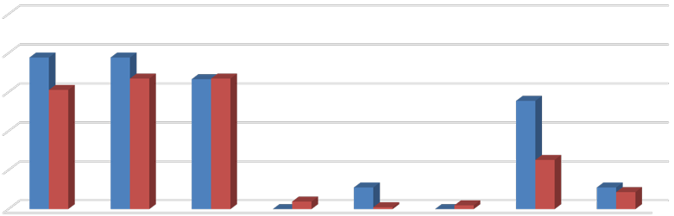
100%
78%
78%
61%
67% 67% 67%
56%
25%
11%
0%
4%
11% 9%
1%
0%
2%
80%
60%
40%
20%





0%
Bed Leases Unit Leases
Source: BAE, 2020.

8 Properties that charge utility fees on a pass-through basis independently meter utility usage by unit and pass on the utility charge to tenants (e.g., Ratio Utility Billing System, or RUBS).

Figure 6 illustrates the types of appliances and other amenities that are provided. Nearly all respondent complexes include a refrigerator, stove/oven, and air conditioning in the unit at no extra charge. All bed lease properties and 68 percent of unit lease properties include a dishwasher, while 89 percent of bed lease properties and 50 percent of unit lease properties include a microwave. Only between 15 and 35 percent of respondent complexes report offering in-unit laundry facilities (including a washer and dryer).

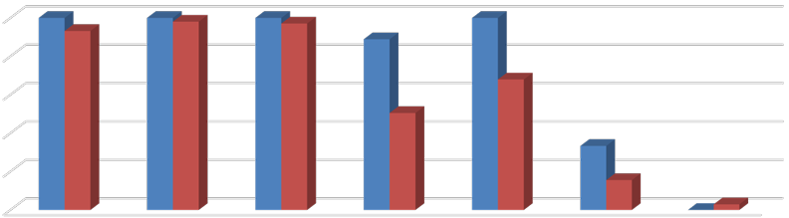
Figure 6: Percent of Respondents Including Appliances in Unit by Lease Type
97%
100%
89%
68%
50%
33%
16%
0% 3%

 | 100% 100%  93% |  | 98% | 100%
100%
80%
60%
40%
20%
0%
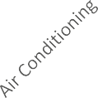





Bed Leases Unit Leases
Source: BAE, 2020.

The 2020 survey also questioned respondents regarding the amenities offered on-site, such as gym or pool facilities, and services provided by the property management staff, such as package service and organized social activities. Figure 7 illustrates the prevalence of these amenities, differentiating between complexes that offer unit leases versus bed leases.
Overall, respondents that offer unit leases generally tend to offer fewer amenities. For example, 55 percent offer a pool and/or hot tub, while 49 percent offer a picnic or BBQ area, and 35 percent offer on-site gym facilities and club houses. The most prevalent amenity offered by unit lease complexes is an on-site laundry facility. Respondents that offer bed leases were more likely to offer a wider assortment of on-site amenities, with most respondents offering multiple types of equipment, facilities, and services. For example, 89 percent of complexes that offer bed leases also offer a picnic or BBQ area and onsite laundry, 78 percent include a clubhouse and planned social activities, while 67 percent offer a pool and/or hot tub and package service, and 44 percent offer an on-site gym. Of the respondents who offered other additional services, most offer study lounges and on-site printing centers.

Figure 7: Percent of Respondents Offering Select Amenities by Lease Type

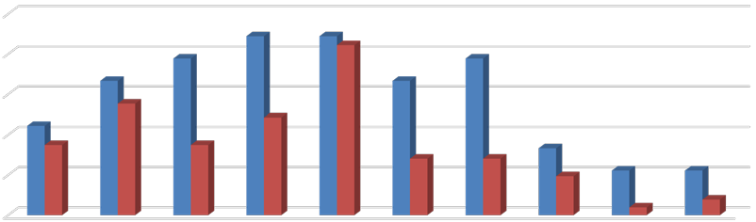
100%
89%
78%
67%
89% 84%
67%
78%
55%
44%
49%
35% 35%
28%
33%
28%
19% 22%
22%
4% 8%
80%
60%
40%
20%
0%

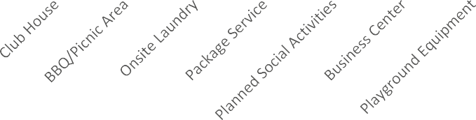

Bed Leases Unit Leases
Source: BAE, 2020.

Furnished and Unfurnished Units
Most of the surveyed properties indicated that they did not offer furnished units in the 2020 leasing season. Figures 8 and 9 illustrate the number of respondents that offered furnishings, by unit size. A total of nine properties indicated that they offered furnished apartments under unit lease arrangements in the 2020 leasing season. Two-bedroom units were the most common unit type offered with furnishings under a unit lease arrangement followed by one- and three-bedroom units. Four of the nine bed lease complexes reported offering furnished bed-leased units.

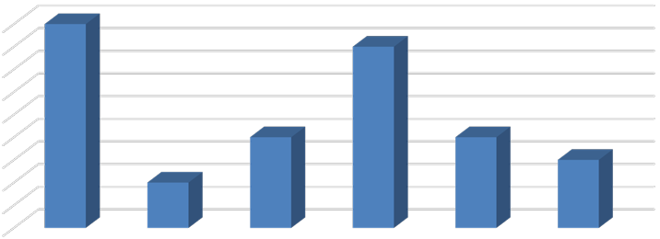
Figure 8: Number of Respondents Offering Furnished Unit Leases by Unit Size
9

9 |  |  |  | 8
8
7
6
5 |  |  | 4 |  | 4
4 |  |  |  |  |  | 3
3 |  | 2
2
1
0
 | All Unit Sizes | Studio | 1 Bedroom | 2 Bedroom | 3 Bedroom 4+ | Bedroom

Source: BAE, 2020.

Figure 9: Number of Respondents Offering Furnished Bed Leases by Unit Size

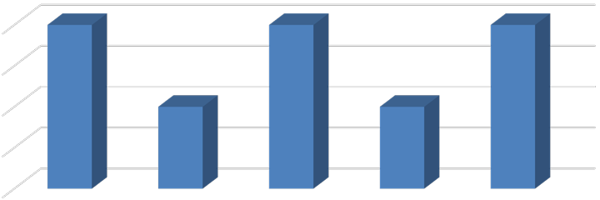
4
4
4
4
2
2

3

2

1

0
All Unit Sizes Studio & 1 Bedroom

2 Bedroom 3 Bedroom 4+ Bedroom

Source: BAE, 2020.

Services and Incentives
For a variety of reasons, it is often in a property owner’s best interest to provide certain services and incentives to residents. This often promotes resident attraction and retention. For properties that offer bed leases, a roommate matching program can often be an important tool. Under such a program, prospective residents fill out applications, stating their interests, and preferences for a roommate. The prevalence of roommate matching programs is roughly unchanged from the 2019 survey period, with a total of 14 properties offering such services, including eight properties that manage apartments that are leased on a per bed basis. A total of 44 apartment complexes reported offering other incentives and move-in specials in the 2020 leasing season to help fill vacancies and attract new residents, which is well above prior years. Common incentives and specials included free or discounted rent, waived application fees, gift cards, and raffles, among other giveaways.

Planned Renovations
Forty respondents reported having plans to undertake renovations within the next 12 months. Most of those that reported planned renovations conduct periodic updates as units turn over. Other common in-unit upgrades include new flooring and countertops, updated appliances and cabinetry, and window replacement. Other exterior upgrades typically include new paint or siding, landscaping, and common area improvements.

