bae urban economics

Overview
2021 Apartment Vacancy and Rental Rate Survey
Presented on behalf of UC Davis Student Housing and Dining Services

The annual Apartment Vacancy and Rental Rate Survey collects information on the characteristics of rental apartment units in the Davis community. Similar surveys have been conducted on an annual, or biennial basis, since at least 1975. Since 2013, the survey has been administered in partnership with BAE Urban Economics (BAE), a private real estate consulting firm with an office in Downtown Davis. The objective of the survey is to provide information that will help inform planning decisions on campus and throughout the broader Davis area. For example, survey results help campus officials assess the current housing market conditions faced by UC Davis students, faculty, and staff. The survey results also help the university to assess the likely feasibility of proposed campus housing projects.
2021 Survey Results
In 2021, a total of 119 apartment complexes and property management companies responded to the survey. These properties represent a total of 10,540 rental units. This is a four percent increase in the number of respondent complexes compared to 2020, and an 18 percent increase in the number of rental units covered in the response pool.1 While the majority of these surveyed properties lease whole units, the survey recorded a total of 17 properties that lease a total of 2,996 units on a per-bed basis with a total inventory of 9,376 leasable beds. This inventory of bed leasing properties represents nearly double the number of bed-leasing properties in prior survey periods. This increase is driven by several factors, including the delivery of new bed-leasing properties, expansion of existing bed-leasing properties, conversion of unit-leasing properties to a bed leasing program, and a slightly higher response rate from bed-leasing properties relative to prior year surveys.

According to estimates from the American Community Survey (ACS) there were approximately 11,975 multifamily housing units, on average, on the UC Davis campus and in the City of Davis between 2015 and 2019.2 3 This indicates that the units captured in the 2021 survey account for approximately 88 percent of the Davis area multifamily housing stock.

1 BAE received responses from 114 unique apartment complexes and property management companies as part of the 2020 survey, representing 8,938 rental units.
2 Includes the City of Davis and the Census Block Groups 1 and 2 in Census Tract 105.1 in Yolo County, California.
3 U.S. Census Bureau. 2015-2019 American Community Survey 5-Year Estimates, Table B25024. Retrieved from: http://data.census.gov/

San Francisco | Sacramento | Los Angeles | Washington DC | New York City
2560 9th St., Suite 211 | 803 2nd St., Suite A | 448 South Hill St., Suite 701 | 1140 3rd St. NE, 2nd Floor | 234 5th Ave.
Berkeley, CA 94710 | Davis, CA 95616 | Los Angeles, CA 90013 | Washington, DC 20002 | New York, NY 10001
510.547.9380 | 530.750.2195 | 213.471.2666 | 202.588.8945 | 212.683.4486
www.bae1.com

Of the 2021 survey’s 119 respondents, 11 reported leasing units at below market rents (i.e., requiring an income eligibility test to qualify prospective tenants for reduced or subsidized rents). Three of those respondents reported renting all of the units in the complex at below market rates, while the remaining ten complexes rent some units at below market rates and some units at market rates. Of the 11 complexes that reported renting units at below market rates, six reported the income eligibility standards that they use to screen prospective tenants. The 2021 survey results for complexes with below market rate units are generally consistent with the 2020 results, which found that the majority of below market rate units in the community were rented to households earning between 50 and 80 percent of the area median income (AMI). The remainder of this analysis excludes units rented at below market rents, as reported by respondents, but does include units rented at market rates in mixed-income complexes.

While all survey respondents reported the total unit numbers, not all respondents provided complete information regarding other unit characteristics, such as the mix of units by size or amenities provided on-site. Additionally, the sum total of all unit sizes may not equal the reported total unit count due to inconsistent reporting of managers’ units and other similar factors. As a result, the unit and bed lease totals discussed elsewhere in this report may not equal those reported above, in some cases.

Leasing “Beds” Versus Complete Apartment Units
One of the increasingly common and complex dynamics of the local rental housing market is the practice of renting out individual apartment units to multiple tenants using multiple lease agreements. Under this type of arrangement, known as a “bed lease,” each bed or bedroom in an apartment is associated with a separate lease agreement. Each resident is thereby contractually responsible for only a portion of the total rent. This is compared to the more conventional approach, in which each unit is rented under a single lease, and all of the tenants living in the unit sign the lease and are jointly responsible for the complete monthly rent payment. For the purposes of this survey, this arrangement is called a “unit lease.”

Unit Leases
Survey respondents provided unit size detail for 7,083 units that are rented under unit lease arrangements, which account for about 70 percent of all reported market-rate rental units. Note that the survey results reported below exclude units for which unit size detail was not provided. Figure 1 illustrates the distribution of unit-leased apartments, by unit size. The majority of reported units had between one and three bedrooms. One-bedroom units accounted for 33 percent of the total, while two-bedroom units accounted for 46 percent and three-bedroom units represented 13 percent. Apartments with four or more bedrooms represented five percent of reported units, while studio units represented just two percent.
This distribution is roughly comparable to the results of the 2020 survey.

Figure 1: Distribution of Unit Leases by Unit Size









367; 5% 161; 2%

947; 13%

2,323; 33%
Studio

1 Bedroom

2 Bedroom

3,285; 46%
3 Bedroom

4+ Bedroom

Source: BAE, 2021.

Figure 2 summarizes the average number of occupants in unit-leased apartments by unit size. As reported below, most units have at least one double occupancy bedroom, on average. For example, the average occupancy for a one-bedroom unit is 1.6 persons, while two-bedroom units average 3.0 residents, three-bedroom units average 4.2 residents, and four-bedroom units average 5.3 residents. Occupancy in studio units is most typically a single person, with an average occupancy factor of 1.2 residents. The data indicate that average number of persons per unit increased slightly across unit types between 2020 and 2021.

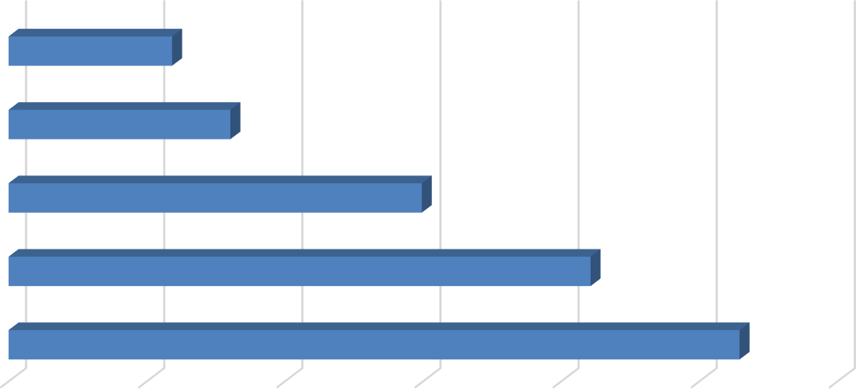
Figure 2: Average Number of Occupants in Unit-Leased Apartments by Type

Studio |  | 1.2
1 Bedroom |  |  | 1.6
2 Bedroom |  |  |  |  | 3.0
3 Bedroom |  |  |  |  |  |  | 4.2
4+ Bedroom |  |  |  |  |  |  |  |  | 5.3
0.0  Source: BAE, 2021. | 1.0 |  | 2.0 | 3.0 |  | 4.0 |  | 5.0 |  | 6.0

Table 1, below, provides detailed unit totals, along with the number of vacant units, and the associated vacancy rate by unit size. Again, the results reflect only those survey responses that provided unit size and vacancy details. Per the survey respondents, there were 81 vacant apartments available for lease on a unit-lease basis during the survey period, which is significantly lower than the 570 vacant units in 2020. This translates to a vacancy rate of 1.1 percent. This vacancy rate is notably lower than the rate recorded in the 2020 survey (8.4 percent) but is closer to the historical average citywide vacancy rates in the Davis market, which have typically averaged around 1.0 percent.

Broken down by unit type, the 2021 survey results show that the vacancy rate was the highest among larger unit sizes. As seen below, four-bedroom and three-bedroom units had the highest reported vacancy rates, at 10.1 percent and 2.4 percent, respectively. Anecdotal information suggests larger units had higher vacancy rates due to challenges with finding roommates and tenant concerns around exposure to a larger number of roommates during the pandemic. Conversely, studio and one-bedroom units reported the lowest vacancy rates, at
0.0 and 0.1 percent, respectively. The vacancy rate for two-bedroom units also was relatively low, at just 0.5 percent.

Table 1: Vacancy Rate for Unit Leases by Unit Size

2021 Survey Results
 |  |  |  |  | Number of Vacant |  |  |  |  |  |  | 2020 |  | 2019
Units Reported (a) |  |  |  |  | Units Reported (b) |  |  |  | Vacancy |  |  | Vacancy |  | Vacancy
Unit Size |  | Number |  | Percent |  | Number |  | Percent |  | Rate (c) |  | Rate (c) |  | Rate (c)
Studio |  | 161 |  | 2% |  | 0 |  | 0% |  | 0.0% |  | 0.6% |  | 0.0%
1 Bedroom |  | 2,323 |  | 33% |  | 3 |  | 4% |  | 0.1% |  | 3.6% |  | 1.0%
2 Bedroom |  | 3,285 |  | 46% |  | 18 |  | 22% |  | 0.5% |  | 10.8% |  | 0.5%
3 Bedroom |  | 947 |  | 13% |  | 23 |  | 28% |  | 2.4% |  | 12.3% |  | 0.0%
4+ Bedroom |  | 367 |  | 5% |  | 37 |  | 46% |  | 10.1% |  | 8.0% |  | 0.0%
Total, All Sizes |  | 7,083 |  | 100% |  | 81 |  | 100% |  | 1.1% |  | 8.4% |  | 0.6%

Notes:
- Includes the number of units, by unit type, reported by respondents as rented on a per unit basis (i.e., unit lease).
- Includes the number of units reported as vacant, by unit type, as reported by survey respondents. May exclude some units in cases where the survey respondent reported the total number of units but did not report the associated number of vacant units.
- The vacancy rate for unit-leased apartments was calculated based on the number of leased and vacant units only, as reported by survey respondents.

Source: BAE, 2021.

Bed Leases
Of the 10,079 market-rate apartment units reported by survey respondents, 2,999 units (30 percent) were reportedly rented under bed lease arrangements. As previously noted, this is more than double the number of units rented under a bed lease arrangement in 2020. This increase is a result of new deliveries of bed-leasing properties, expansion of existing bed- leasing properties, and conversion of unit-leasing properties to bed-leasing arrangements.

Figure 3 illustrates the distribution of bed leases and bed-leased units, by unit size, which are also reported in Table 2. Most of the bed-leased units, nearly 76 percent, had between two and four bedrooms. Four-bedroom units were the most common, accounting for 37 percent of the total. Two- and three-bedroom units accounted for 28 percent and 11 percent of all reported bed-leased units, respectively. Studio and one-bedroom units accounted for the remaining 24 percent.

Survey respondents reported a total of 9,376 leasable beds, which also represents more than double the number of leasable beds reported in 2020. The distribution of leasable beds, by unit size, reflects a distribution similar to that shown for bed-leased units. As shown in Figure 3, 55 percent of the leased beds were in four-bedroom units, while 22 percent were in two- bedroom units, and 12 percent were in three-bedroom units. Studio and one-bedroom units that were reported as rented under bed lease agreements accounted for 11 percent of the total.

Figure 3: Distribution of Leasable Beds and Associated Units by Unit Size
Units Beds

















Studio & 1 Bedroom
713; 24%
1,115; 37%
824; 28%
344; 11%
999; 11%
2,089; 22%
5,165; 55%
1,123; 12%
2 Bedroom
3 Bedroom
4+ Bedroom

Source: BAE, 2021.

Figure 4 reports the average number of beds per unit, by unit size. This generally illustrates the relatively low incidence of double-occupancy bedrooms among bed-leased units. The number of double-occupancy bedrooms was similar among the various unit types, though four- bedroom and two-bedroom units reported a slightly higher number of double-occupancy rooms. Compared to 2020, the data indicate a minor increase in the prevalence of double-ups among smaller units, or those with less than four bedrooms, and a minor decrease in the prevalence of double-ups in units with four or more bedrooms. The number of double-ups, however, is more comparable to the 2019 survey results, suggesting 2020 occupancy trends may have been impacted by the Coronavirus pandemic and that residents were more comfortable doubling up for the 2021 leasing season.

Figure 4: Average Number of Beds Per Bed-Leased Unit

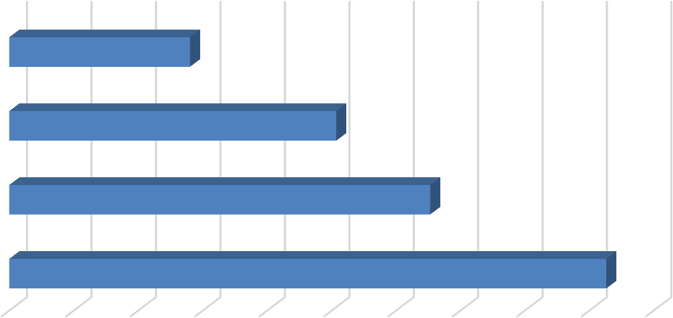
Studio and 1 Bedroom
1.4
2.5
3.3
4.6

  - Bedroom

  - Bedroom

4+ Bedroom

- 0.5 1.0 1.5 2.0 2.5 3.0 3.5 4.0 4.5 5.0
Source: BAE, 2021.

As documented in Table 2, respondents reported 225 vacant beds in 2021. This equals a vacancy rate of 2.4 percent. While this vacancy rate is well below the rate reported in 2020 (29.8 percent), it is comparable to historical average vacancy rates for bed-leased apartments, typically ranging between one and four percent. The return to historical average vacancy rates, despite the increase in available bed leases, indicates that demand is very strong and growing within the Davis multifamily housing market, despite the ongoing Coronavirus pandemic.

Table 2: Vacancy Rate for Bed Leases by Unit Size

2021 Survey Results
Bed Leased |  |  |  |  | Number of |  |  |  | Number of Vacant |  |  |  |  |  |  | 2020 |  | 2019
Units Reported (a) |  |  |  |  | Beds Reported (b) |  |  |  | Beds Reported (c) |  |  |  | Vacancy |  |  | Vacancy |  | Vacancy
Unit Size |  | Number |  | Percent |  | Number |  | Percent |  | Number |  | Percent |  | Rate (d) |  | Rate (d) |  | Rate (d)
Studio & 1 Bedroom |  | 713 |  | 24% |  | 999 |  | 11% |  | 13 |  | 6% |  | 1.3% |  | 40.0% |  | 4.4%
2 Bedroom |  | 824 |  | 28% |  | 2,089 |  | 22% |  | 36 |  | 16% |  | 1.7% |  | 38.9% |  | 2.8%
3 Bedroom |  | 344 |  | 11% |  | 1,123 |  | 12% |  | 29 |  | 13% |  | 2.6% |  | 34.1% |  | 3.3%
4+ Bedroom |  | 1,115 |  | 37% |  | 5,165 |  | 55% |  | 147 |  | 65% |  | 2.8% |  | 23.7% |  | 3.4%
Total, All Sizes |  | 2,996 |  | 100% |  | 9,376 |  | 100% |  | 225 |  | 100% |  | 2.4% |  | 29.8% |  | 3.4%

Notes:
- Includes the number of units, by unit type, reported by respondents as rented on a per bed basis (i.e., bed lease).
- Includes the number of beds located within bed-leased units, by unit type, as reported by survey respondents. May exclude some beds in cases where the survey respondent reported bed-leased units but did not report the associated number of leased.
- Includes the number of leasable beds reported as vacant, by unit type, as reported by survey respondents. May exclude some beds in cases where the survey respondent reported bed-leased units but did not report the associated number of leased or vacant beds.
- The vacancy rate for bed leases was calculated based on the number of leased and vacant beds only, as reported by survey respondents.
Source: BAE, 2021.

Blended Vacancy Rate
To estimate a community-wide vacancy rate for all lease types, BAE combined the unit lease and bed lease vacancy rates, to generate a combined, or “blended,” vacancy estimate.4 The results of the blended vacancy rate calculation for the 2021 survey are shown in Table 3.
Given that unit-leased apartments account for 70 percent of the reported market-rate rental inventory, the blended vacancy rate aligns more closely with the unit lease vacancy rate, but is drawn upward due to the addition of the slightly higher bed lease vacancy rate. The blended vacancy rate for all rental units is 1.4 percent. This vacancy rate is significantly lower than the 2020 blended vacancy rate of 12.2 percent, but is comparable to the historical blended vacancy rates recorded prior to the pandemic of roughly 1.0 percent.

Table 3: Blended Vacancy Rate Summary

2021 Vacancy Rate
Unit Size |  | Unit  Lease (a) |  | Bed  Lease (b) |  | Blended (c) |  | 2020 Blended  Vacancy Rate (c) |  | 2019 Blended  Vacancy Rate (c)
Studio & 1 Bedroom |  | 0.1% |  | 1.3% |  | 0.4% |  | 5.7% |  | 1.3%
2 Bedroom |  | 0.5% |  | 1.7% |  | 0.8% |  | 13.7% |  | 0.7%
3 Bedroom |  | 2.4% |  | 2.6% |  | 2.5% |  | 16.9% |  | 0.6%
4+ Bedroom |  | 10.1% |  | 2.8% |  | 4.5% |  | 17.1% |  | 2.0%
Total, All Sizes |  | 1.1% |  | 2.4% |  | 1.4% |  | 12.2% |  | 1.0%

Notes:
- Based on the number of units, by unit type, reported as rented on a per unit basis (i.e., unit lease).
- Based on the number of units, by unit type, reported as rented on a per bed basis (i.e., bed lease).
- Based on the number of units, by unit type, reported as rented on a per unit basis (i.e., unit lease), with vacant units leased on a per bed basis converted to "vacant unit equivalents."

Source: BAE, 2021.

Rental Rates
Only nine percent of respondents reported decreasing rental rates relative to the prior leasing period. This is slightly higher than the historical average, of between zero and five percent, but is significantly lower than the 2020 survey where over one-third of respondents reported decreasing rents to help fill vacancies. Generally, complexes lowered rents by between two and 30 percent, with an average rent reduction of around ten percent.

Unit Leases
Table 4 reports the range and weighted average of the reported rental rates for apartments leased under unit lease arrangements. Note that the survey results reported here represent properties for which respondents reported both the total number of units, by type, and the

4 To calculate the “blended” vacancy rate, BAE calculated the bed lease vacancy rate on a per bed basis, then applied that rate to the total number of bed-leased units. The resulting “vacant unit equivalents” were then added to the total number of vacant unit-leased apartments to calculate the combined vacancy rate.

corresponding rental rate information. Based on this information, the average rental rate for all units was $2,034 per month.5 This represents a 4.7 percent increase over 2020, when the average rental rate for unit-leased apartments was $1,943. This rental rate increase is above the 2.2 percent increase recorded between 2019 and 2020, but is comparable to historical annual rent increases, which range from four to nine percent per year.

Table 4: Rental Rates for Unit Leases by Unit Size

2021 Survey Results 2020 2019
Weighted Weighted |  |  |  |  |  |  |  |  |  | Weighted
Unit Size |  | Minimum |  | Maximum |  | Average (a) |  | Average (a) |  | Average (a)
Studio |  | $800 |  | $1,798 |  | $1,283 |  | $1,229 |  | $1,180
1 Bedroom |  | $928 |  | $2,650 |  | $1,598 |  | $1,498 |  | $1,430
2 Bedroom |  | $1,090 |  | $3,550 |  | $2,038 |  | $1,909 |  | $1,893
3 Bedroom |  | $1,675 |  | $3,700 |  | $2,702 |  | $2,610 |  | $2,529
4+ Bedroom |  | $2,375 |  | $4,995 |  | $3,373 |  | $3,392 |  | $3,210
Total, All Sizes |  | $800 |  | $4,995 |  | $2,034 |  | $1,943 |  | $1,901

Note:
(a) Figures represent weighted average rental rates and include only those complexes where the respondent identified the number of units by type, the number of beds per unit, and associated rental rates.

Source: BAE, 2021.

Bed Leases
Table 5 illustrates the weighted average of the reported rental rates for individual bed leases. Note that the reported survey results only include those responses that identified the total number of bed-leased units, by type, the total number of beds per unit, and the associated rental rate information. According to the survey respondents, the weighted average rental rate for a bed lease, in units of all sizes, was $1,062 per month.6 This represents an increase of just 1.2 percent over 2020, when the average monthly bed lease rate was $1,050. This increase is below the historical average annual rental rate increase for bed lease properties, which has ranged from four to seven percent, which is likely explained by the significant increase in the number of bed-leased units in the market, as well as a modest increase in the prevalence of double occupancy bedrooms within bed-leased units.

5 In cases where the respondent provided a range of prices for a given unit type, but no corresponding unit totals, BAE applied the mid-point of the range. The reported values represent weighted averages, which reflect the reported rental rates and the total number of units and/or beds.
6 See footnote 6.

Table 5: Average Rental Rate for Bed Leases by Unit Size

 |  | 2021 |  | 2020 |  | 2019
Unit Size |  | Weighted  Average (a) |  | Weighted  Average (a) |  | Weighted  Average (a)
Studio & 1 Bedroom (b) |  | $1,162 |  | $1,312 |  | $1,344
2 Bedroom |  | $1,007 |  | $1,282 |  | $1,077
3 Bedroom |  | $1,136 |  | $1,090 |  | $1,033
4+ Bedroom |  | $1,049 |  | $916 |  | $937
Total, All Sizes |  | $1,062 |  | $1,050 |  | $1,003

Notes:
- Figures represent weighted average rental rates and include only those complexes where the respondent identified the number of units by type, the number of beds per unit, and associated rental rates.
- Studio and One-bedroom bed-leased apartments are in complexes that only rent units under bed lease arrangements. These complexes offer a greater set of amenities, compared to the average unit-leased complex, and are priced as such.

Source: BAE, 2021.

Blended Rental Rate
To estimate the average citywide rental rate for all units, regardless of lease type, BAE combined the rental rates for unit leases and calculated the unit equivalent rental rate for units rented under bed lease arrangements.7 As reported in Table 6, the unit equivalent bed lease rental rates are generally higher than the average unit lease rents (e.g., ranging from three to 45 percent higher depending on the unit type). Across all unit types, the average rental rate is $2,420. This represents a 10.9 percent increase over the 2020 blended average rental rate of $2,183 per month. This blended rental rate increase significantly exceeds the 3.1 percent increase observed between 2019 and 2020, as well as the historical average, which typically ranges from five to seven percent. The primary reason for the increase is the growing number of larger bed-leased units present in the market, which bring in more rent per unit compared to unit-leased apartments. In addition, although the increase in the blended rental rate between 2020 and 2021 is well above historical increases, when averaged with the 3.1 percent increase experienced between 2019 and 2020, the average annual increase over these two years is comparable to historical annual averages. This suggests that properties may have increased rents in 2021 at a higher rate in order to make up for a lower increase in the prior year.

7 To calculate the “blended” rental rate, BAE calculated a “unit lease equivalent” for bed-leased units. This is equal to the weighted average bed lease rate multiplied by average the number of beds per unit, by unit type. This value was then used to calculate a weighted average rental rate for all units.

Table 6: Blended Rental Rate Summary

2021 Survey Results
Unit Size |  | Unit  Lease |  | Bed  Lease (a) |  | Blended (b) |  | 2020 Blended  Rental Rate (b) |  | 2019 Blended  Rental Rate (b)
Studio & 1 Bedroom |  | $1,578 |  | $1,629 |  | $1,589 |  | $1,499 |  | $1,435
2 Bedroom |  | $2,038 |  | $2,553 |  | $2,142 |  | $2,027 |  | $1,929
3 Bedroom |  | $2,702 |  | $3,708 |  | $2,970 |  | $2,746 |  | $2,731
4+ Bedroom |  | $3,373 |  | $4,860 |  | $4,507 |  | $3,947 |  | $3,856
Total, All Sizes |  | $2,034 |  | $3,324 |  | $2,420 |  | $2,183 |  | $2,117

Notes:
- Based on the number of beds and the weighted average bed lease rental rate, by unit type.
- Based on the weighted average unit lease rate and unit lease equivalent rate (for bed-leased units), by unit type.

Source: BAE, 2021.

Additional Recurring Charges
Prior survey efforts identified an increasing prevalence of complexes charging tenants separately for amenities and services that have historically been included in rent. For example, some complexes have started charging a recurring monthly fee for water, sewer, and garbage service, or for the use of certain on-site amenities. In many cases, these newly itemized charges are mandatory, but are considered to be separate from rent. To account for this, and to identify other optional charges, the 2021 survey included a question asking respondents to more clearly identify additional monthly charges that are not included in the monthly rent amount paid by tenants.

Additional Unit Lease Charges
A total of 34 unit-lease complexes indicated that they levy additional mandatory charges in addition to rent. These are most typically associated with utility usage and parking. Among the 27 complexes that charge a separate utility fee, thirteen of them charged between $15 and $65 per person, while 14 others reported an additional utility fee based on usage. A total of five complexes charge separately for parking. Four respondents reported charging parking fees on a monthly basis, with an average cost of $30 per month, while the other did not report the payment amount. Some examples of other additional charges include monthly pet fees, storage, and concierge service fees.

Additional Bed Lease Charges
Similar to the unit lease complexes, bed lease complexes most commonly reported additional utility usage and parking charges. Of the 17 bed lease complexes, seven complexes charge a flat per person utility fee, ranging from ten to $55 per person. Another four complexes charge

for utilities on a passthrough basis8. Among complexes that charge for parking, the typical cost is around $50 per month; though there is some slight variation between the amount charged for covered versus uncovered spaces. Other additional charges include pet rent and furniture rentals, both ranging from $20 to $30 per month.

Utilities, Appliances, and Amenities
As in prior years, the 2021 survey included questions regarding the utilities, appliances, and amenities that are provided at no additional charge (i.e., included in the monthly rental rate). As shown in Figure 5, an average of 60 to 72 percent of respondent complexes include water, sewer, and trash collection in rent. Approximately 65 percent of bed lease complexes report also offering internet and Wi-Fi connectivity, as do 36 percent of unit lease complexes.

Figure 5: Percent of Respondents Including Utilities in Rent by Utility Type and Lease Type

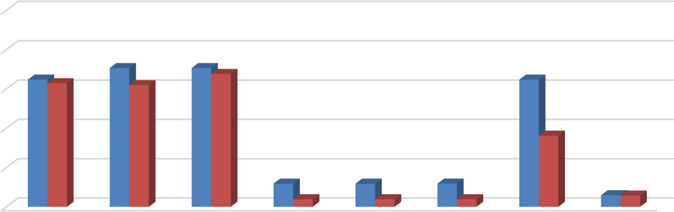
100%
65% 63%
71%
71%
62%
68%
65%
36%
12%
12%
12%
4% 4%
4%
6% 6%
80%
60%
40%
20%





0%
Bed Leases Unit Leases
Source: BAE, 2021.

Figure 6 illustrates the types of appliances and other amenities that are provided. All respondent complexes include a refrigerator and stove/oven, while nearly all included an air conditioning unit at no extra charge. All bed lease properties and 70 percent of unit lease properties include a dishwasher, while 94 percent of bed lease properties and 57 percent of unit lease properties include a microwave. Nearly 60 percent of bed lease complexes provide in-unit laundry facilities, while only 20 percent of unit lease complexes provide this facility in the unit.

8 Properties that charge utility fees on a pass-through basis independently meter utility usage by unit and pass on the utility charge to tenants (e.g., Ratio Utility Billing System, or RUBS).

Figure 6: Percent of Respondents Including Appliances in Unit by Lease Type

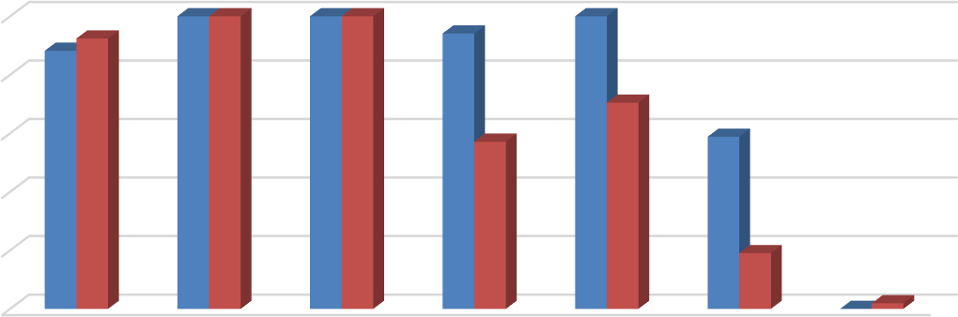
100%
100% 100% 100% 100%
100%
88% 92%
94%
70%
57%
59%
19%
0% 2%

80%

60%

40%

20%

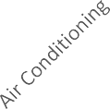





0%
Bed Leases Unit Leases
Source: BAE, 2021.

The 2020 survey also questioned respondents regarding the amenities offered on-site, such as gym or pool facilities, and services provided by the property management staff, such as package service and organized social activities. Figure 7 illustrates the prevalence of these amenities, differentiating between complexes that offer unit leases versus bed leases.
Overall, respondents that offer unit leases generally tend to offer fewer amenities. For example, 55 percent offer a pool and/or hot tub, while 49 percent offer a picnic or BBQ area, and 35 percent offer on-site gym facilities and club houses. The most prevalent amenity offered by unit lease complexes is an on-site laundry facility. Respondents that offer bed leases were more likely to offer a wider assortment of on-site amenities, with most respondents offering multiple types of equipment, facilities, and services. For example, 89 percent of complexes that offer bed leases also offer a picnic or BBQ area, 88 percent provide a pool and/or hot tub onsite, 82 percent offer an on-site gym, business center, and planned social activities, and 76 percent include a club house. Of the respondents who offered other additional services, most offer study lounges, pet amenities, and sport courts.

Figure 7: Percent of Respondents Offering Select Amenities by Lease Type

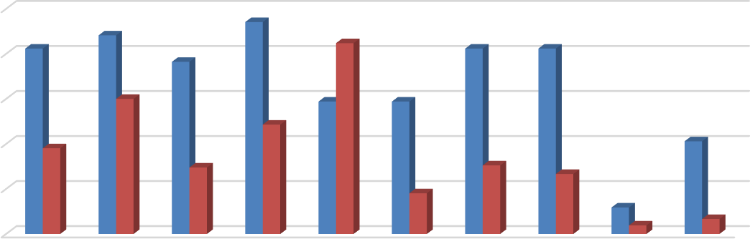
100%
82%
88%
94%
85%
76%
82%
82%
60%
59%
59%
49%
38%
41%
30% 30%
27%
18%
12%
4%
7%

80%

60%

40%

20%

0%

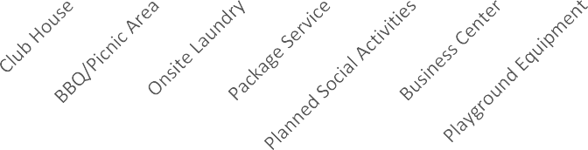


Bed Leases Unit Leases
Source: BAE, 2021.

Furnished and Unfurnished Units
Most of the surveyed properties indicated that they did not offer furnished units in the 2021 leasing season. Figures 8 and 9 illustrate the number of respondents that offered furnishings, by unit size. A total of ten properties indicated that they offered furnished apartments under unit lease arrangements in the 2021 leasing season. Two-bedroom units were the most common unit type offered with furnishings under a unit lease arrangement followed by one- and three-bedroom units. Ten of the 17 bed lease complexes reported offering furnished bed- leased units.

Figure 8: Number of Respondents Offering Furnished Unit Leases by Unit Size

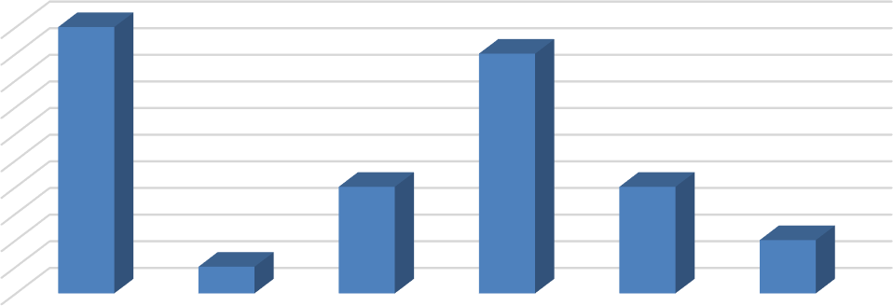
10
10
9
4
4
2
1
9
8
7
6
5
4
3
2
1
0
All Unit Sizes Studio 1 Bedroom 2 Bedroom 3 Bedroom 4+ Bedroom
Source: BAE, 2021.

Figure 9: Number of Respondents Offering Furnished Bed Leases by Unit Size

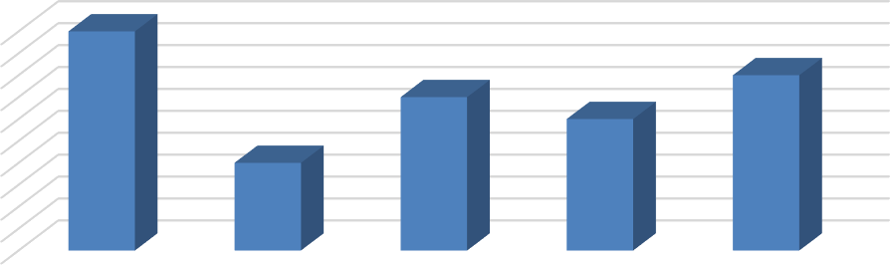
10
10
8
7
6
4
9
8
7
6
5
4
3
2
1
0
All Unit Sizes Studio & 1
Bedroom

2 Bedroom 3 Bedroom 4+ Bedroom

Source: BAE, 2021.

Services and Incentives
For a variety of reasons, it is often in a property owner’s best interest to provide certain services and incentives to residents. This often promotes resident attraction and retention. For properties that offer bed leases, a roommate matching program can often be an important tool. Under such a program, prospective residents fill out applications, stating their interests, and preferences for a roommate. The prevalence of roommate matching programs is slightly higher relative to the 2020 survey period, with a total of 19 properties offering such services, including 16 of the 17 properties that manage apartments that are leased on a per bed basis. A total of 40 apartment complexes reported offering other incentives and move-in specials in the 2021 leasing season to help fill vacancies and attract new residents, which is comparable to the 2020 leasing season, but well above prior years. Common incentives and specials included free or discounted rent, waived application fees, and gift cards, among other giveaways. The value of these incentives ranged from a $100 gift card to $3,000 in free rent for one month, with the average value equaling roughly $700 in incentives.

Lease Terms and Turnover
All but two complexes reported offering 12-month lease terms, with the two other complexes providing shorter lease terms or strictly month-to-month leases. In addition to 12-month leases, a total of 12 complexes offered other lease terms, including five complexes that offered ten- or 11-month leases. Three complexes offered month-to-month leases, two offered six-month leases, and one offered quarterly leases. Although the 12-month leases still represent the predominant lease structure, the number of alternative leasing structures reported in the 2021 survey is significantly higher than any prior survey period. These flexible lease terms may have been offered to provide further incentives to residents.

Regarding turnover of bed-leased units, all bed-leasing complexes allow units to partially turnover, meaning the re-lease of a bed or bedroom within an already occupied unit. This turnover strategy provides additional flexibility for tenants and allows the property owner or manager to minimize long-term vacancy.

Planned Renovations
Twenty-two respondents reported having plans to undertake renovations within the next 12 months. Most of those that reported planned renovations conduct periodic updates as units turn over. Other common upgrades include new kitchen and bath facilities, windows, and countertops. Other exterior upgrades typically include new paint or siding, landscaping, and common area improvements.

