bae urban economics

2022 Apartment Vacancy and Rental Rate Survey
Presented on behalf of UC Davis Student Housing and Dining Services

Overview
The annual Apartment Vacancy and Rental Rate Survey collects information on the characteristics of rental apartment units in the Davis community. Similar surveys have been conducted on an annual, or biennial basis, since at least 1975. Since 2013, the survey has been administered in partnership with BAE Urban Economics (BAE), a private real estate consulting firm with an office in Downtown Davis. The objective of the survey is to provide information that will help inform planning decisions on campus and throughout the broader Davis area. For example, survey results help campus officials assess the current housing market conditions faced by UC Davis students, faculty, and staff. The survey results also help the university to assess the likely feasibility of proposed campus housing projects.

2022 Survey Results
In 2022, a total of 119 apartment complexes and property management companies responded to the survey. These properties represent a total of 11,006 rental units. This represents the same number of respondent complexes as received in 2021, but a four percent increase in the number of rental units covered in the response pool.1 While the majority of these surveyed properties lease whole units, the survey recorded a total of 18 properties that lease a total of 2,974 units on a per-bed basis with a total inventory of 9,040 leasable beds.

According to estimates from the American Community Survey (ACS) there were approximately 12,603 multifamily housing units, on average, on the UC Davis campus and in the City of Davis between 2017 and 2021.2 3 This indicates that the units captured in the 2022 survey account for approximately 87 percent of the Davis area multifamily housing stock.

Of the 119 properties that responded to the 2022 survey, 13 reported leasing units at below market rents (i.e., requiring an income eligibility test to qualify prospective tenants for reduced or subsidized rents). Four of those respondents reported renting all of the units in the complex at below market rates, while the remaining nine properties rent some units at below market

1 BAE received responses from 119 unique apartment complexes and property management companies as part of the 2021 survey, representing 10,540 rental units.
2 Includes the City of Davis and the Census Block Groups 1 and 2 in Census Tract 105.1 in Yolo County, California.
3 U.S. Census Bureau. 2017-2021 American Community Survey 5-Year Estimates, Table B25024. Retrieved from: http://data.census.gov/

San Francisco | Sacramento | Los Angeles | Washington DC | New York City
2560 9th St., Suite 211 | 803 2nd St., Suite A | 448 South Hill St., Suite 701 | 1140 3rd St. NE, 2nd Floor | 234 5th Ave.
Berkeley, CA 94710 | Davis, CA 95616 | Los Angeles, CA 90013 | Washington, DC 20002 | New York, NY 10001
510.547.9380 | 530.750.2195 | 213.471.2666 | 202.588.8945 | 212.683.4486
www.bae1.com

rates and some units at market rates. Of the 13 complexes that reported renting units at below market rates, eight reported the income eligibility standards that they use to screen prospective tenants. The 2022 survey results for complexes with below market rate units are generally consistent with the 2021 results, which found that the majority of below market rate units were rented to households earning between 50 and 80 percent of the area median income (AMI). The remainder of this analysis excludes units rented at below market rents, but does include units rented at market rates in mixed-income complexes.

While all survey respondents reported the total unit numbers, not all respondents provided complete information regarding other unit characteristics, such as the mix of units by size or amenities provided on-site. Additionally, the sum total of all unit sizes may not equal the reported total unit count due to inconsistent reporting of managers’ units and other similar factors. As a result, the unit and bed lease totals discussed elsewhere in this report may not equal those reported above, in some cases.

Leasing “Beds” Versus Complete Apartment Units
One of the increasingly common and complex dynamics of the local rental housing market is the practice of renting out individual apartment units to multiple tenants using multiple lease agreements. Under this type of arrangement, known as a “bed lease,” each bed or bedroom in an apartment is associated with a separate lease agreement. Each resident is thereby contractually responsible for only a portion of the total rent. This is compared to the more conventional approach, in which each unit is rented under a single lease, and all of the tenants living in the unit sign the lease and are jointly responsible for the complete monthly rent payment. For the purposes of this survey, this arrangement is called a “unit lease.”

Unit Leases
Survey respondents provided unit size detail for 7,403 units that are rented under unit lease arrangements, which account for about 71 percent of all reported market-rate rental units. Note that the survey results reported below exclude units for which unit size detail was not provided. Figure 1 on the following page illustrates the distribution of unit-leased apartments, by unit size. The majority of reported units had between one and three bedrooms. One-bedroom units accounted for 31 percent of the total, while two-bedroom units accounted for 45 percent and three-bedroom units represented 15 percent. Apartments with four or more bedrooms represented six percent of reported units, while studio units represented just three percent. This distribution is roughly comparable to the results of the 2021 survey.

Figure 1: Distribution of Unit Leases by Unit Size











Studio
189; 3%
455; 6%
1,119; 15%
2,294; 31%
3,346; 45%
1 Bedroom
2 Bedroom
3 Bedroom
4+ Bedroom

Source: BAE, 2022.

Figure 2 summarizes the average number of occupants in unit-leased apartments by unit size. As reported below, most units have at least one double occupancy bedroom, on average. For example, the average occupancy for a one-bedroom unit is 1.5 persons, while two-bedroom units average 2.8 residents, three-bedroom units average 4.1 residents, and units with four or more bedrooms average 4.8 residents. Occupancy in studio units is typically a single person, with an average occupancy factor of 1.2 residents. Contrary to recent trends, the average number of occupants in unit-leased apartments decreased slightly relative to the 2021 survey period. This may be driven by the recent increase in available rental units in the Davis market, while it may also be influenced by other factors, such as the COVID pandemic and changing resident preferences.

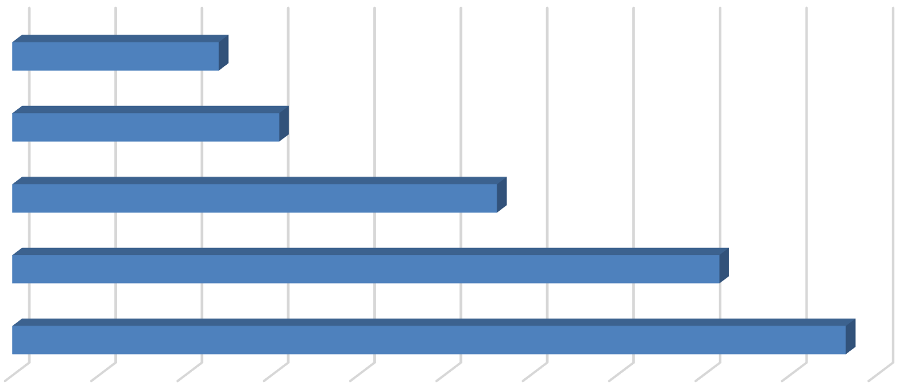
Figure 2: Average Number of Occupants in Unit-Leased Apartments by Type

Studio |  |  | 1.2
1 Bedroom |  |  |  | 1.5
2 Bedroom |  |  |  |  |  |  | 2.8
3 Bedroom |  |  |  |  |  |  |  |  |  | 4.1
4+ Bedroom |  |  |  |  |  |  |  |  |  |  |  | 4.8
0.0  Source: BAE, 2022. | 0.5 | 1.0 | 1.5 |  | 2.0 | 2.5 | 3.0 | 3.5 | 4.0 |  | 4.5 | 5.0

Table 1, on the following page, provides detailed unit totals, along with the number of vacant units, and the associated vacancy rate by unit size. Again, the results reflect only those survey responses that provided unit size and vacancy details. There were 18 vacant apartments reported as available for lease on a unit-lease basis during the survey period, which is significantly lower than the 81 vacant units identified in 2021, and significantly lower than the 570 vacant units reported in 2020. This translates to a vacancy rate of 0.2 percent. This represents a return to the historical trended of exceptionally low vacancy rates (i.e., below one percent) observed prior to the onset of the COVID-19 pandemic in early 2020.

Broken down by unit type, the 2022 survey results show that the vacancy rate was fairly evenly distributed among unit sizes. As seen below, studio units and three-bedroom units had the highest reported vacancy rates, at 0.5 and 0.4 percent, although these only amount to five vacant units. Larger units, or those with four or more bedrooms, had zero vacant units, while one-bedroom units had a low vacancy rate of 0.1 percent. The vacancy for two-bedroom units was also relatively low, at just 0.3 percent.

Table 1: Vacancy Rate for Unit Leases by Unit Size

2022 Survey Results
 |  |  |  |  | Number of Vacant |  |  |  |  |  |  | 2021 |  | 2020
Units Reported (a) |  |  |  |  | Units Reported (b) |  |  |  | Vacancy |  |  | Vacancy |  | Vacancy
Unit Size |  | Number |  | Percent |  | Number |  | Percent |  | Rate (c) |  | Rate (c) |  | Rate (c)
Studio |  | 189 |  | 3% |  | 1 |  | 6% |  | 0.5% |  | 0.0% |  | 0.6%
1 Bedroom |  | 2,294 |  | 31% |  | 3 |  | 17% |  | 0.1% |  | 0.1% |  | 3.6%
2 Bedroom |  | 3,346 |  | 45% |  | 10 |  | 56% |  | 0.3% |  | 0.5% |  | 10.8%
3 Bedroom |  | 1,119 |  | 15% |  | 4 |  | 22% |  | 0.4% |  | 2.4% |  | 12.3%
4+ Bedroom |  | 455 |  | 6% |  | 0 |  | 0% |  | 0.0% |  | 10.1% |  | 8.0%
Total, All Sizes |  | 7,403 |  | 100% |  | 18 |  | 100% |  | 0.2% |  | 1.1% |  | 8.4%

Notes:
- Includes the number of units, by unit type, reported by respondents as rented on a per unit basis (i.e., unit lease).
- Includes the number of units reported as vacant, by unit type, as reported by survey respondents. May exclude some units in cases where the survey respondent reported the total number of units but did not report the associated number of vacant units.
- The vacancy rate for unit-leased apartments was calculated based on the number of leased and vacant units only, as reported by survey respondents.
Source: BAE, 2022.

Bed Leases
Of the 10,337 market-rate apartment units reported by survey respondents, 2,974 units (29 percent) were reportedly rented under bed lease arrangements. This is comparable to the number of units rented under a bed lease arrangement in 2021, but more than double the number of bed-leased units in 2020. This recent increase is a result of new deliveries of bed-leasing properties, expansion of existing bed-leasing properties, and conversion of previously unit-leased properties to bed lease arrangements.

Figure 3 illustrates the distribution of bed leases and bed-leased units, by unit size, which are also reported in Table 2. Most of the bed-leased units, nearly 76 percent, had between two and four bedrooms. Four-bedroom units were the most common, accounting for 37 percent of the total. Two- and three-bedroom units accounted for 28 percent and 11 percent of all reported bed-leased units, respectively. Studio and one-bedroom units accounted for the remaining 24 percent.

Survey respondents reported a total of 9,040 leasable beds, comparable to the number reported in 2021. The distribution of leasable beds, by unit size, reflects a distribution similar to that shown for bed-leased units. As shown in Figure 3, 54 percent of the leased beds were in four-bedroom units, while 23 percent were in two-bedroom units, and 12 percent were in three-bedroom units. Studio and one-bedroom units that were reported as rented under bed lease agreements accounted for 11 percent of the total.

Figure 3: Distribution of Leasable Beds and Associated Units by Unit Size









Studio & 1 Bedroom
2 Bedroom
3 Bedroom

Units

717; 24%

Beds









998; 11%
2,114; 23%
4,839; 54%
1,089; 12%

4+ Bedroom
1,106; 37%

830; 28%
321; 11%

Source: BAE, 2022.

Figure 4 reports the average number of beds per unit, by unit size. This generally illustrates the relatively low incidence of double-occupancy bedrooms among bed-leased units. The number of double-occupancy bedrooms was similar among the various unit types, though four-bedroom and two-bedroom units reported a slightly higher number of double-occupancy rooms. Compared to 2021, the data indicate a minor increase in the prevalence of double-ups among smaller units, or those with less than four bedrooms, and a minor decrease in the prevalence of double-ups in units with four or more bedrooms.

Figure 4: Average Number of Beds Per Bed-Leased Unit

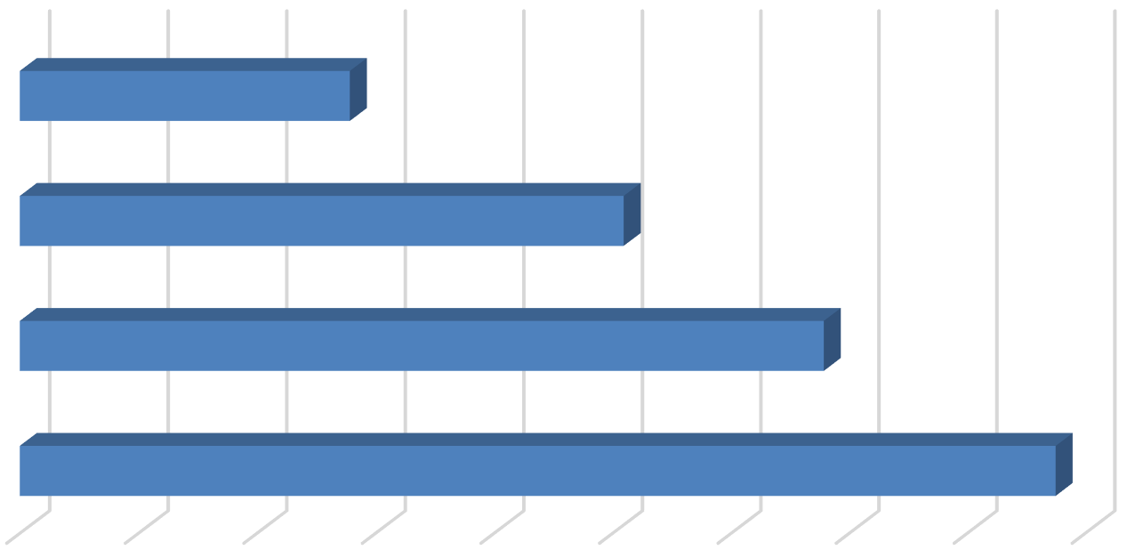
Studio and 1 Bedroom
1.4
2.5
3.4
4.4

- Bedroom

- Bedroom

4+ Bedroom
0.0 0.5 1.0 1.5 2.0 2.5 3.0 3.5 4.0 4.5
Source: BAE, 2022.

As documented in Table 2 below, respondents reported 75 vacant beds in 2022. This equals a vacancy rate of 0.8 percent. This vacancy rate is below the rate reported in 2021 (2.4 percent) and well below the vacancy rate reported in 2020 of nearly 30 percent. Compared to pre-pandemic trends, the 2022 vacancy rate is comparable to historical average vacancy rates for bed-leased apartments which have typically ranged between 0.5 and 4.0 percent. The return to historical average vacancy rates, despite the increase in available bed leases over the past two years, indicates that demand is very strong and growing within the Davis multifamily housing market, despite the impact of the Coronavirus pandemic.
Table 2: Vacancy Rate for Bed Leases by Unit Size
2022 Survey Results
Bed Leased |  |  |  |  | Number of |  |  |  | Number of Vacant |  |  |  |  |  |  | 2021 |  | 2020
Units Reported (a) |  |  |  |  | Beds Reported (b) |  |  |  | Beds Reported (c) |  |  |  | Vacancy |  |  | Vacancy |  | Vacancy
Unit Size |  | Number |  | Percent |  | Number |  | Percent |  | Number |  | Percent |  | Rate (d) |  | Rate (d) |  | Rate (d)
Studio & 1 Bedroom |  | 717 |  | 24% |  | 998 |  | 11% |  | 19 |  | 25% |  | 1.9% |  | 1.3% |  | 40.0%
2 Bedroom |  | 830 |  | 28% |  | 2,114 |  | 23% |  | 30 |  | 40% |  | 1.4% |  | 1.7% |  | 38.9%
3 Bedroom |  | 321 |  | 11% |  | 1,089 |  | 12% |  | 2 |  | 3% |  | 0.2% |  | 2.6% |  | 34.1%
4+ Bedroom |  | 1,106 |  | 37% |  | 4,839 |  | 54% |  | 24 |  | 32% |  | 0.5% |  | 2.8% |  | 23.7%
Total, All Sizes |  | 2,974 |  | 100% |  | 9,040 |  | 100% |  | 75 |  | 100% |  | 0.8% |  | 2.4% |  | 29.8%
Notes:
- Includes the number of units, by unit type, reported by respondents as rented on a per bed basis (i.e., bed lease).
- Includes the number of beds located within bed-leased units, by unit type, as reported by respondents. May exclude some beds in cases where the respondent reported bed-leased units but did not report the associated number of leased.
- Includes the number of leasable beds reported as vacant, by unit type, as reported by survey respondents. May exclude some beds in cases where the survey respondent reported bed-leased units but did not report the associated number of leased or vacant beds.
- The vacancy rate for bed leases was calculated based on the number of leased and vacant beds only, as reported by survey respondents.

Source: BAE, 2022.

Blended Vacancy Rate
To estimate a community-wide vacancy rate for all lease types, BAE combined the unit lease and bed lease vacancy rates, to generate a combined, or “blended,” vacancy estimate.4 The results of the blended vacancy rate calculations for the 2022 survey are shown in Table 3.
Given that unit-leased apartments account for 71 percent of the reported market-rate rental inventory, the blended vacancy rate aligns more closely with the unit lease vacancy rate but is drawn upward due to the addition of the slightly higher bed lease vacancy rate. The blended vacancy rate for all rental units is 0.5 percent. This vacancy rate is notably lower than the 2021 blended vacancy rate of 1.4 percent, and well below the 2020 blended vacancy rate of
12.2 percent, and roughly aligns with historical blended vacancy rates recorded prior to the pandemic of below 1.0 percent.
Table 3: Blended Vacancy Rate Summary
2022 Vacancy Rate
Unit Size |  | Unit  Lease (a) |  | Bed  Lease (b) |  | Blended (c) |  | 2021 Blended  Vacancy Rate (c) |  | 2020 Blended  Vacancy Rate (c)
Studio & 1 Bedroom |  | 0.2% |  | 1.9% |  | 0.5% |  | 0.4% |  | 5.7%
2 Bedroom |  | 0.3% |  | 1.4% |  | 0.5% |  | 0.8% |  | 13.7%
3 Bedroom |  | 0.4% |  | 0.2% |  | 0.3% |  | 2.5% |  | 16.9%
4+ Bedroom |  | 0.0% |  | 0.5% |  | 0.4% |  | 4.5% |  | 17.1%
Total, All Sizes |  | 0.2% |  | 0.8% |  | 0.5% |  | 1.4% |  | 12.2%
Notes:
- Based on the number of units, by unit type, reported as rented on a per unit basis (i.e., unit lease).
- Based on the number of units, by unit type, reported as rented on a per bed basis (i.e., bed lease).
- Based on the number of units, by unit type, reported as rented on a per unit basis (i.e., unit lease), with vacant units leased on a per bed basis converted to "vacant unit equivalents."
Source: BAE, 2022.

Rental Rates
The overall trend indicated by the 2022 survey is that rental rates increased significantly in 2022 over 2021 and 2020. This appears to largely be a function of relatively modest rent increases that occurred during the COVID-19 pandemic and shifts in the prevalence of double ups and single-occupancy bed leased apartments, combined with an increased prevalence of bed-leased units which typically charge a premium compared to unit leases.
Only two percent of responding properties reported decreasing rental rates relative to the prior year. This is similar to the historical average of between zero and five percent, but is notably lower than the fall 2020 survey where over one-third of respondents reported decreasing rents to fill vacancies, due to the COVID-19 pandemic. Based on the responses, complexes only modestly reduced rents, and often these reductions were only on a portion of units.

4 To calculate the “blended” vacancy rate, BAE calculated the bed lease vacancy rate on a per bed basis, then applied that rate to the total number of bed-leased units. The resulting “vacant unit equivalents” were then added to the total number of vacant unit-leased apartments to calculate the combined vacancy rate.

Unit Leases
Table 4 reports the range and weighted average of the reported rental rates for apartments leased under unit lease arrangements. Note that the survey results reported here represent properties for which respondents reported both the total number of units, by type, and the corresponding rental rate information. Based on this information, the average rental rate for all units was $2,226 per month.5 This represents a 9.4 percent increase over 2021, when the average rental rate for unit-leased apartments was $2,034. This rental rate increase is roughly double the increase recorded between 2020 and 2021 of 4.7 percent, although it is comparable to historical average increases which range from four to ten percent.

Table 4: Rental Rates for Unit Leases by Unit Size

2022 Survey Results 2021 2020
Weighted Weighted |  |  |  |  |  |  |  |  |  | Weighted
Unit Size |  | Minimum |  | Maximum |  | Average (a) |  | Average (a) |  | Average (a)
Studio |  | $800 |  | $2,262 |  | $1,340 |  | $1,283 |  | $1,229
1 Bedroom |  | $1,075 |  | $3,050 |  | $1,736 |  | $1,598 |  | $1,498
2 Bedroom |  | $1,148 |  | $3,765 |  | $2,188 |  | $2,038 |  | $1,909
3 Bedroom |  | $1,709 |  | $3,695 |  | $2,936 |  | $2,702 |  | $2,610
4+ Bedroom |  | $3,025 |  | $5,395 |  | $3,606 |  | $3,373 |  | $3,392
Total, All Sizes |  | $800 |  | $5,395 |  | $2,226 |  | $2,034 |  | $1,943

Note:
(a) Figures represent weighted average rental rates and include only those complexes where the respondent identified the number of units by type, the number of beds per unit, and associated rental rates.

Source: BAE, 2022.

Bed Leases
Table 5, on the following page, illustrates the weighted average of the reported rental rates for individual bed leases. Note that the reported survey results only include those responses that identified the total number of bed-leased units, by type, the total number of beds per unit, and the associated rental rate information. According to survey respondents, the weighted average rental rate for a bed lease, across all unit sizes, was $1,241 per month.6 This represents an increase of 17 percent over 2021, when the average monthly bed lease rate was $1,062. While the annual increase in the average monthly rental rate is well above prior survey periods, this is partly driven by the slight increase in single-occupancy rooms which generate higher rent per bed compared to double-occupancy rooms.

5 In cases where the respondent provided a range of prices for a given unit type, but no corresponding unit totals, BAE applied the mid-point of the range. The reported values represent weighted averages, which reflect the reported rental rates and the total number of units and/or beds.
6 See footnote 6.

Table 5: Average Rental Rate for Bed Leases by Unit Size
 |  | 2022 |  | 2021 |  | 2020
Unit Size |  | Weighted  Average (a) |  | Weighted  Average (a) |  | Weighted  Average (a)
Studio & 1 Bedroom (b) |  | $1,266 |  | $1,162 |  | $1,312
2 Bedroom |  | $1,111 |  | $1,007 |  | $1,282
3 Bedroom |  | $1,204 |  | $1,136 |  | $1,090
4+ Bedroom |  | $1,302 |  | $1,049 |  | $916
Total, All Sizes |  | $1,241 |  | $1,062 |  | $1,050

Notes:
- Figures represent weighted average rental rates and include only those complexes where the respondent identified the number of units by type, the number of beds per unit, and associated rental rates.
- Studio and one-bedroom bed-leased apartments are in complexes that only rent units under bed lease arrangements. These complexes offer a greater set of amenities, compared to the average unit-leased complex, and are priced as such.
Source: BAE, 2022.

Blended Rental Rate
To estimate the average citywide rental rate for all units, regardless of lease type, BAE combined the rental rates for unit leases and calculated the unit equivalent rental rate for units rented under bed lease arrangements.7 As reported in Table 6, the unit equivalent bed lease rental rates are generally higher than the average unit lease rents (e.g., ranging from three to 58 percent higher depending on the unit type). Across all unit types, the average rental rate is $2,671. This represents a 10.4 percent increase over the 2021 blended average rental rate of $2,420 per month. This blended rental rate increase is comparable to the increase observed between 2020 and 2021, but exceeds the historic average blended rental rate increase, which has typically ranged from three to seven percent.
Table 6: Blended Rental Rate Summary

2022 Survey Results
Unit Size |  | Unit  Lease |  | Bed  Lease (a) |  | Blended (b) |  | 2021 Blended  Rental Rate (b) |  | 2020 Blended  Rental Rate (b)
Studio & 1 Bedroom |  | $1,706 |  | $1,762 |  | $1,718 |  | $1,589 |  | $1,499
2 Bedroom |  | $2,188 |  | $2,829 |  | $2,316 |  | $2,142 |  | $2,027
3 Bedroom |  | $2,936 |  | $4,085 |  | $3,192 |  | $2,970 |  | $2,746
4+ Bedroom |  | $3,606 |  | $5,696 |  | $5,093 |  | $4,507 |  | $3,947
Total, All Sizes |  | $2,226 |  | $3,773 |  | $2,671 |  | $2,420 |  | $2,183

Notes:
- Based on the number of beds and the weighted average bed lease rental rate, by unit type.
- Based on the weighted average unit lease rate and unit lease equivalent rate (for bed-leased units), by unit type.
Source: BAE, 2022.

7 To calculate the “blended” rental rate, BAE calculated a “unit lease equivalent” for bed-leased units. This is equal to the weighted average bed lease rate multiplied by average the number of beds per unit, by unit type. This value was then used to calculate a weighted average rental rate for all units.

Additional Recurring Charges
Prior survey efforts identified an increasing prevalence of complexes charging tenants separately for utilities, amenities, and services that have historically been included in rent. For example, some complexes have started charging a recurring monthly fee for water, sewer, and garbage service, or for the use of certain on-site amenities. In many cases, these newly itemized charges are mandatory, but are considered to be separate from rent. To account for this, and to identify other optional charges, the survey included a question asking respondents to more clearly identify additional monthly charges that are not included in the monthly rent amount paid by tenants.

Additional Unit Lease Charges
A total of 40 unit-lease complexes indicated that they levy additional mandatory charges in addition to rent, an increase from 2021 when 34 unit-lease complexes reported additional charges. These are most typically associated with utility usage and parking. Among the 34 complexes that charge a separate utility fee, seventeen of them charged between $20 and
$85 per person or bedroom, while five charged between $65 and $160 per unit. An additional 12 properties reported charging an additional utility fee based on usage. A total of six complexes charge separately for parking. Five respondents reported charging parking fees on a monthly basis, with an average cost of $42 per month, while the other reported a one-time payment for parking. Some examples of other additional charges include monthly pet fees and storage access fees.

Additional Bed Lease Charges
Similar to the unit lease complexes, bed lease complexes most commonly reported additional utility usage and parking charges. Of the 18 bed lease complexes, five complexes charge a flat per person utility fee, ranging from ten to $90 per person. Another four complexes charge for utilities on a passthrough basis8. Among complexes that charge for parking, the typical cost is around $70 per month; though there is some slight variation between the amount charged for covered versus uncovered spaces. Other additional charges include pet rent and furniture rentals, both ranging from $20 to $40 per month. Lastly, two properties charged a monthly fee to cover landlord liability insurance.

Utilities, Appliances, and Amenities
As in prior years, the 2022 survey included questions regarding the utilities, appliances, and amenities that are provided at no additional charge (i.e., included in the monthly rental rate). As shown in Figure 5, an average of 50 to 60 percent of respondent complexes include water,

8 Properties that charge utility fees on a pass-through basis independently meter utility usage by unit and pass on the utility charge to tenants (e.g., Ratio Utility Billing System, or RUBS).

sewer, and trash collection in rent. This represents a modest decline from historic averages due to the increase in additional recurring charges. In addition, approximately 78 percent of bed lease complexes report also offering internet, as do 39 percent of unit lease complexes.

Figure 5: Percent of Respondents Including Utilities in Rent by Utility Type and Lease Type
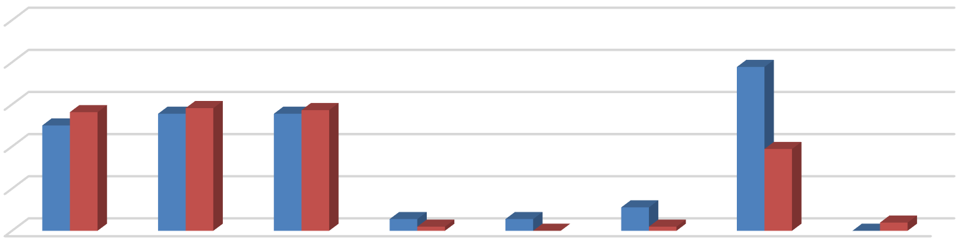
100%
78%
50% 56%
56%58%
56% 57%
39%
6% 2% 6% 0%
11%
2%
0% 4%
80%
60%
40%
20%





0%
Bed Leases Unit Leases
Source: BAE, 2022.
Figure 6 illustrates the types of appliances and other amenities that are provided. Nearly all respondent complexes include a refrigerator and stove/oven, while nearly all included an air conditioning unit at no extra charge. Approximately 89 percent of bed leasing properties and 64 percent of unit lease properties include a dishwasher, while 83 percent of bed lease properties and 51 percent of unit lease properties include a microwave. Approximately half of the bed lease complexes provide in-unit laundry facilities, while only 20 percent of unit lease complexes provide this facility in the unit.

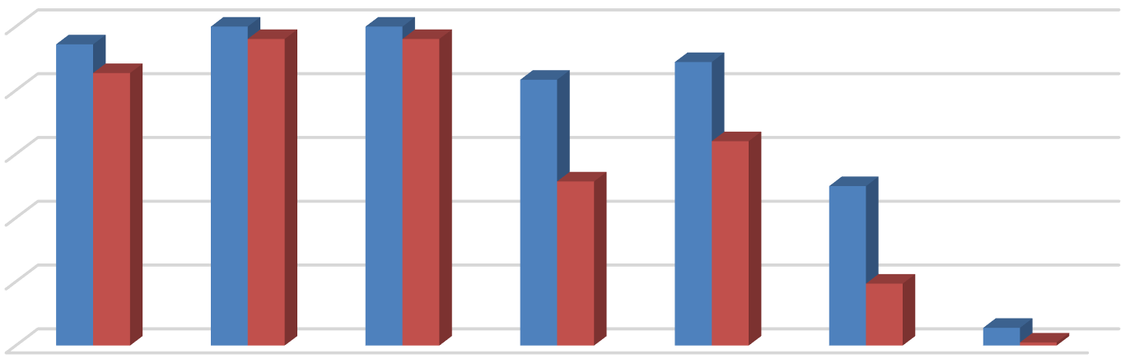
Figure 6: Percent of Respondents Including Appliances in Unit by Lease Type
94%
100% 96% 100% 96%
85%
83%
89%
64%
51%
50%
19%
6%1%

100%
80%
60%
40%
20%
0%
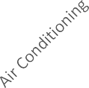




Bed Leases Unit Leases
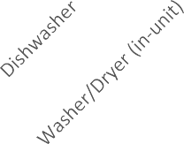
Source: BAE, 2022.

The 2022 survey also questioned respondents regarding the amenities offered on-site, such as gym or pool facilities, and services provided by the property management staff, such as package service and organized social activities. Figure 7 illustrates the prevalence of these amenities, differentiating between complexes that offer unit leases versus bed leases.
Overall, respondents that offer unit leases generally tend to offer fewer amenities. For example, 63 percent offer a pool and/or hot tub, while 49 percent offer a picnic or BBQ area, and 39 percent offer on-site gym facilities and club houses. Respondents that offer bed leases were more likely to offer a wider assortment of on-site amenities, with most respondents offering multiple types of equipment, facilities, and services. For example, 89 percent of complexes that offer bed leases also provide a pool and/or hot tub onsite, 83 percent offer a picnic or BBQ area and club house, and 78 percent provide an on-site gym. Of the respondents who offered other additional services, the most common was sport courts.

Figure 7: Percent of Respondents Offering Select Amenities by Lease Type
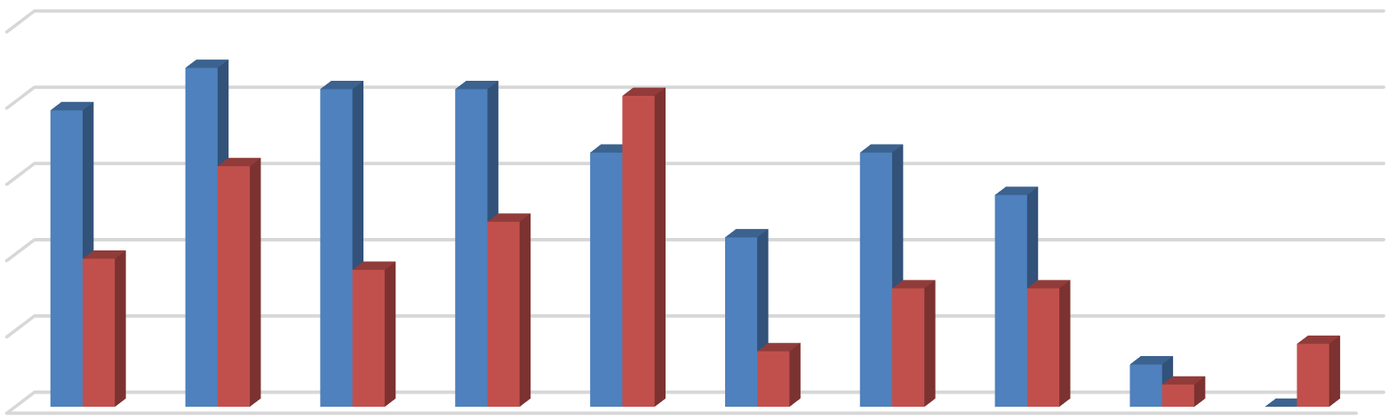
100%
89%
78%
83%
83%
82%
63%
67%
67%
56%
49%
39%
44%
36%
31%
31%
15%
11%
17%
6%
0%
80%
60%
40%
20%
0%

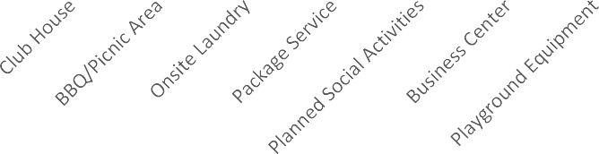


Bed Leases Unit Leases
Source: BAE, 2022.

Furnished and Unfurnished Units
Most of the surveyed properties indicated that they did not offer furnished units in the 2022 leasing season. Figures 8 and 9 illustrate the number of respondents that offered furnishings, by unit size. Only five properties indicated that they offered furnished apartments under unit lease arrangements in the 2021 leasing season. Two-bedroom units were the most common unit type offered with furnishings under a unit lease arrangement followed by one- and three-bedroom units. Ten of the 18 bed lease complexes reported offering furnished units.

Figure 8: Number of Respondents Offering Furnished Unit Leases by Unit Size

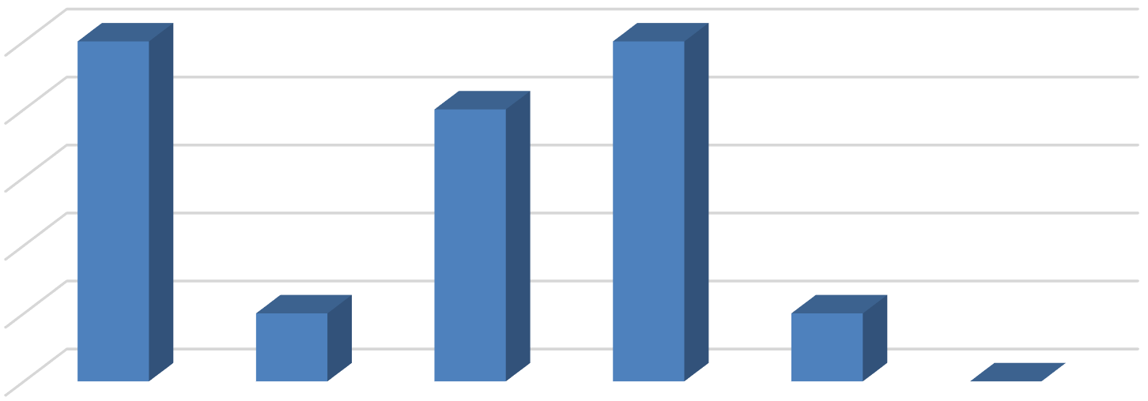
5
5
5
4
1
1
0
4
3
2
1
0
All Unit Sizes Studio 1 Bedroom 2 Bedroom 3 Bedroom 4+ Bedroom
Source: BAE, 2022.

Figure 9: Number of Respondents Offering Furnished Bed Leases by Unit Size

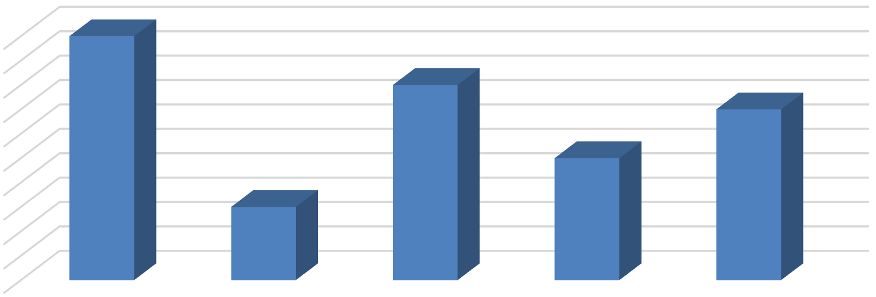
10
10
8
7
5
3
9
8
7
6
5
4
3
2
1
0
All Unit Sizes Studio & 1
Bedroom

2 Bedroom 3 Bedroom 4+ Bedroom

Source: BAE, 2022.

Services and Incentives
For a variety of reasons, it is often in a property owner’s best interest to provide certain services and incentives to residents. This often promotes resident attraction and retention. For properties that offer bed leases, a roommate matching program can often be an important tool. Under such a program, prospective residents fill out applications, stating their interests, and preferences for a roommate. The prevalence of roommate matching programs is similar to the 2021 survey period, with a total of 19 properties offering such services, including 17 of the 18 properties that manage apartments that are leased on a per bed basis. A total of 12 apartment complexes reported offering other incentives and move-in specials in the 2022 leasing season to help fill vacancies and attract new residents, which is much lower than the 2021 leasing season, though comparable to historic averages. Common incentives and specials included free or discounted rent, waived application fees, and gift cards, among other giveaways. The value of these incentives ranged from a $150 gift card to $500 in discounted rent for one month, with the average value equaling roughly $400 in incentives.

Planned Renovations
Thirty-six respondents reported having plans to undertake renovations within the next 12 months. Most of those that reported planned renovations conduct periodic updates as units turn over. Other common upgrades include new kitchen and bath facilities, windows, and countertops. Other exterior upgrades typically include new paint or siding, landscaping, and common area improvements.

