bae urban economics

2023 Apartment Vacancy and Rental Rate Survey
Presented on behalf of UC Davis Student Housing and Dining Services

Overview
The annual Apartment Vacancy and Rental Rate Survey collects information on the characteristics of rental apartment units in the Davis community. Similar surveys have been conducted annually since at least 1975. Since 2013, the survey has been administered in partnership with BAE Urban Economics (BAE), a private real estate consulting firm with an office in Downtown Davis. The survey's objective is to provide information that will help inform planning decisions on campus and throughout the broader Davis area. For example, survey results help campus officials assess the current housing market conditions faced by UC Davis students, faculty, and staff. The survey results also help the university to assess the likely feasibility of proposed campus housing projects.

2023 Survey Results
One hundred eight apartment complexes and property management companies responded to the 2023 survey. These properties feature a total of 10,801 reported rental units. This represents a minor decrease in the number of respondent complexes and associated rental units compared to 2022.1 While the majority of these surveyed properties lease whole units, the survey recorded a total of 18 properties that lease a total of 2,611 units on a per-bed basis with a total inventory of 7,988 leasable beds.

According to estimates from the American Community Survey (ACS) there were approximately 13,057 multifamily housing units, on average, on the UC Davis campus and in the City of Davis between 2018 and 2022.2 3 This indicates that the units captured in the 2023 survey account for approximately 83 percent of the Davis area multifamily housing stock.

Of the 108 properties that responded to the 2023 survey, 11 reported leasing units at below market rents (i.e., requiring an income eligibility test to qualify prospective tenants for reduced or subsidized rents). Three of those respondents reported renting all the units in the complex at below market rates, while the remaining eight properties rent some units at below market rates and some at market rates. Of the 11 complexes that reported renting units at below market rates, seven reported the income eligibility standards that they use to screen

1 BAE received responses from 119 unique apartment complexes and property management companies as part of the 2022 survey, representing 11,006 rental units.
2 Includes the City of Davis and the UC Davis Census Designated Place (CDP).
3 U.S. Census Bureau. 2018-2022 American Community Survey 5-Year Estimates, Table B25024. Retrieved from: http://data.census.gov/
San Francisco Sacramento Los Angeles Washington DC Atlanta New York City

www.bae1.com

prospective tenants. The 2023 survey results for complexes with below market rate units are consistent with the 2022 results, which found that most below market rate units were rented to households earning between 50 and 80 percent of the area median income (AMI). The remainder of this analysis excludes units rented at below market rents but does include units rented at market rates in mixed-income complexes.

While all survey respondents reported the total unit numbers, not all respondents provided complete information regarding other unit characteristics, such as the mix of units by size or amenities provided on-site. Additionally, the total of all unit sizes may not equal the reported total unit count due to inconsistent reporting of managers’ units and other similar factors. As a result, the unit and bed lease totals discussed elsewhere in this report may not equal those reported above, in some cases.

Leasing “Beds” Versus Complete Apartment Units
One of the increasingly common and complex dynamics of the local rental housing market is the practice of renting out individual apartment units to multiple tenants using multiple lease agreements. Under this type of arrangement, known as a “bed lease,” each bed or bedroom in an apartment is associated with a separate lease agreement. Each resident is thereby contractually responsible for only a portion of the total rent. This is compared to the more conventional approach, in which each unit is rented under a single lease, and all of the tenants living in the unit sign the lease and are jointly responsible for the complete monthly rent payment. For the purposes of this survey, this arrangement is called a “unit lease.”

Unit Leases
Survey respondents provided unit size detail for 6,668 units that are rented under unit lease arrangements, which account for about 72 percent of all reported market-rate rental units. Note that the survey results reported below exclude units for which unit size detail was not provided. Figure 1 illustrates the distribution of unit-leased apartments, by unit size. The majority of reported units had between one and three bedrooms. One-bedroom units accounted for 30 percent of the total, while two-bedroom units accounted for 45 percent and three-bedroom units represented 15 percent. Apartments with four or more bedrooms represented seven percent of reported units, while studio units represented just three percent. This distribution is roughly comparable to the results of the 2022 survey.

Figure 1: Distribution of Unit Leases by Unit Size











Studio
187; 3%
451;
7%
1,029; 15%
2,000; 30%
3,001; 45%
1 Bedroom
2 Bedroom
3 Bedroom
4+ Bedroom

Source: BAE, 2023.

Figure 2 summarizes the average number of occupants in unit-leased apartments by unit size. As reported below, most units have at least one double occupancy bedroom, on average. For example, the average occupancy for a one-bedroom unit is 1.6 persons, while two-bedroom units average 3.0 residents, three-bedroom units average 4.0 residents, and units with four or more bedrooms average 5.4 residents. Occupancy in studio units is typically a single person, with an average occupancy factor of 1.2 residents. While respondents to the 2022 survey reported a decrease in the average number of residents per unit, results from the 2023 survey indicate an increase in the average number of residents for most unit types. The prior decrease in the average number of residents per unit may have been influenced by several factors, such as the COVID pandemic and changing resident preferences, however the 2023 survey results indicate a return to a higher number of residents per unit on average.

Figure 2: Average Number of Occupants in Unit-Leased Apartments by Type

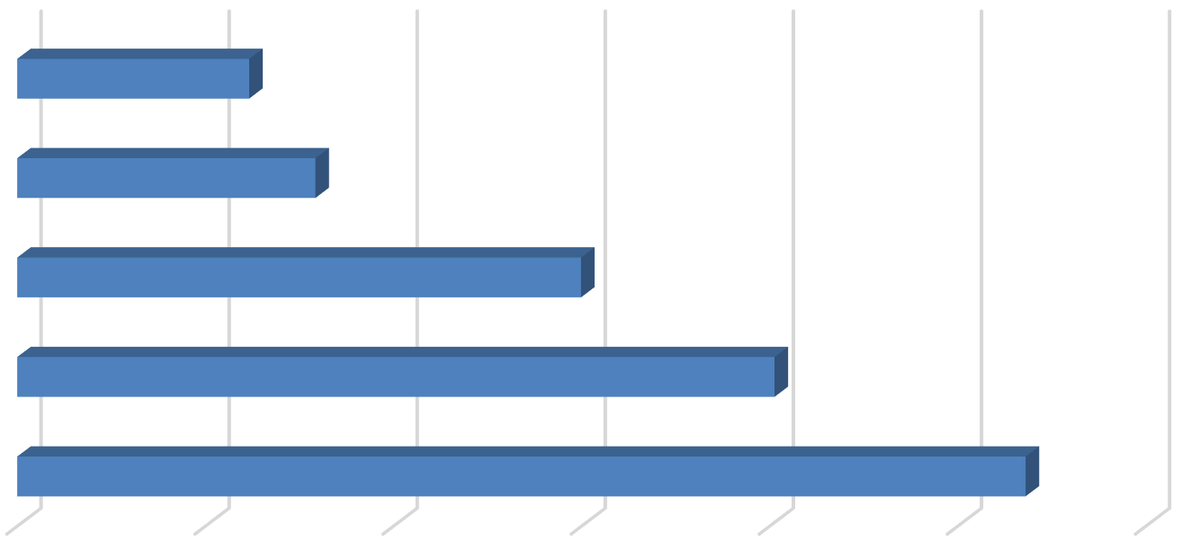
Studio
1.2
1.6
3.0
4.0
5.4

- Bedroom

- Bedroom

- Bedroom

4+ Bedroom

0.0 1.0 2.0 3.0 4.0 5.0 6.0

Source: BAE, 2023.

Table 1: Vacancy Rate for Unit Leases by Unit Size
2023 Survey Results
 |  |  |  |  | Number of Vacant |  |  |  |  |  |  | 2022 |  | 2021
Units Reported (a) |  |  |  |  | Units Reported (b) |  |  |  | Vacancy |  |  | Vacancy |  | Vacancy
Unit Size |  | Number |  | Percent |  | Number |  | Percent |  | Rate (c) |  | Rate (c) |  | Rate (c)
Studio |  | 187 |  | 3% |  | 0 |  | 0% |  | 0.0% |  | 0.5% |  | 0.0%
1 Bedroom |  | 2,000 |  | 30% |  | 22 |  | 14% |  | 1.1% |  | 0.1% |  | 0.1%
2 Bedroom |  | 3,001 |  | 45% |  | 96 |  | 63% |  | 3.2% |  | 0.3% |  | 0.5%
3 Bedroom |  | 1,029 |  | 15% |  | 31 |  | 20% |  | 3.0% |  | 0.4% |  | 2.4%
4+ Bedroom |  | 451 |  | 7% |  | 3 |  | 2% |  | 0.7% |  | 0.0% |  | 10.1%
Total, All Sizes |  | 6,668 |  | 100% |  | 152 |  | 100% |  | 2.3% |  | 0.2% |  | 1.1%
Notes:
- Includes the number of units, by unit type, reported by respondents as rented on a per unit basis (i.e., unit lease).
- Includes the number of units reported as vacant, by unit type, as reported by survey respondents. May exclude some units in cases where the survey respondent reported the total number of units but did not report the associated number of vacant units.
- The vacancy rate for unit-leased apartments was calculated based on the number of leased and vacant units only, as reported by survey respondents.
Source: BAE, 2023.

Table 1, above, provides detailed unit totals, along with the number of vacant units, and the associated vacancy rate by unit size. Again, the results reflect only those survey responses that provided unit size and vacancy details. There were roughly 150 vacant apartments reported as available for lease on a unit-lease basis during the survey period, which is significantly higher than the 18 vacant units identified in 2022. This translates to a vacancy rate of 2.3 percent. This represents a higher vacancy rate relative to the historical trended average since the 2017 survey period, which has ranged between 0.2 and 2.0 percent.

Broken down by unit type, the 2023 survey results show that the vacancy rate was concentrated in larger units. As seen above, two-bedroom units reported a vacancy rate of 3.2 percent, followed by three-bedroom units which reported a vacancy rate of 3.0 percent. One- bedroom units and units with four or more bedrooms reported vacancy rates around 1.0 percent, while there were no vacancies among the studio rental inventory.

Bed Leases
Of the 9,279 market-rate apartment units reported by survey respondents, 2,611 units (28 percent) were reportedly rented under bed lease arrangements. This is comparable to the number of units rented under a bed lease arrangement in 2022, but more than double the number of bed-leased units reported in 2020. This recent increase is a result of new deliveries of bed-leasing properties, expansion of existing bed-leasing properties, and conversion of previously unit-leased properties to bed lease arrangements.

Figure 3, below, illustrates the distribution of bed leases and bed-leased units, by unit size, which are also reported in Table 2. Most of the bed-leased units, nearly 78 percent, had between two and four bedrooms. Four-bedroom units were the most common, accounting for 37 percent of the total. Two- and three-bedroom units accounted for 28 percent and 13

percent of all reported bed-leased units, respectively. Studio and one-bedroom units accounted for the remaining 22 percent.

Survey respondents reported a total of 7,988 leasable beds, comparable to the number reported in 2022. The distribution of leasable beds, by unit size, reflects a distribution similar to that shown for bed-leased units. As shown in Figure 3, 53 percent of the leased beds were in four-bedroom units, while 23 percent were in two-bedroom units, and 14 percent were in three-bedroom units. Studio and one-bedroom units that were reported as rented under bed lease agreements accounted for ten percent of the total.

Figure 3: Distribution of Leasable Beds and Associated Units by Unit Size

Units

Beds









808; 10%
4,256;
53%
1,836;
23%
1,088;
14%









Studio & 1 Bedroom
578; 22%
972; 37%
725; 28%
336; 13%
2 Bedroom
3 Bedroom
4+ Bedroom

Source: BAE, 2023.

Figure 4: Average Number of Beds Per Bed-Leased Unit

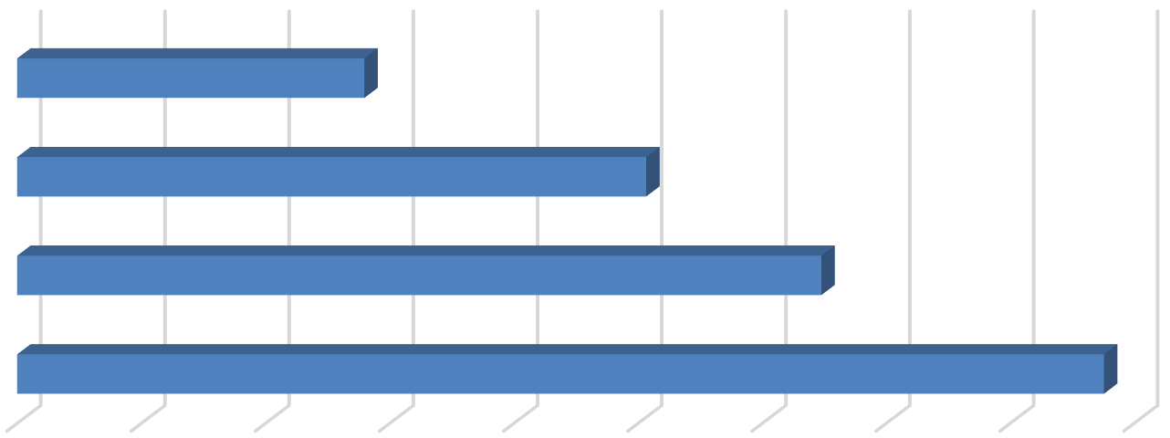
Studio and 1 Bedroom
1.4
2.5
3.2
4.4

  - Bedroom

  - Bedroom

4+ Bedroom
0.0 0.5 1.0 1.5 2.0 2.5 3.0 3.5 4.0 4.5
Source: BAE, 2023.

Figure 4, above, reports the average number of beds per unit, by unit size. This generally illustrates the relatively low incidence of double-occupancy bedrooms among bed-leased units. The number of double-occupancy bedrooms was similar among the various unit types, though four-bedroom and two-bedroom units reported a slightly higher number of double-occupancy rooms. Compared to 2022, the data indicate a minor decrease in the prevalence of double- ups among smaller units, or those with less than four bedrooms.

As documented in Table 2, respondents reported 470 vacant beds in 2023. This equals a vacancy rate of 5.9 percent. This vacancy rate is well above the rate reported in 2022 (0.8 percent) and above the historical bed-leased vacancy rate of 0.5 and 3.5 percent. The increase in vacancy rates among bed-leased units may be associated with the addition of new in bed-leasing properties in Davis, as well as more limited enrollment growth at the UC Davis main campus following the pandemic.4
Table 2: Vacancy Rate for Bed Leases by Unit Size
2023 Survey Results
Bed Leased |  |  |  |  | Number of |  |  |  | Number of Vacant |  |  |  |  |  |  | 2022 |  | 2021
Units Reported (a) |  |  |  |  | Beds Reported (b) |  |  |  | Beds Reported (c) |  |  |  | Vacancy |  |  | Vacancy |  | Vacancy
Unit Size |  | Number |  | Percent |  | Number |  | Percent |  | Number |  | Percent |  | Rate (d) |  | Rate (d) |  | Rate (d)
Studio & 1 Bedroom |  | 578 |  | 22% |  | 808 |  | 10% |  | 32 |  | 7% |  | 4.0% |  | 1.9% |  | 1.3%
2 Bedroom |  | 725 |  | 28% |  | 1,836 |  | 23% |  | 52 |  | 11% |  | 2.8% |  | 1.4% |  | 1.7%
3 Bedroom |  | 336 |  | 13% |  | 1,088 |  | 14% |  | 82 |  | 17% |  | 7.5% |  | 0.2% |  | 2.6%
4+ Bedroom |  | 972 |  | 37% |  | 4,256 |  | 53% |  | 304 |  | 65% |  | 7.1% |  | 0.5% |  | 2.8%
Total, All Sizes |  | 2,611 |  | 100% |  | 7,988 |  | 100% |  | 470 |  | 100% |  | 5.9% |  | 0.8% |  | 2.4%
Notes:
- Includes the number of units, by unit type, reported by respondents as rented on a per bed basis (i.e., bed lease).
- Includes the number of beds located within bed-leased units, by unit type, as reported by survey respondents. May exclude some beds in cases where the survey respondent reported bed-leased units but did not report the associated number of leased.
- Includes the number of leasable beds reported as vacant, by unit type, as reported by survey respondents. May exclude some beds in cases where the survey respondent reported bed-leased units but did not report the associated number of leased or vacant beds.
- The vacancy rate for bed leases was calculated based on the number of leased and vacant beds only, as reported by survey respondents.
Source: BAE, 2023.

Blended Vacancy Rate
To estimate a community-wide vacancy rate for all lease types, BAE combined the unit lease and bed lease vacancy rates, to generate a combined, or “blended,” vacancy estimate.5 The results of the blended vacancy rate calculations for the 2023 survey are shown in Table 3.

4 According to data published by UC Davis, available at https://aggiedata.ucdavis.edu/, the total headcount on the general UC Davis campus has grown by 0.9 percent per year since 2020, which is below the average annual growth between 2010 and 2020, of 2.4 percent per year.
5 To calculate the “blended” vacancy rate, BAE calculated the bed lease vacancy rate on a per bed basis, then applied that rate to the total number of bed-leased units. The resulting “vacant unit equivalents” were then added to the total number of vacant unit-leased apartments to calculate the combined vacancy rate.

Given that unit-leased apartments account for 72 percent of the reported market-rate rental inventory, the blended vacancy rate aligns more closely with the unit lease vacancy rate but is drawn upward due to the addition of the higher bed lease vacancy rate. The blended vacancy rate for all rental units is 3.0 percent. This vacancy rate is notably higher than the 2022 blended vacancy rate of 0.5 percent, and above the historical blended vacancy rates of between zero and two percent calculated since 2017.

Table 3: Blended Vacancy Rate Summary

2023 Vacancy Rate
Unit Size |  | Unit  Lease (a) |  | Bed  Lease (b) |  | Blended (c) |  | 2022 Blended  Vacancy Rate (c) |  | 2021 Blended  Vacancy Rate (c)
Studio & 1 Bedroom |  | 1.0% |  | 4.0% |  | 1.6% |  | 0.5% |  | 0.4%
2 Bedroom |  | 3.2% |  | 2.8% |  | 3.1% |  | 0.5% |  | 0.8%
3 Bedroom |  | 3.0% |  | 7.5% |  | 4.2% |  | 0.3% |  | 2.5%
4+ Bedroom |  | 0.7% |  | 7.1% |  | 4.4% |  | 0.4% |  | 4.5%
Total, All Sizes |  | 2.3% |  | 5.9% |  | 3.0% |  | 0.5% |  | 1.4%

Notes:
- Based on the number of units, by unit type, reported as rented on a per unit basis (i.e., unit lease).
- Based on the number of units, by unit type, reported as rented on a per bed basis (i.e., bed lease).
- Based on the number of units, by unit type, reported as rented on a per unit basis (i.e., unit lease), with vacant units leased on a per bed basis converted to "vacant unit equivalents."
Source: BAE, 2023.

Rental Rates
The 2023 survey results indicate that rental rates increased at a more modest rate relative to prior survey periods Whereas the prior two survey periods reported significant annual rent increases following the COVID-19 pandemic, the 2023 survey reports a more modest year- over-year increase in rental rates, likely driven by increased vacancy.
Nearly ten percent of responding properties reported decreasing rental rates relative to the prior leasing period This is higher than the historical average of between zero and five percent. These respondent complexes reported an average rent reduction of seven percent, though these reductions often apply only to a portion of the units within the complex.

Unit Leases
Table 4 reports the range and weighted average of the reported rental rates for apartments leased under unit lease arrangements. Note that the survey results reported here represent properties for which respondents reported both the total number of units, by type, and the corresponding rental rate information. Based on this information, the average rental rate for all

units was $2,372 per month,6 which represents a 6.6 percent increase over 2022, when the average rental rate for unit-leased apartments was $2,226. This suggests that the pace of rental rate increases has likely slowed somewhat compared to prior years.

Table 4: Rental Rates for Unit Leases by Unit Size
2023 Survey Results 2022 2021
Unit Size |  | Minimum |  | Maximum |  | Weighted  Average (a) |  | Weighted  Average (a) |  | Weighted  Average (a)
Studio |  | $800 |  | $2,207 |  | $1,504 |  | $1,340 |  | $1,283
1 Bedroom |  | $1,020 |  | $2,300 |  | $1,813 |  | $1,736 |  | $1,598
2 Bedroom |  | $1,230 |  | $3,200 |  | $2,295 |  | $2,188 |  | $2,038
3 Bedroom |  | $1,645 |  | $4,100 |  | $3,202 |  | $2,936 |  | $2,702
4+ Bedroom |  | $3,100 |  | $5,870 |  | $3,825 |  | $3,606 |  | $3,373
Total, All Sizes |  | $800 |  | $5,870 |  | $2,372 |  | $2,226 |  | $2,034
Note:
(a) Figures represent weighted average rental rates and include only those complexes where the respondent identified the number of units by type, the number of beds per unit, and associated rental rates.

Source: BAE, 2023.

Table 5: Average Rental Rate for Bed Leases by Unit Size
 |  | 2023 |  | 2022 |  | 2021
Unit Size |  | Weighted  Average (a) |  | Weighted  Average (a) |  | Weighted  Average (a)
Studio & 1 Bedroom (b) |  | $1,285 |  | $1,266 |  | $1,162
2 Bedroom |  | $1,139 |  | $1,111 |  | $1,007
3 Bedroom |  | $1,308 |  | $1,204 |  | $1,136
4+ Bedroom |  | $1,137 |  | $1,302 |  | $1,049
Total, All Sizes |  | $1,176 |  | $1,241 |  | $1,062
Notes:
- Figures represent weighted average rental rates and include only those complexes where the respondent identified the number of units by type, the number of beds per unit, and associated rental rates.
- Studio and one-bedroom bed-leased apartments are in complexes that only rent units under bed lease arrangements. These complexes offer a greater set of amenities, compared to the average unit-leased complex, and are priced as such.

Source: BAE, 2023.

Bed Leases
Table 5, above, illustrates the weighted average of the reported rental rates for individual bed leases. Note that the reported survey results only include those responses that identified the total number of bed-leased units, by type, the total number of beds per unit, and the associated rental rate information. The weighted average rental rate for a bed lease, across all

6 In cases where the respondent provided a range of prices for a given unit type, but no corresponding unit totals, BAE applied the mid-point of the range. The reported values represent weighted averages, which reflect the reported rental rates and the total number of units and/or beds.

unit sizes, was $1,176 per month,7 which represents a decrease of 5.3 percent over 2022, when the average monthly bed lease rate was $1,241. This decrease is partly driven by the mix of units reported in the survey, as well as a slight increase in the number of double-ups in four-bedroom units, which decreases the average rent per bed lease. For reference, the average rental rate reported for smaller units actually increased relative to 2022, whereas the rental rate for four-bedroom apartments declined by nearly 13 percent.

Blended Rental Rate
To estimate the average citywide rental rate for all units, regardless of lease type, BAE combined the rental rates for unit leases and calculated the unit equivalent rental rate for units rented under bed lease arrangements.8 As reported in Table 6, the unit equivalent bed lease rental rates are generally higher than the average unit lease rents (e.g., ranging from three to 58 percent higher depending on the unit type). Across all unit types, the average rental rate is $2,719. This represents a 1.8 percent increase over the 2022 blended average rental rate of $2,671 per month. This blended rental rate increase is below the historical average which typically ranges from around three to 11 percent.

Table 6: Blended Rental Rate Summary

2023 Survey Results
Unit Size |  | Unit  Lease |  | Bed  Lease (a) |  | Blended (b) |  | 2022 Blended  Rental Rate (b) |  | 2021 Blended  Rental Rate (b)
Studio & 1 Bedroom |  | $1,787 |  | $1,796 |  | $1,789 |  | $1,718 |  | $1,589
2 Bedroom |  | $2,295 |  | $2,885 |  | $2,411 |  | $2,316 |  | $2,142
3 Bedroom |  | $3,202 |  | $4,235 |  | $3,457 |  | $3,192 |  | $2,970
4+ Bedroom |  | $3,825 |  | $4,979 |  | $4,615 |  | $5,093 |  | $4,507
Total, All Sizes |  | $2,372 |  | $3,597 |  | $2,719 |  | $2,671 |  | $2,420

Notes:
- Based on the number of beds and the weighted average bed lease rental rate, by unit type.
- Based on the weighted average unit lease rate and unit lease equivalent rate (for bed-leased units), by unit type.
Source: BAE, 2023.

Additional Recurring Charges
Prior survey efforts identified an increasing prevalence of complexes charging tenants separately for utilities, amenities, and services that have historically been included in rent. For example, some complexes have started charging a recurring monthly fee for water, sewer, and garbage service, or for the use of certain on-site amenities. In many cases, these newly itemized charges are mandatory, but are considered to be separate from rent. To account for

7 See footnote 6.
8 To calculate the “blended” rental rate, BAE calculated a “unit lease equivalent” for bed-leased units. This is equal to the weighted average bed lease rate multiplied by average the number of beds per unit, by unit type. This value was then used to calculate a weighted average rental rate for all units.

this, the survey included a question asking respondents to more clearly identify additional monthly charges that are not included in the monthly rent amount paid by tenants.

Additional Unit Lease Charges
A total of 40 unit-lease complexes indicated that they levy additional mandatory charges in addition to rent, which is comparable to the 2022 survey. These are most typically associated with utility usage and parking. Among the 33 complexes that charge a separate utility fee, nine of them charged between $20 and $50 per person or bedroom, while twelve charged between
$50 and $135 per unit. An additional 12 properties reported charging an additional utility fee based on usage. A total of ten complexes charge separately for parking, charging fees on a monthly basis, with an average cost of $34 per month. Some examples of other additional charges include monthly pet fees and a resident services fee.

Additional Bed Lease Charges
Similar to the unit lease complexes, bed lease complexes most commonly reported additional utility usage and parking charges. Of the 18 bed lease complexes, seven charge a flat per person utility fee, ranging from $10.00 to $112.50 per person. Another four complexes charge for utilities on a passthrough basis.9 Among complexes that charge for parking, the typical cost is around $50 per month; with complexes charging more for covered spaces. Other additional charges include pet rent and required renters’ insurance.

Figure 5: Percent of Respondents Including Utilities in Rent by Utility Type and Lease Type
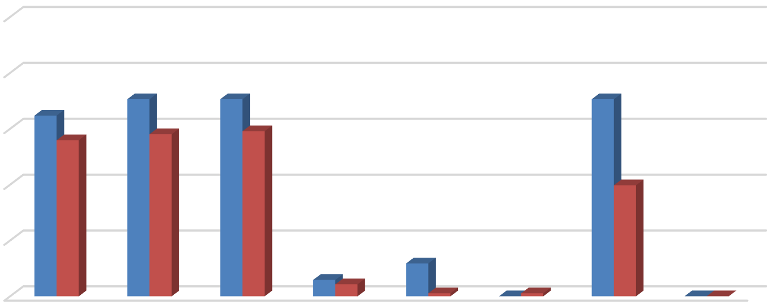
100%
65%
56%
71% 71%
58%
71%
59%
40%
6% 4%
12%
1% 0% 1%
0% 0%

80%

60%

40%

20%

0%


Source: BAE, 2023.



Bed Leases Unit Leases

9 Properties that charge utility fees on a pass-through basis independently meter utility usage by unit and pass on the utility charge to tenants (e.g., Ratio Utility Billing System, or RUBS).

Utilities, Appliances, and Amenities
As in prior years, the 2023 survey included questions regarding the utilities, appliances, and amenities that are provided at no additional charge (i.e., included in the monthly rental rate). As shown in Figure 5, above, between 55 and 70 percent of respondent complexes include water, sewer, and trash collection in rent, which is comparable to historic averages.

Figure 6 illustrates the types of appliances and other amenities that are provided. Nearly all respondent complexes include a refrigerator and stove/oven, while nearly all included an air conditioning unit at no extra charge. Approximately 88 percent of bed leasing properties and 68 percent of unit lease properties include a dishwasher, while 76 percent of bed lease properties and 51 percent of unit lease properties include a microwave. Approximately half of the bed lease complexes provide in-unit laundry facilities, while only 22 percent of unit lease complexes provide this facility in the unit.

Figure 6: Percent of Respondents Including Appliances in Unit by Lease Type

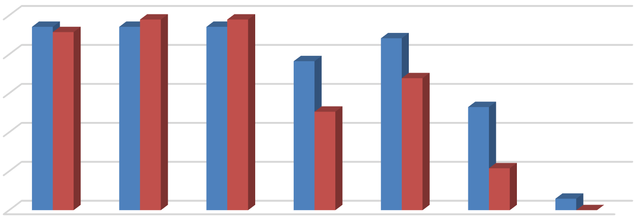
100%
94%91%
94% 98%
94% 98%
88%
76%
68%
51%
53%
22%
6%
0%
80%
60%
40%
20%
0%




Bed Leases Unit Leases
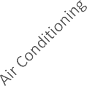
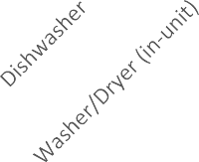
Source: BAE, 2023.

The 2023 survey also questioned respondents regarding the amenities offered on-site, such as gym or pool facilities, and services provided by the property management staff, such as package service and organized social activities. Figure 7, on the following page, illustrates the prevalence of these amenities, differentiating between complexes that offer unit leases versus bed leases. Overall, respondents that offer unit leases generally tend to offer fewer amenities. For example, 60 percent offer a pool and/or hot tub, while 55 percent offer a picnic or BBQ area, and 42 percent offer on-site gym facilities. The most prevalent amenity offered by unit lease complexes is an on-site laundry facility. Respondents that offer bed leases were more likely to offer a wider assortment of on-site amenities, with most respondents offering multiple types of equipment, facilities, and services. For example, 88 percent of complexes include a picnic or BBQ area and onsite laundry, 82 percent include a club house and pool area, and 76

percent include an onsite gym facility. Of the respondents who offered other additional services, most offer study lounges, pet amenities, and sport courts.

Figure 7: Percent of Respondents Offering Select Amenities by Lease Type

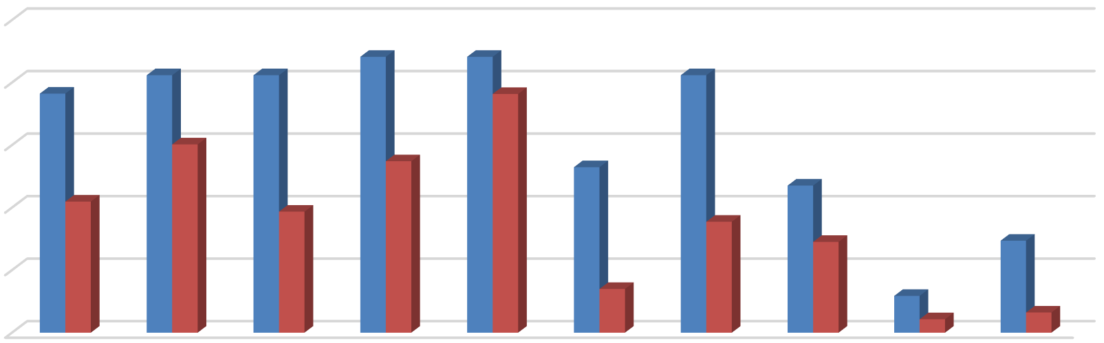
100%
76%
82%
82%
88%
88%
76%
82%
60%
55%
53%
42%
47%
39%
35%
29%
29%
14%
12%
4%
6%
80%
60%

40%
20%
0%

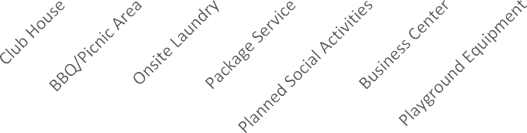

Source: BAE, 2023.

Bed Leases Unit Leases

Furnished and Unfurnished Units
Most of the surveyed properties indicated that they did not offer furnished units in the 2023 leasing season. Figures 8 and 9, on the next page, illustrate the number of respondents that offered furnishings, by unit size. Only five properties offered furnished apartments under unit lease arrangements in the 2023 leasing season. Two-bedroom units were the most common unit type offered with furnishings under a unit lease arrangement followed by one-bedroom units. Seven of the 18 bed lease complexes reported offering furnished units.

Services and Incentives
For a variety of reasons, it is often in a property owner’s best interest to provide certain services and incentives to residents. This often promotes resident attraction and retention. For properties that offer bed leases, a roommate matching program can often be an important tool. Under such a program, prospective residents fill out applications, stating their interests, and preferences for a roommate. The prevalence of roommate matching programs is similar to the 2022 survey period, with a total of 17 properties offering such services, including 14 of the 18 properties that manage apartments that are leased on a per bed basis. A total of 20 apartment complexes reported offering other incentives and move-in specials in the 2023 leasing season to help fill vacancies and attract new residents, which represents an increase compared to the 2022 leasing season. Common incentives and specials included free or discounted rent, waived application fees, and gift cards, among other giveaways. The value of

these incentives ranged from a $200 gift card to a full month of discounted rent, with the average value equaling roughly $1,570 in incentives, which is well above prior years.

Figure 8: Number of Respondents Offering Furnished Unit Leases by Unit Size

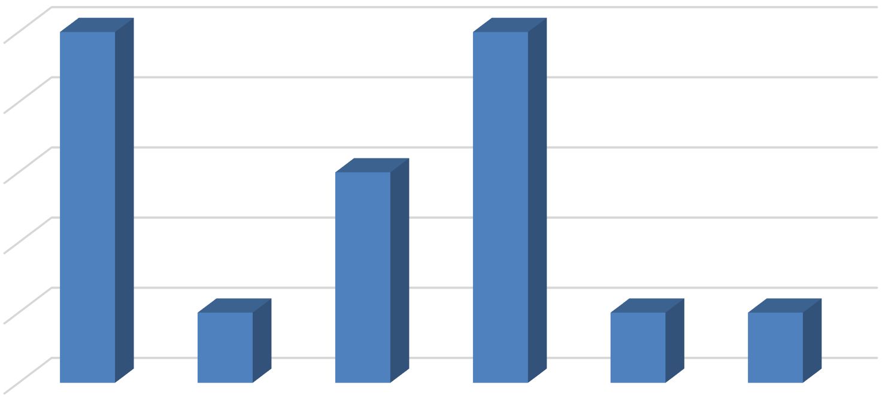
5
5
5
3
1
1
1

4

3

2

1

0
All Unit Sizes Studio 1 Bedroom 2 Bedroom 3 Bedroom 4+ Bedroom
Source: BAE, 2023.

Figure 9: Number of Respondents Offering Furnished Bed Leases by Unit Size

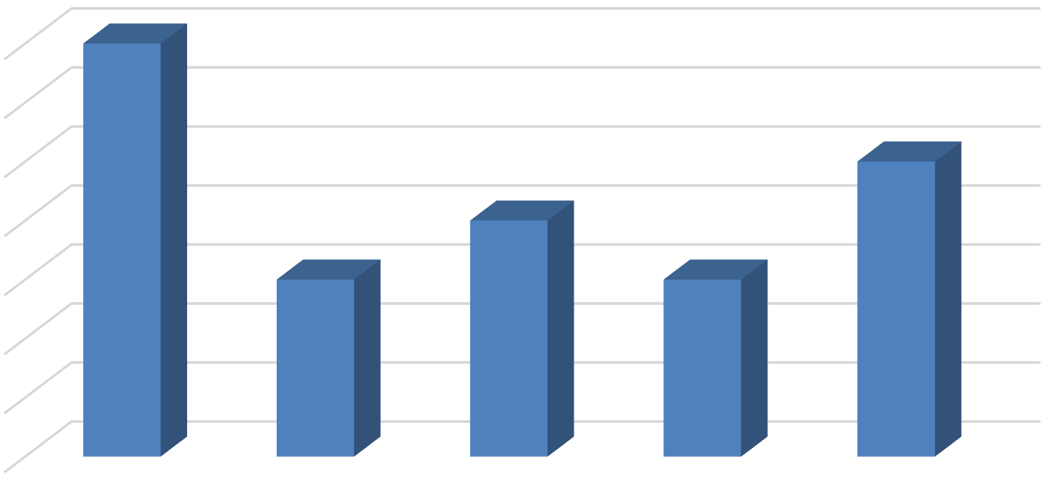
7
7
5
4
3
3
6
5
4
3
2
1

0
All Unit Sizes Studio & 1 Bedroom

2 Bedroom 3 Bedroom 4+ Bedroom

Source: BAE, 2023.

Planned Renovations
Twenty-two respondents reported having plans to undertake renovations within the next 12 months. Most of those that reported planned renovations conduct periodic updates as units turn over. Other common upgrades include new kitchen and bath facilities, windows, and countertops. Other exterior upgrades typically include new paint or siding, landscaping, and common area improvements.

