bae urban economics

2024 Apartment Vacancy and Rental Rate Survey
Presented on behalf of UC Davis Student Housing and Dining Services

Overview
The annual Apartment Vacancy and Rental Rate Survey collects information on the characteristics of rental apartment units in the Davis community. Similar surveys have been conducted annually since at least 1975. Since 2013, the survey has been administered in partnership with BAE Urban Economics (BAE), a private real estate consulting firm with an office in Downtown Davis. The survey's objective is to provide information that will help inform planning decisions on campus and throughout the broader Davis area. For example, survey results help campus officials assess the current housing market conditions faced by UC Davis students, faculty, and staff. The survey results also help the university to assess the likely feasibility of proposed campus housing projects.

2024 Survey Results
One hundred sixteen (116) apartment complexes and property management companies responded to the 2024 survey. These properties feature a total of 11,144 reported rental units. This represents an increase in the number of respondent complexes and associated rental units compared to 2023.1 While the majority of the surveyed properties lease whole units, the survey recorded a total of 18 properties that lease a total of 3,674 units on a per- bed basis with a total inventory of 10,579 leasable beds, an increase of 2,561 over 2023.
According to estimates from the American Community Survey (ACS) there were approximately 13,187 multifamily housing units, on average, on the UC Davis campus and in the City of Davis between 2019 and 2023.2 3 This indicates that the units captured in the 2024 apartment survey account for approximately 84.5 percent of the Davis area multifamily housing stock.
Of the 116 properties that responded to the 2024 survey, 12 reported leasing units at below market rents (i.e., requiring an income eligibility test to qualify prospective tenants for reduced or subsidized rents). Four of those respondents reported renting all the units in the complex at below market rates, while the remaining eight properties rent some units at below market rates and some at market rates. Of the 12 complexes that reported renting units at below market rates, six reported the income eligibility standards that they use to screen prospective tenants. The 2024 survey results for complexes with below market rate units are consistent

1 BAE received responses from 108 unique apartment complexes and property management companies as part of the 2023 survey, representing 10,801 rental units.
2 Includes the City of Davis and Census Tract 105.01 in Yolo County, California.
3 U.S. Census Bureau. 2019-2023 American Community Survey 5-Year Estimates, Table B25024. Retrieved from: http://data.census.gov/
San Francisco Sacramento Los Angeles Washington DC Atlanta New York City

www.bae1.com

with the 2023 results, which found that most below market rate units were rented to households earning between 50 and 80 percent of the area median income (AMI). The remainder of this analysis excludes units rented at below market rents but does include units rented at market rates in mixed-income complexes.
While all survey respondents reported the total unit numbers, not all respondents provided complete information regarding other unit characteristics, such as vacancy and rental rate information, the mix of units by size, or amenities provided on-site. Additionally, the total of all unit sizes may not equal the reported total unit count due to inconsistent reporting of managers’ units and other similar factors. As a result, the unit and bed lease totals discussed elsewhere in this report may not equal those reported above, in some cases.

Leasing “Beds” Versus Complete Apartment Units
One of the increasingly common and complex dynamics of the local rental housing market is the practice of renting out individual apartment units to multiple tenants using multiple lease agreements. Under this type of arrangement, known as a “bed lease,” each bed or bedroom in an apartment is associated with a separate lease agreement. Each resident is thereby contractually responsible for only a portion of the total rent. This is compared to the more conventional approach, in which each unit is rented under a single lease and all of the tenants living in the unit sign the lease and are jointly responsible for the complete monthly rent payment. For the purposes of this survey, this arrangement is called a “unit lease.”

Unit Leases
Survey respondents provided unit size detail for 6,763 units that are rented under unit lease arrangements, which account for about 65 percent of all reported market-rate rental units. Note that the survey results reported below exclude units for which unit size detail was not provided. Figure 1, on the following page, illustrates the distribution of unit-leased apartments, by unit size. The majority of reported units had between one and three bedrooms. One- bedroom units accounted for 31 percent of the total, while two-bedroom units accounted for 46 percent and three-bedroom units represented 14 percent. Apartments with four or more bedrooms represented six percent of reported units, while studio units represented just three percent. This distribution is roughly comparable to the results of the 2023 survey.

Figure 1: Distribution of Unit Leases by Unit Size











Studio
201; 3%
376;
6%
965; 14%
2,128; 31%
3,093; 46%
1 Bedroom
2 Bedroom
3 Bedroom
4+ Bedroom

Source: BAE, 2024.

Figure 2 summarizes the average number of occupants in unit-leased apartments by unit size. As reported below, most units have at least one double occupancy bedroom, on average. For example, the average occupancy for a one-bedroom unit is 1.6 persons, while two-bedroom units average 3.0 residents, three-bedroom units average 4.0 residents, and units with four or more bedrooms average 4.8 residents. Occupancy in studio units is typically a single person, with an average occupancy factor of 1.1 residents. The 2024 survey indicates a slight decrease in the average number of residents in units that have four bedrooms or more, which may be influenced by several factors, such as changing resident preferences in the post- pandemic housing market (i.e., preference for fewer roommates).

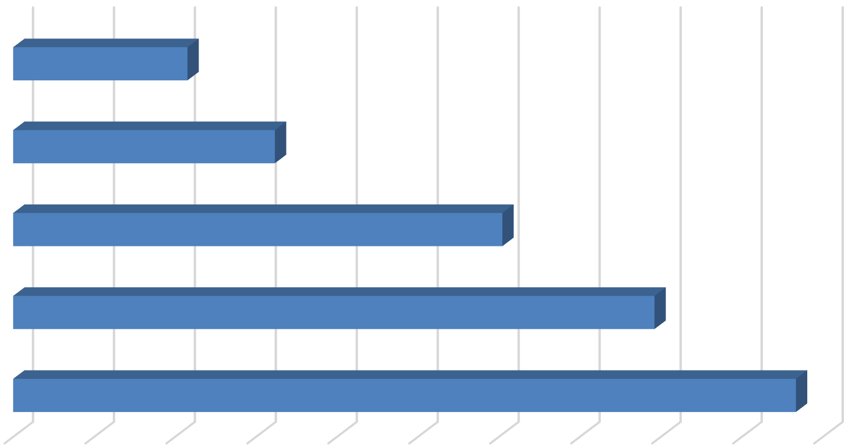
Figure 2: Average Number of Occupants in Unit-Leased Apartments by Type

Studio |  |  |  | 1.1
1 Bedroom |  |  |  |  |  | 1.6
2 Bedroom |  |  |  |  |  |  |  |  |  | 3.0
3 Bedroom |  |  |  |  |  |  |  |  |  |  |  |  | 4.0
4+ Bedroom |  |  |  |  |  |  |  |  |  |  |  |  | 4.8

0 0.5 1 1.5 2 2.5 3 3.5 4 4.5 5
Source: BAE, 2024.

Table 1, below, provides detailed unit totals, along with the number of vacant units, and the associated vacancy rate by unit size. Again, the results reflect only those survey responses that provided unit size and vacancy details. There were roughly 283 vacant apartments reported as available for lease on a unit-lease basis during the survey period, which is greater than the 152 vacant units in 2023, and significantly more than the 18 vacant units identified in 2022. This translates to a vacancy rate of 4.2 percent, the highest vacancy rate since 2020, when vacancy peaked at 8.4 percent. This is also notably higher relative to the historical trended average dating back to when BAE took over administration of the survey in 2013.
Table 1: Vacancy Rate for Unit Leases by Unit Size
2024 Survey Results
 |  |  |  |  | Number of Vacant |  |  |  |  |  |  | 2023 |  | 2022
Units Reported (a) |  |  |  |  | Units Reported (b) |  |  |  | Vacancy |  |  | Vacancy |  | Vacancy
Unit Size |  | Number |  | Percent |  | Number |  | Percent |  | Rate (c) |  | Rate (c) |  | Rate (c)
Studio |  | 201 |  | 3% |  | 2 |  | 1% |  | 1.0% |  | 0.0% |  | 0.5%
1 Bedroom |  | 2,128 |  | 31% |  | 76 |  | 27% |  | 3.6% |  | 1.1% |  | 0.1%
2 Bedroom |  | 3,093 |  | 46% |  | 145 |  | 51% |  | 4.7% |  | 3.2% |  | 0.3%
3 Bedroom |  | 965 |  | 14% |  | 52 |  | 18% |  | 5.4% |  | 3.0% |  | 0.4%
4+ Bedroom |  | 376 |  | 6% |  | 8 |  | 3% |  | 2.1% |  | 0.7% |  | 0.0%
Total, All Sizes |  | 6,763 |  | 100% |  | 283 |  | 100% |  | 4.2% |  | 2.3% |  | 0.2%
Notes:
- Includes the number of units, by unit type, reported by respondents as rented on a per unit basis (i.e., unit lease).
- Includes the number of units reported as vacant, by unit type, as reported by survey respondents. May exclude some units in cases where the respondent reported the total number of units but not the associated number of vacant units.
- The vacancy rate for unit-leased apartments was calculated based on the number of leased and vacant units only, as reported by survey respondents.
Source: BAE, 2024.

Bed Leases
Of the 10,437 market-rate apartment units reported by survey respondents, 3,674 units (35 percent) were reportedly rented under bed lease arrangements. This represents an increase of roughly 1,000 units relative to the number of bed lease units reported in the 2023 survey. This recent increase is primarily a result of new construction, expansion of existing bed-leasing properties, and conversion of previously unit-leased properties to by-the-bed leasing.
Figure 3, on the following page, illustrates the distribution of bed leases and bed-leased units, by unit size, which are also reported in Table 2 on page 6. Most of the bed-leased units, nearly 67 percent, are either two-bedroom or four-bedroom units. Four-bedroom units were the most common, accounting for 36 percent of the total. Two-bedroom units accounted for 31 percent of bed-leased units, while three-bedroom units comprised only eight percent of the bed-leased unit inventory. Studio and one-bedroom units accounted for the remaining 25 percent.
Survey respondents reported a total of 10,579 leasable beds, an increase of roughly 32 percent relative to the 7,988 reported in 2023. The distribution of leasable beds, by unit size, reflects a distribution similar to that shown for bed-leased units. As shown in Figure 3, 56 percent of the leased beds were in four-bedroom units, while 23 percent were in two-bedroom units, and ten percent were in three-bedroom units. Studio and one-bedroom units that were reported as rented under bed lease agreements accounted for 11 percent of the total.

Figure 3: Distribution of Leasable Beds and Associated Units by Unit Size

Units
Beds

1,185;
















11%
900; 25%
1,340; 36%
5,935;
56%
2,388;
23%
303; 8%
1,131; 31%
1,071;
10%

Studio & 1 Bedroom
2 Bedroom

3 Bedroom

4+ Bedroom

Source: BAE, 2024.

Figure 4 reports the average number of beds per unit, by unit size. This illustrates the relatively low occurrence of double-occupancy bedrooms. The number of double-occupancy bedrooms was similar among the various unit types, though four-bedroom and three-bedroom units reported a slightly higher number of double-occupancy rooms. Compared to 2023, the data indicate a minor decrease in the prevalence of double-ups within smaller units, or those with less than four bedrooms, and a slight increase in double-ups in three-bedroom units.

Figure 4: Average Number of Beds Per Bed-Leased Unit

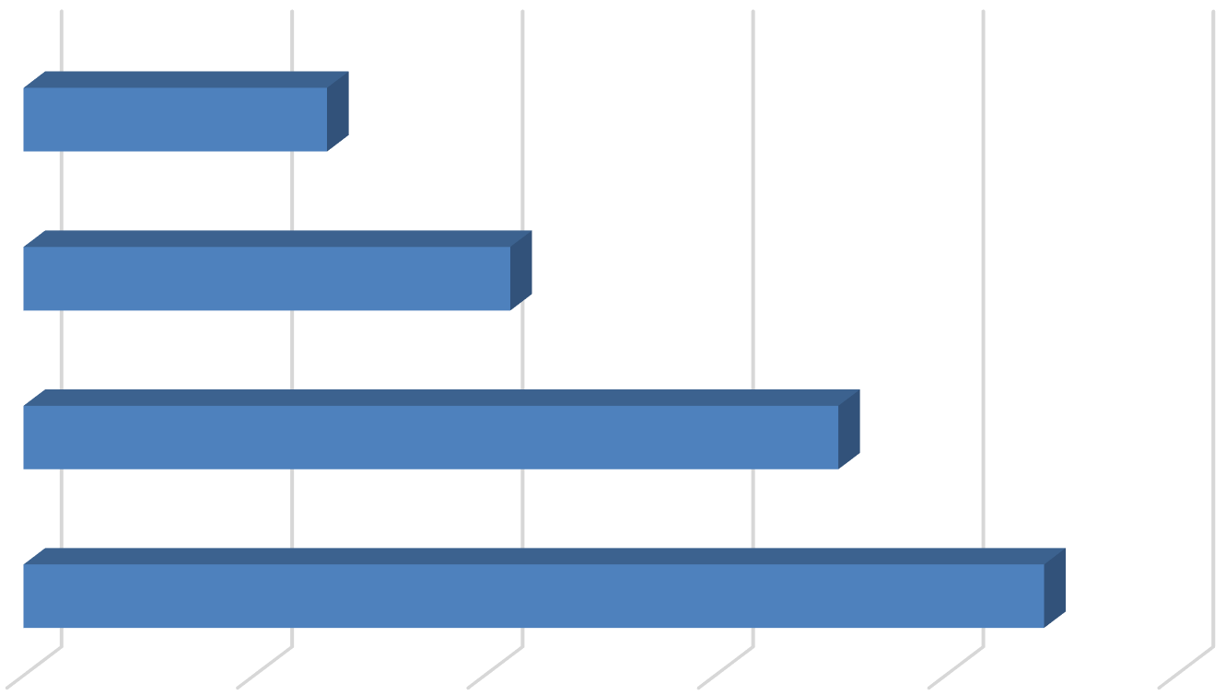
Studio & 1 Bedroom
1.3
2.1
3.5
4.4

  - Bedroom

  - Bedroom

4+ Bedroom

0.0 1.0 2.0 3.0 4.0 5.0

Source: BAE, 2024.

As documented in Table 2, respondents reported 406 vacant beds in 2024. This equals a vacancy rate of 3.8 percent. This vacancy rate is below the rate reported in 2023 (5.9 percent) and slightly above the historical range for bed-leased vacancy of between 0.5 and 3.5 percent. The increase in vacancy rates among bed-leased units may be associated with the addition of new bed-leasing properties in Davis, as well as more limited enrollment growth at the UC Davis main campus following the pandemic.4

Table 2: Vacancy Rate for Bed Leases by Unit Size
2024 Survey Results
Bed Leased |  |  |  |  | Number of |  |  |  | Number of Vacant |  |  |  |  |  |  | 2023 |  | 2022
Units Reported (a) |  |  |  |  | Beds Reported (b) |  |  |  | Beds Reported (c) |  |  |  | Vacancy |  |  | Vacancy |  | Vacancy
Unit Size |  | Number |  | Percent |  | Number |  | Percent |  | Number |  | Percent |  | Rate (d) |  | Rate (d) |  | Rate (d)
Studio & 1 Bedroom |  | 900 |  | 24% |  | 1,185 |  | 11% |  | 45 |  | 11% |  | 3.8% |  | 4.0% |  | 1.9%
2 Bedroom |  | 1,131 |  | 31% |  | 2,388 |  | 23% |  | 78 |  | 19% |  | 3.3% |  | 2.8% |  | 1.4%
3 Bedroom |  | 303 |  | 8% |  | 1,071 |  | 10% |  | 65 |  | 16% |  | 6.1% |  | 7.5% |  | 0.2%
4+ Bedroom |  | 1,340 |  | 36% |  | 5,935 |  | 56% |  | 218 |  | 54% |  | 3.7% |  | 7.1% |  | 0.5%
Total, All Sizes |  | 3,674 |  | 100% |  | 10,579 |  | 100% |  | 406 |  | 100% |  | 3.8% |  | 5.9% |  | 0.8%
Notes:
- Includes the number of units, by unit type, reported by respondents as rented on a per bed basis (i.e., bed lease).
- Includes the number of beds located within bed-leased units, by unit type, as reported by survey respondents. May exclude some beds in cases where the survey respondent reported bed-leased units but did not report the associated number of leased.
- Includes the number of leasable beds reported as vacant, by unit type, as reported by survey respondents. May exclude some beds in cases where the survey respondent reported bed-leased units but did not report the associated number of leased or vacant beds.
- The vacancy rate for bed leases was calculated based on the number of leased and vacant beds only, as reported by survey respondents.

Source: BAE, 2024.

Blended Vacancy Rate
To estimate a community-wide vacancy rate for all lease types, BAE combined the unit lease and bed lease vacancy rates, to generate a combined, or “blended,” vacancy estimate.5 The results of the blended vacancy rate calculations for the 2024 survey are shown in Table 3, on the following page. Given that the vacancy rate was similar for unit-lease and bed-lease apartments, the blended vacancy rate aligns with these rates. The blended vacancy rate for all rental units is 4.0 percent. This vacancy rate is one percentage point higher than the 2023 blended vacancy rate of 3.0 percent, and well above the historical blended vacancy rates.

4 According to data published by UC Davis, available at https://aggiedata.ucdavis.edu/, the total headcount on the general UC Davis campus has grown by 0.9 percent per year since 2020, which is below the average annual growth between 2010 and 2020, of 2.4 percent per year.
5 Calculated by applying the bed lease vacancy rate per bed to the number of bed-leased units resulting in a “vacant unit equivalent,” which was then added to the number of vacant unit-leased apartments.

Table 3: Blended Vacancy Rate Summary
2024 Vacancy Rate
Unit Size |  | Unit  Lease (a) |  | Bed  Lease (b) |  | Blended (c) |  | 2023 Blended  Vacancy Rate (c) |  | 2022 Blended  Vacancy Rate (c)
Studio & 1 Bedroom |  | 3.3% |  | 3.8% |  | 3.4% |  | 1.6% |  | 0.5%
2 Bedroom |  | 4.7% |  | 3.3% |  | 4.3% |  | 3.1% |  | 0.5%
3 Bedroom |  | 5.4% |  | 6.1% |  | 5.5% |  | 4.2% |  | 0.3%
4+ Bedroom |  | 2.1% |  | 3.7% |  | 3.1% |  | 4.4% |  | 0.4%
Total, All Sizes |  | 4.2% |  | 3.8% |  | 4.0% |  | 3.0% |  | 0.5%
Notes:
- Based on the number of units, by unit type, reported as rented on a per unit basis (i.e., unit lease).
- Based on the number of units, by unit type, reported as rented on a per bed basis (i.e., bed lease).
- Based on the number of units, by unit type, reported as rented on a per unit basis (i.e., unit lease), with vacant units leased on a per bed basis converted to "vacant unit equivalents."
Source: BAE, 2024.

Rental Rates
The 2024 survey results indicate that rental rates increased at a more modest rate relative to prior survey periods. Following onset of the COVID-19 pandemic, the 2021 and 2022 surveys documented significant annual rent increases. The 2024 and 2023 surveys, by comparison, documented more modest year-over-year rent growth, likely driven by increased vacancy.
Notably, almost 30 percent of respondents reported decreasing rents in 2024 relative to the prior leasing season. This is a notable increase from 2023, when only 10 percent of respondents reported decreasing rents, and a significant departure from historical trends.

Unit Leases
Table 4, on the following page, reports the range and weighted average of the reported rental rates for apartments leased under unit lease arrangements. Note that the survey results reported here represent properties for which respondents reported both the total number of units, by type, and the corresponding rental rate information. Based on this information, the average rental rate for all units was $2,425 per month,6 which represents a 2.2 percent increase over 2023, when the average rental rate for unit-leased apartments was $2,372. This suggests that the pace of rent growth has slowed compared to the long-term historical trend.

6 In cases where the respondent provided a range of prices for a given unit type, but no corresponding unit totals, BAE applied the mid-point of the range. The reported values represent weighted averages, which reflect the reported rental rates and the total number of units and/or beds.

Table 4: Rental Rates for Unit Leases by Unit Size
2024 Survey Results 2023 2022
Unit Size |  | Minimum |  | Maximum |  | Weighted  Average (a) |  | Weighted  Average (a) |  | Weighted  Average (a)
Studio |  | $800 |  | $2,350 |  | $1,538 |  | $1,504 |  | $1,340
1 Bedroom |  | $1,220 |  | $3,390 |  | $1,938 |  | $1,813 |  | $1,736
2 Bedroom |  | $1,250 |  | $3,295 |  | $2,374 |  | $2,295 |  | $2,188
3 Bedroom |  | $2,000 |  | $4,375 |  | $3,273 |  | $3,202 |  | $2,936
4+ Bedroom |  | $2,755 |  | $6,995 |  | $4,077 |  | $3,825 |  | $3,606
Total, All Sizes |  | $800 |  | $6,995 |  | $2,425 |  | $2,372 |  | $2,226
Note:
(a) Figures represent weighted average rental rates and include only those complexes where the respondent identified the number of units by type, the number of beds per unit, and associated rental rates.
Source: BAE, 2024.

Bed Leases
Table 5, below, illustrates the weighted average of the reported rental rates for individual bed leases. Note that the reported survey results only include those responses that identified the total number of bed-leased units, by type, the total number of beds per unit, and the associated rental rate information. The weighted average rental rate for a bed lease, across all unit sizes, was $1,168 per month,7 which represents a decrease of 0.7 percent over 2023, when the average monthly bed lease rate was $1,176. This decrease is partly driven by the mix of units reported in the survey, as well as by a slight increase in the number of double-ups in four-bedroom units, which decreases the average rent per bed lease. For reference, the average bed-lease rental rate reported for smaller units actually increased relative to 2022 for both the 2024 and 2023 survey periods, whereas the rental rate for four-bedroom apartments decreased in 2024 by three percent and in 2023 by nearly 13 percent.

Table 5: Average Rental Rate for Bed Leases by Unit Size

 |  | 2024 |  | 2023 |  | 2022
Unit Size |  | Weighted  Average (a) |  | Weighted  Average (a) |  | Weighted  Average (a)
Studio & 1 Bedroom (b) |  | $1,250 |  | $1,285 |  | $1,266
2 Bedroom |  | $1,222 |  | $1,139 |  | $1,111
3 Bedroom |  | $1,102 |  | $1,308 |  | $1,204
4+ Bedroom |  | $1,106 |  | $1,137 |  | $1,302
Total, All Sizes |  | $1,168 |  | $1,176 |  | $1,241
Notes:
- Figures represent weighted average rental rates and include only those complexes where the respondent identified the number of units by type, the number of beds per unit, and associated rental rates.
- Studio and one-bedroom bed-leased apartments are in complexes that only rent units under bed lease arrangements. These complexes offer a greater set of amenities, compared to the average unit-leased complex, and are priced as such.
Source: BAE, 2024.

7 See footnote 6.

It is also worth noting that many of the new bed-leased apartments that were built in the past few years are located on UC Davis land. Those properties are subject to agreements that result in lower rents relative to similar privately owned developments in Davis. The data reported in Table 5 include these lower priced units because although the units are rented at somewhat below market rate rents, they are not income restricted, and the units are available for occupancy by UC Davis students. Therefore, the data presented in Table 5 reports the average rental rate that UC Davis students may reasonably expect to encounter in the market.

Blended Rental Rate
To estimate the average citywide rental rate for all units, regardless of lease type, BAE combined the rental rates for unit leases and calculated the unit equivalent rental rate for units rented under bed lease arrangements.8 As reported in Table 6, the unit equivalent bed lease rental rates are generally higher than the average unit lease rents (e.g., ranging from 11 to 24 percent higher depending on the unit type), except for studio and one-bedroom units, which have a lower average bed lease rent than unit lease rent. Across all unit types, the average rental rate is $2,762 per unit. This represents a 1.6 percent increase over the 2023 blended average rental rate of $2,719 per month. This blended rental rate increase is below the historical average, which typically ranges from around three to 11 percent.
Table 6: Blended Rental Rate Summary
2024 Survey Results
 |  |  | Unit |  | Bed |  |  |  | 2023 Blended |  | 2022 Blended
 | Unit Size |  | Lease |  | Lease (a) |  | Blended (b) |  | Blended (b) |  | Rental Rate (b)
 | Studio & 1 Bedroom |  | $1,904 |  | $1,646 |  | $1,832 |  | $1,789 |  | $1,718
 | 2 Bedroom |  | $2,374 |  | $2,654 |  | $2,451 |  | $2,411 |  | $2,316
 | 3 Bedroom |  | $3,273 |  | $4,318 |  | $3,533 |  | $3,457 |  | $3,192
 | 4+ Bedroom |  | $4,077 |  | $4,900 |  | $4,731 |  | $4,615 |  | $5,093
 | Total, All Sizes |  | $2,425 |  | $3,363 |  | $2,762 |  | $2,719 |  | $2,671
Notes:
- Based on the number of beds and the weighted average bed lease rental rate, by unit type.
- Based on the weighted average unit lease rate and unit lease equivalent rate (for bed-leased units), by unit type.

Source: BAE, 2024.

Additional Recurring Charges
Prior survey efforts identified an increasing prevalence of complexes charging tenants separately for utilities, amenities, and services that have historically been included in rent. For example, some complexes have started charging a recurring monthly fee for water, sewer, and garbage service, or for the use of certain on-site amenities. In many cases, these newly itemized charges are mandatory, but are considered to be separate from rent. To account for this, the survey included a question asking respondents to more clearly identify additional monthly charges that are not included in the monthly rent amount paid by tenants.

8 Calculated by multiplying the weighted average bed lease rate the average number of beds per unit by unit type to calculate a “unit lease equivalent,” which was then combined with the weighted average unit lease rent to calculated a “blended” average rental rate estimate by unit type.

Additional Unit Lease Charges
A total of 39 unit-lease complexes indicated that they levy additional mandatory charges in addition to rent, which is comparable to the 2023 survey. These are most typically associated with utility usage and parking. Among the 25 complexes that charge a separate utility fee, eight of them charged between $10 and $45 per person or bedroom, while five charged between $65 and $135 per unit. An additional 12 properties reported charging an additional utility fee based on usage. A total of 11 complexes charge separately for parking, charging fees on a monthly basis, with an average cost of $31 per month. Some examples of other additional charges include monthly pet fees and a resident services fee.

Additional Bed Lease Charges
Bed lease complexes most commonly reported additional utility usage and parking charges.
Of the 18 bed lease complexes, five charged a flat per person utility fee, ranging from $6.00 to
$55.00 per person. Another six complexes charged for utilities on a passthrough basis.9 Among complexes that charge for parking, the typical cost is around $50 per month; with complexes charging more for covered spaces. Other additional charges include pet rent and required renters’ insurance.

Utilities, Appliances, and Amenities
As in prior years, the 2024 survey included questions regarding the utilities, appliances, and amenities that are provided at no additional charge (i.e., included in the monthly rental rate). As shown in Figure 5, on the following page, between 65 and 70 percent of respondent complexes include water, sewer, and trash collection in rent, which is comparable to historic averages.

Figure 6, below, illustrates the types of appliances and other amenities that are provided. Nearly all respondent complexes include a refrigerator and stove/oven, while nearly all included an air conditioning unit at no extra charge. Almost all of the bed leasing properties and 64 percent of unit lease properties include a dishwasher, while 89 percent of bed lease properties and 50 percent of unit lease properties include a microwave. Roughly half of the bed lease complexes, but only around 20 percent of unit lease complexes, provide in-unit laundry.

9 Properties that charge utility fees on a pass-through basis independently meter utility usage by unit and pass on the utility charge to tenants (e.g., Ratio Utility Billing System, or RUBS).

Figure 5: Percent of Respondents Including Utilities in Rent by Utility Type and Lease Type

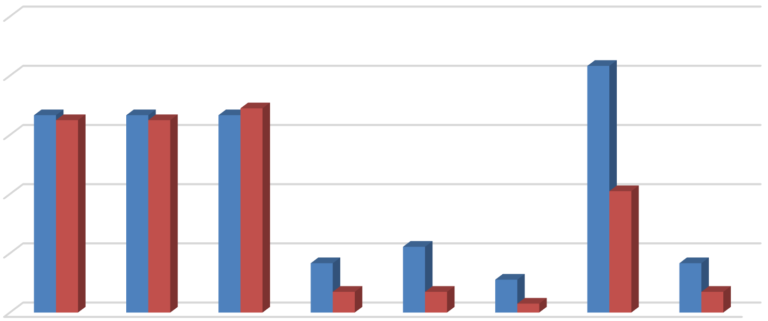
100%
83%
67% 65%
67%
65%
67% 69%
41%
22%
17%
17%
7%
7%
11%
3%
7%

80%

60%

40%

20%





0%
Bed Leases Unit Leases
Source: BAE, 2024.

Figure 6: Percent of Respondents Including Appliances in Unit by Lease Type

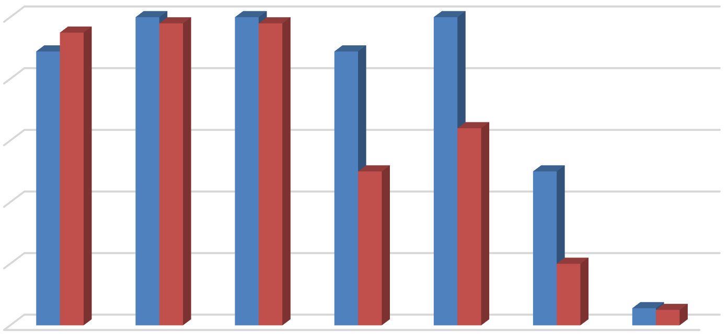
100%
100%
95%
98%
100%
98%
100%
89% 89%
64%
50%
50%
20%
6%5%

80%

60%

40%

20%

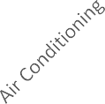



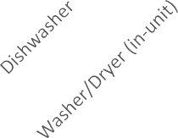

0%

Bed Leases Unit Leases

Source: BAE, 2024.

The 2024 survey also questioned respondents regarding the amenities offered on-site, such as gym or pool facilities, and services provided by the property management staff, such as package service and organized social activities. Figure 7 illustrates the prevalence of these amenities, differentiating between complexes that offer unit leases versus bed leases. Overall, respondents that offer unit leases generally tend to offer fewer amenities. For example, 56 percent offer a pool and/or hot tub, while 45 percent offer a picnic or BBQ area, and 36 percent offer on-site gym facilities. The most prevalent amenity offered by unit lease complexes is an on-site laundry facility. Respondents that offer bed leases were more likely to offer a wider assortment of on-site amenities, with most respondents offering multiple types of equipment, facilities, and services. For example, 78 percent include a pool or hot tub, 67 percent of complexes include a picnic or BBQ area and an onsite gym, and 61 percent include a clubhouse. Of the respondents who offered other additional services, most offer study lounges, pet amenities, and sport courts.

Figure 7: Percent of Respondents Offering Select Amenities by Lease Type

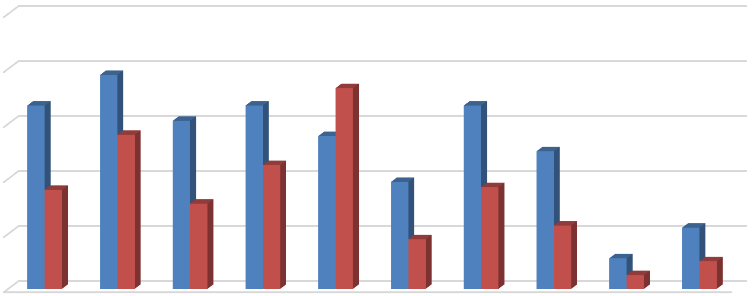
100%
78%
73%
67%
67%
67%
61%
56%
56%
45%
50%
36%
39%
37%
31%
18%
23%
22%
11%
5%
10%

80%

60%

40%

20%

0%

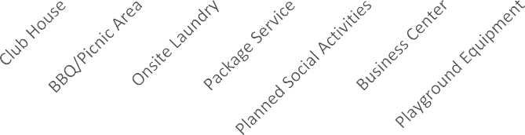


Bed Leases Unit Leases
Source: BAE, 2024.

Furnished and Unfurnished Units
Most of the surveyed properties indicated that they did not offer furnished units in the 2024 leasing season. Figures 8 and 9, on the next page, illustrate the number of respondents that offered furnishings, by unit size. Only seven properties offered furnished apartments under unit lease arrangements in the 2024 leasing season. Two-bedroom units were the most common unit type offered with furnishings under a unit lease arrangement followed by one- bedroom units. Ten of the 18 bed lease complexes reported offering furnished units.

Figure 8: Number of Respondents Offering Furnished Unit Leases by Unit Size

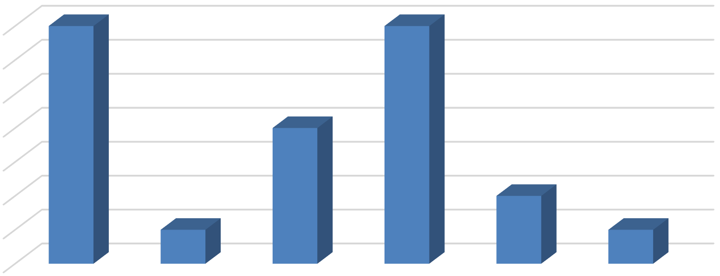
7
7
7
4
2
1
1
6
5
4
3
2
1
0
All Unit Sizes Studio 1 Bedroom 2 Bedroom 3 Bedroom 4+ Bedroom
Source: BAE, 2024.

Figure 9: Number of Respondents Offering Furnished Bed Leases by Unit Size

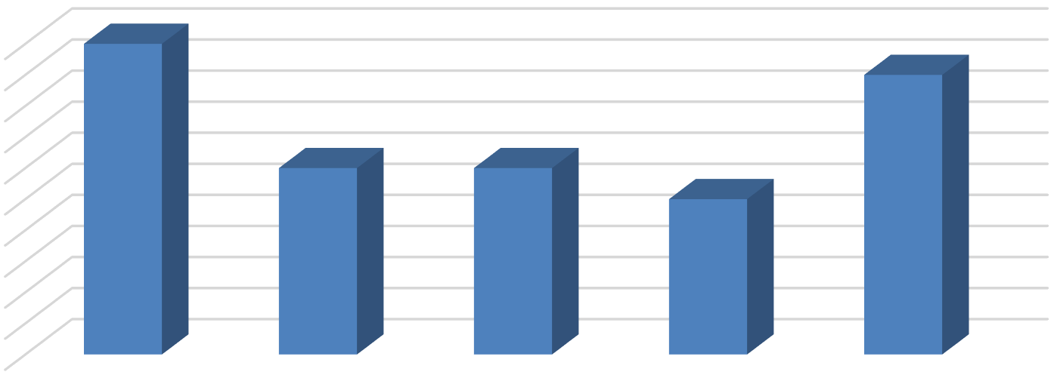
10
10
9
6
6
5
9
8
7
6
5
4
3
2
1
0
All Unit Sizes Studio & 1
Bedroom

2 Bedroom 3 Bedroom 4+ Bedroom

Source: BAE, 2024.

Services and Incentives
For a variety of reasons, it is often in a property owner’s best interest to provide certain services and incentives to residents. This often promotes resident recruitment and retention. For properties that offer bed leases, a roommate matching program can often be an important tool. Under such programs, prospective residents fill out applications, stating their interests and preferences for a roommate. The prevalence of roommate matching programs is similar to the 2023 survey period, with a total of 20 properties offering such services, including 15 of the 18 properties that lease apartments on a per bed basis. Forty-three apartment complexes reported offering other incentives and move-in specials in the 2024 leasing season to help fill vacancies and attract new residents, which is more than double the number of properties that offered incentives in the 2023 leasing season. Common incentives and specials included free or discounted rent, waived application fees, and gift cards, among other giveaways. The value of these incentives ranged from a $25 gift card to two full months of discounted rent, with the average value equaling roughly $2,320 in incentives, which is well above prior years.

Planned Renovations
Twenty-four respondents reported having plans to undertake renovations within the next 12 months. Most of those that reported planned renovations conduct periodic updates as units turn over. Other common upgrades include new kitchen and bath facilities, windows, and countertops. Other exterior upgrades typically include new paint or siding, landscaping, and common area improvements.

