bae urban economics

2025 Apartment Vacancy and Rental Rate Survey
Presented on behalf of UC Davis Student Housing and Dining Services

Overview
The annual Apartment Vacancy and Rental Rate Survey collects information on the characteristics of rental apartment units in the Davis community. Similar surveys have been conducted annually, since at least 1975. Since 2013, the survey has been administered in partnership with BAE Urban Economics (BAE), a private real estate consulting firm with an office in the City of Davis. The survey's objective is to provide information that will help inform planning decisions on campus and throughout the broader Davis area. For example, survey results help campus officials assess the current housing market conditions faced by UC Davis students, faculty, and staff. The survey results also help the university to assess the likely need for and feasibility of proposed campus housing projects.

2025 Survey Results
One hundred eleven (111) apartment complexes and property management companies responded to the 2025 survey. These properties feature a total of 10,917 reported rental units. This represents a slight decrease in the number of respondent complexes and associated rental units compared to 2024.1 While the majority of the surveyed properties lease whole units, the survey recorded a total of 21 properties that lease a total of 3,664 units on a per-bed basis with a total inventory of 10,329 leasable beds. This represents an increase in properties providing units on a per bed basis, but a slight decrease of 250 beds in comparison to the 2024 survey.
According to estimates from the American Community Survey (ACS) there were approximately 12,939 multifamily housing units, on average, on the UC Davis campus and in the City of Davis between 2020 and 2024.2 3 This indicates that the units captured in the 2024 apartment survey account for approximately 84.4 percent of the Davis area multifamily housing stock.
Of the 111 properties that responded to the 2025 survey, 12 reported leasing units at below market rents (i.e., requiring an income eligibility test to qualify prospective tenants for reduced or subsidized rents). Four of those respondents reported renting all the units in the complex at below market rates, while the remaining eight properties rent some units at below market rates and some at market rates. Of the 12 complexes that reported renting units at below

1 BAE received responses from 116 unique apartment complexes and property management companies as part of the 2024 survey, representing 11,144 rental units.
2 Includes the City of Davis and the University of California-Davis Census Designated Place.
3 U.S. Census Bureau. 2020-2024 American Community Survey 5-Year Estimates, Table B25024. Retrieved from: http://data.census.gov/

Northern California Southern California Pacific Northwest Mid-Atlantic Southeast www.bae1.com

market rates, five reported the income eligibility standards that they use to screen prospective tenants. The 2025 survey results for complexes with below market rate units are consistent with the 2024 results, which found that most below market rate units were rented to households earning between 50 and 80 percent of the area median income (AMI). The remainder of this analysis excludes units rented at below market rents but does include units rented at market rates in mixed-income complexes.

While all survey respondents reported the total unit numbers, not all respondents provided complete information regarding other unit characteristics, such as vacancy and rental rate information, the mix of units by size, or amenities provided on-site. Additionally, the total of all unit sizes may not equal the reported total unit count due to inconsistent reporting of managers’ units and other similar factors. As a result, the unit and bed lease totals discussed elsewhere in this report may not equal those reported above, in some cases.

Leasing “Beds” Versus Complete Apartment Units
One of the increasingly common and complex dynamics of the local rental housing market is the practice of renting out individual apartment units to multiple tenants using multiple lease agreements. Under this type of arrangement, known as a “bed lease,” each bed or bedroom in an apartment is associated with a separate lease agreement. Each resident is thereby contractually responsible for only a portion of the total rent. This is compared to the more conventional approach, in which each unit is rented under a single lease and all of the tenants living in the unit sign the lease and are jointly responsible for the complete monthly rent payment. For the purposes of this survey, this arrangement is called a “unit lease.”

Unit Leases
Survey respondents provided unit size detail for 6,705 units that are rented under unit lease arrangements, which account for about 65 percent of all reported market-rate rental units. Note that the survey results reported below exclude units for which unit size detail was not provided. Figure 1, on the following page, illustrates the distribution of unit-leased apartments, by unit size. The majority of reported units had between one and three bedrooms. One-bedroom units accounted for 35 percent of the total, while two-bedroom units accounted for 45 percent and three-bedroom units represented 12 percent. Apartments with four or more bedrooms represented four percent of reported units, while studio units also represented four percent. This distribution is roughly comparable to the results of the 2024 survey.

Figure 1: Distribution of Unit Leases by Unit Size










260; 4% 293; 4%
779; 12%
2,331; 35%
3,042; 45%

Studio
1 Bedroom
2 Bedroom
3 Bedroom
4+ Bedroom

Source: BAE, 2025.

Figure 2, below, summarizes the average number of occupants in unit-leased apartments by unit size. As reported in Figure 2, most units have at least one double occupancy bedroom, on average. For example, the average occupancy for a one-bedroom unit is 1.6 persons, while two-bedroom units average 3.0 residents, three-bedroom units average 4.0 residents, and units with four or more bedrooms average 4.9 residents. Occupancy in studio units is typically a single person, with an average occupancy factor of 1.2 residents. These occupancy characteristics are similar to those found in the 2024 survey period.

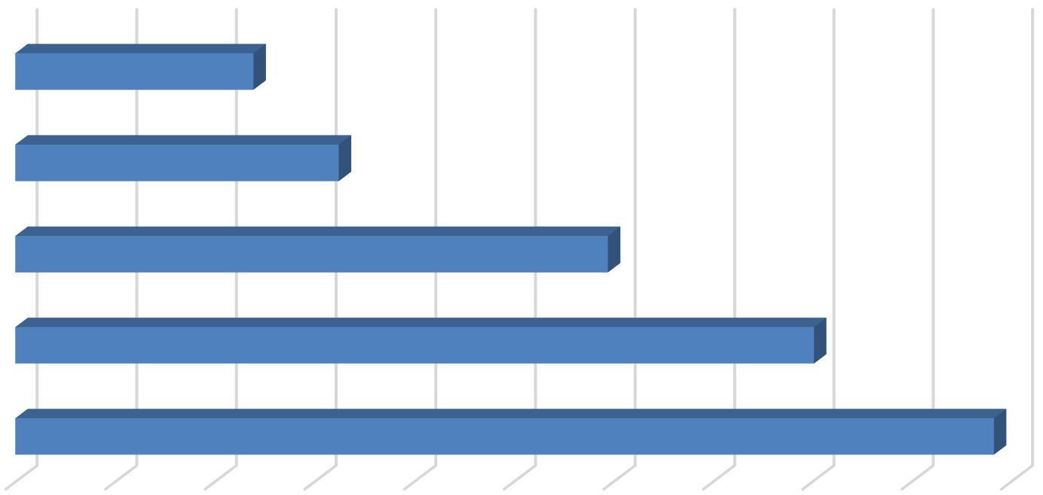
Figure 2: Average Number of Occupants in Unit-Leased Apartments by Type

Studio |  |  | 1.2
1 Bedroom |  |  |  | 1.6
2 Bedroom |  |  |  |  |  |  | 3.0
3 Bedroom |  |  |  |  |  |  |  |  |  | 4.0
4+ Bedroom |  |  |  |  |  |  |  |  |  |  |  |  | 4.9
0  Source: BAE, 2025. | 0.5 | 1 | 1.5 | 2 | 2.5 | 3 |  | 3.5 | 4 |  | 4.5 | 5

Table 1, below, provides detailed unit totals, along with the number of vacant units, and the associated vacancy rate by unit size. Again, the results reflect only those survey responses that provided unit size and vacancy details. There were roughly 174 vacant apartments reported as available for lease on a unit-lease basis during the survey period, which is less than the 283 vacant units in 2024, but significantly more than the historically low number of vacant units found in 2022, of just 18 vacant units. This translates to a vacancy rate of 2.6 percent, lower than the observed vacancy rate in 2024 of 4.2 percent, but higher than the historical trended average dating back to when BAE took over administration of the survey in 2013.

Table 1: Vacancy Rate for Unit Leases by Unit Size
2025 Survey Results
 |  |  |  |  | Number of Vacant |  |  |  |  |  |  | 2024 |  | 2023
Units Reported (a) |  |  |  |  | Units Reported (b) |  |  |  | Vacancy |  |  | Vacancy |  | Vacancy
Unit Size |  | Number |  | Percent |  | Number |  | Percent |  | Rate (c) |  | Rate (c) |  | Rate (c)
Studio |  | 293 |  | 4% |  | 2 |  | 1% |  | 0.7% |  | 1.0% |  | 0.0%
1 Bedroom |  | 2,331 |  | 35% |  | 32 |  | 18% |  | 1.4% |  | 3.6% |  | 1.1%
2 Bedroom |  | 3,042 |  | 45% |  | 88 |  | 51% |  | 2.9% |  | 4.7% |  | 3.2%
3 Bedroom |  | 779 |  | 12% |  | 44 |  | 25% |  | 5.6% |  | 5.4% |  | 3.0%
4+ Bedroom |  | 260 |  | 4% |  | 8 |  | 5% |  | 3.1% |  | 2.1% |  | 0.7%
Total, All Sizes |  | 6,705 |  | 100% |  | 174 |  | 100% |  | 2.6% |  | 4.2% |  | 2.3%
Notes:
- Includes the number of units, by unit type, reported by respondents as rented on a per unit basis (i.e., unit lease).
- Includes the number of units reported as vacant, by unit type, as reported by survey respondents. May exclude some units in cases where the survey respondent reported the total number of units but did not report the associated number of vacant units.
- The vacancy rate for unit-leased apartments was calculated based on the number of leased and vacant units only, as reported by survey respondents.

Source: BAE, 2025.

Bed Leases
Of the 10,369 market-rate apartment units reported by survey respondents, 3,664 units (35 percent) were reportedly rented under bed lease arrangements. This represents a decrease of just 10 units relative to the number of bed lease units reported in the 2024 survey, but a significant increase over the 2023 results and preceding survey periods. This recent increase in bed lease units is primarily a result of new construction, expansion of existing bed-leasing properties, and conversion of previously unit-leased properties to by-the-bed leasing, both within the City of Davis and on the UC Davis campus.

Figure 3, on the following page, below illustrates the distribution of bed leases and bed-leased units, by unit size, which are also reported in Table 2 on Page 6. Most of the bed-leased units, nearly 65 percent, are either two-bedroom or four-bedroom units. Two-bedroom units were the most common, accounting for 34 percent of the total. Four-bedroom units accounted for 31 percent of bed-leased units, while three-bedroom units comprised only 11 percent of the bed-leased unit inventory. Studio and one-bedroom units accounted for the remaining 24 percent.

Survey respondents reported a total of 10,329 leasable beds. This is a very slight decrease from the 10,579 leasable beds reported in the 2024 survey, but an increase of roughly 29 percent relative to the 7,988 reported in 2023. The distribution of leasable beds, by unit size, reflects a distribution similar to that shown for bed-leased units. As shown in Figure 3, half of the leased beds were in four-bedroom units, while 26 percent were in two-bedroom units, and 13 percent were in three-bedroom units. Studio and one-bedroom units that were reported as rented under bed lease agreements accounted for 11 percent of the total.

Figure 3: Distribution of Leasable Beds and Associated Units by Unit Size








Units Beds
1,154; 11%
5,114; 50%
2,683; 26%
1,378; 13%









Studio & 1 Bedroom
878; 24%
1,137; 31%
396; 11%
1,253; 34%
2 Bedroom
3 Bedroom
4+ Bedroom

Source: BAE, 2025.

Figure 4 reports the average number of beds per unit, by unit size. This illustrates the relatively low occurrence of double-occupancy bedrooms. The number of double-occupancy bedrooms was similar among the various unit types, though four-bedroom and three-bedroom units reported a slightly higher number of double-occupancy rooms. Compared to 2024, the data reflect a minor increase in the prevalence of double-ups within units of four or more bedrooms, with consistent results in all other unit types.
Figure 4: Average Number of Beds Per Bed-Leased Unit

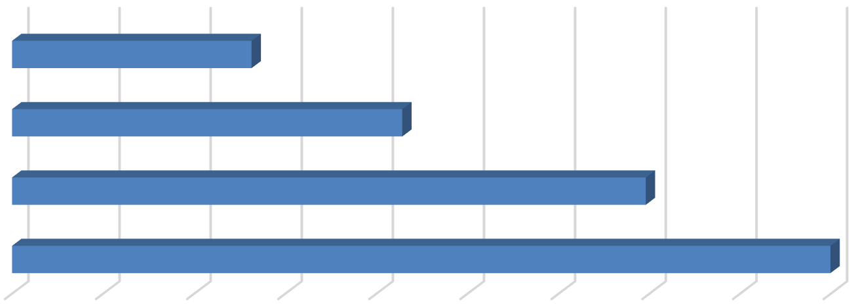
Studio & 1 Bedroom
1.3
2.1
3.5

- Bedroom

- Bedroom

4+ Bedroom
4.5

0.0 0.5 1.0 1.5 2.0 2.5 3.0 3.5 4.0 4.5
Source: BAE, 2025.

As documented in Table 2, below, respondents reported 460 vacant beds in 2025. This equals a vacancy rate of 4.5 percent. This vacancy rate is slightly above the rate reported in 2024 (3.8 percent), but below the 2023 vacancy rate of 5.9 percent. The increase in vacancy rates among bed-leased units may be associated with the addition of new bed-leased properties in Davis, as well as slower UC Davis enrollment growth.4

Table 2: Vacancy Rate for Bed Leases by Unit Size
2025 Survey Results
Bed Leased |  |  |  |  | Number of |  |  |  | Number of Vacant |  |  |  |  |  |  | 2024 |  | 2023
Units Reported (a) |  |  |  |  | Beds Reported (b) |  |  |  | Beds Reported (c) |  |  |  | Vacancy |  |  | Vacancy |  | Vacancy
Unit Size |  | Number |  | Percent |  | Number |  | Percent |  | Number |  | Percent |  | Rate (d) |  | Rate (d) |  | Rate (d)
Studio & 1 Bedroom |  | 878 |  | 24% |  | 1,154 |  | 11% |  | 67 |  | 15% |  | 5.8% |  | 3.8% |  | 4.0%
2 Bedroom |  | 1,253 |  | 34% |  | 2,683 |  | 26% |  | 197 |  | 43% |  | 7.3% |  | 3.3% |  | 2.8%
3 Bedroom |  | 396 |  | 11% |  | 1,378 |  | 13% |  | 82 |  | 18% |  | 6.0% |  | 6.1% |  | 7.5%
4+ Bedroom |  | 1,137 |  | 31% |  | 5,114 |  | 50% |  | 114 |  | 25% |  | 2.2% |  | 3.7% |  | 7.1%
Total, All Sizes |  | 3,664 |  | 100% |  | 10,329 |  | 100% |  | 460 |  | 100% |  | 4.5% |  | 3.8% |  | 5.9%
Notes:
- Includes the number of units, by unit type, reported by respondents as rented on a per bed basis (i.e., bed lease).
- Includes the number of beds located within bed-leased units, by unit type, as reported by survey respondents. May exclude some beds in cases where the survey respondent reported bed-leased units but did not report the associated number of leased.
- Includes the number of leasable beds reported as vacant, by unit type, as reported by survey respondents. May exclude some beds in cases where the survey respondent reported bed-leased units but did not report the associated number of leased or vacant beds.
- The vacancy rate for bed leases was calculated based on the number of leased and vacant beds only, as reported by survey respondents.
Source: BAE, 2025.

Blended Vacancy Rate
To estimate a community-wide vacancy rate for all lease types, BAE combined the unit lease and bed lease vacancy rates, to generate a combined, or “blended,” vacancy estimate.5 The results of the blended vacancy rate calculations for the 2025 survey are shown in Table 3 on the following page. Given that the vacancy rate was fairly similar for unit-lease and bed-lease apartments, the blended vacancy rate aligns with these rates. The blended vacancy rate for all rental units is 3.5 percent. This vacancy rate is slightly lower than the 2024 blended vacancy rate of 4.0 percent, both of which are well above the historical blended vacancy rates.

4 According to data published by UC Davis, available at https://aggiedata.ucdavis.edu/, the total headcount at UC Davis has grown by 0.1 percent per year since 2020, which is below the average annual growth between 2010 and 2020, of 2.1 percent per year.
5 Calculated by applying the bed lease vacancy rate per bed to the number of bed-leased units resulting in a “vacant unit equivalent,” which was then added to the number of vacant unit-leased apartments.

Table 3: Blended Vacancy Rate Summary
2025 Vacancy Rate
Unit Size |  | Unit  Lease (a) |  | Bed  Lease (b) |  | Blended (c) |  | 2024 Blended  Vacancy Rate (c) |  | 2023 Blended  Vacancy Rate (c)
Studio & 1 Bedroom |  | 1.3% |  | 5.8% |  | 2.5% |  | 3.4% |  | 1.6%
2 Bedroom |  | 2.9% |  | 7.3% |  | 4.1% |  | 4.3% |  | 3.1%
3 Bedroom |  | 5.6% |  | 6.0% |  | 5.7% |  | 5.5% |  | 4.2%
4+ Bedroom |  | 3.1% |  | 2.2% |  | 2.1% |  | 3.1% |  | 4.4%
Total, All Sizes |  | 2.6% |  | 4.5% |  | 3.5% |  | 4.0% |  | 3.0%
Notes:
- Based on the number of units, by unit type, reported as rented on a per unit basis (i.e., unit lease).
- Based on the number of units, by unit type, reported as rented on a per bed basis (i.e., bed lease).
- Based on the number of units, by unit type, reported as rented on a per unit basis (i.e., unit lease), with vacant units leased on a per bed basis converted to "vacant unit equivalents."

Source: BAE, 2025.

Rental Rates
The 2025 survey results indicate that overall rental rates decreased for the first time since BAE began conducting the survey in 2013. Following onset of the COVID-19 pandemic, the 2021 and 2022 surveys documented significant annual rent increases. The 2024 and 2023 surveys, by comparison, documented more modest year-over-year rent growth, likely driven by the increase in new unit production and associated increases in citywide vacancy. The reported rental rate decrease in the 2025 survey may further reflect the impact of new unit production throughout the City and on UC Davis land, as well as changes in overall demand preferences. Furthermore, approximately 51 percent of respondents reported decreasing rents in 2025 relative to the prior leasing season. This is a notable change from 2024, when only 30 percent of respondents reported decreasing rents, and a significant departure from historical trends where very few properties reported rental rate decreases year-over-year.

Unit Leases
Table 4, on the following page, reports the range and weighted average of the reported rental rates for apartments leased under unit lease arrangements. Note that the survey results reported here represent properties for which respondents reported both the total number of units, by type, and the corresponding rental rate information. Based on this information, the average rental rate for all units was $2,309 per month,6 which represents a 4.8 percent decrease over 2024, when the average rental rate for unit-leased apartments was $2,435 per month. This rental rate decrease comes after several years of limited year-over-year rent growth.

6 In cases where the respondent provided a range of prices for a given unit type, but no corresponding unit totals, BAE applied the mid-point of the range. The reported values represent weighted averages, which reflect the reported rental rates and the total number of units and/or beds.

Table 4: Rental Rates for Unit Leases by Unit Size
2025 Survey Results 2024 2023
Unit Size |  | Minimum |  | Maximum |  | Weighted  Average (a) |  | Weighted  Average (a) |  | Weighted  Average (a)
Studio |  | $1,050 |  | $2,438 |  | $1,673 |  | $1,538 |  | $1,504
1 Bedroom |  | $1,259 |  | $2,845 |  | $1,895 |  | $1,938 |  | $1,813
2 Bedroom |  | $1,250 |  | $3,475 |  | $2,303 |  | $2,374 |  | $2,295
3 Bedroom |  | $1,709 |  | $4,575 |  | $3,216 |  | $3,273 |  | $3,202
4+ Bedroom |  | $3,295 |  | $6,748 |  | $4,098 |  | $4,077 |  | $3,825
Total, All Sizes |  | $1,050 |  | $6,748 |  | $2,309 |  | $2,425 |  | $2,372
Note:
(a) Figures represent weighted average rental rates and include only those complexes where the respondent identified the number of units by type, the number of beds per unit, and associated rental rates.

Source: BAE, 2025.

Bed Leases
Table 5 illustrates the weighted average of the reported rental rates for individual bed leases. Note that the reported survey results only include those responses that identified the total number of bed-leased units, by type, the total number of beds per unit, and the associated rental rate information. The weighted average rental rate for a bed lease, across all unit sizes, was $1,223 per month, which represents an increase of 4.7 percent over 2024, when the average monthly bed lease rate was $1,168. This increase is partly driven by the mix of units reported in the survey, as well as by a slight decrease in the number of double-ups in four-bedroom units. In typical bed lease arrangements, the prevalence of double-occupancy rooms results in a lower per-bed lease rate. Therefore, the slight decrease in double-occupancy rooms increases the average rental rate for bed leases. The average bed-lease rental rate reported for smaller units increased more substantially compared to the 2024 survey period, while larger units saw a more modest increase in the average bed lease rental rate.

Table 5: Average Rental Rate for Bed Leases by Unit Size

 |  | 2025 |  | 2024 |  | 2023
Unit Size |  | Weighted  Average (a) |  | Weighted  Average (a) |  | Weighted  Average (a)
Studio & 1 Bedroom (b) |  | $1,427 |  | $1,250 |  | $1,285
2 Bedroom |  | $1,224 |  | $1,222 |  | $1,139
3 Bedroom |  | $1,148 |  | $1,102 |  | $1,308
4+ Bedroom |  | $1,141 |  | $1,106 |  | $1,137
Total, All Sizes |  | $1,223 |  | $1,168 |  | $1,176
Notes:
- Figures represent weighted average rental rates and include only those complexes where the respondent identified the number of units by type, the number of beds per unit, and associated rental rates.
- Studio and one-bedroom bed-leased apartments are in complexes that only rent units under bed lease arrangements. These complexes offer a greater set of amenities, compared to the average unit-leased complex, and are priced as such.

Source: BAE, 2025.

It is also worth noting that many of the new bed-leased apartments that were built in the past few years are located on UC Davis land. Those properties are subject to agreements that result in lower rents relative to similar privately owned developments in Davis. The data reported in Table 5 include these lower-priced units because although the units are rented at somewhat below market rate rents, they are not income restricted, and the units are available for occupancy by UC Davis students. Therefore, the data presented in Table 5 reports the average rental rate that UC Davis students may reasonably expect to encounter in the market.

Blended Rental Rate
To estimate the average citywide rental rate for all units, regardless of lease type, BAE combined the rental rates for unit leases and calculated the unit equivalent rental rate for units rented under bed lease arrangements.7 As reported in Table 6 below, the unit equivalent bed lease rental rates are generally higher than the average unit lease rents (e.g., ranging from 0.1 to 17 percent higher depending on the unit type). Across all unit types, the average rental rate is $2,711 per unit. This represents a 1.8 percent decrease over the 2024 blended average rental rate of $2,762 per month. As reported above, this is the first decrease in the blended rental rate observed in more than a decade.

Table 6: Blended Rental Rate Summary
2025 Survey Results
 | Unit Size |  | Unit  Lease |  | Bed  Lease (a) |  | Blended (b) |  | 2024 Blended  Blended (b) |  | 2023 Blended  Blended (b)
 | Studio & 1 Bedroom |  | $1,871 |  | $1,876 |  | $1,872 |  | $1,832 |  | $1,789
 | 2 Bedroom |  | $2,303 |  | $2,764 |  | $2,437 |  | $2,451 |  | $2,411
 | 3 Bedroom |  | $3,216 |  | $4,258 |  | $3,567 |  | $3,533 |  | $3,457
 | 4+ Bedroom |  | $4,098 |  | $5,132 |  | $4,939 |  | $4,731 |  | $4,615
 | Total, All Sizes |  | $2,309 |  | $3,447 |  | $2,711 |  | $2,762 |  | $2,719
Notes:
- Based on the number of beds and the weighted average bed lease rental rate, by unit type.
- Based on the weighted average unit lease rate and unit lease equivalent rate (for bed-leased units), by unit type.

Source: BAE, 2025.

Additional Recurring Charges
Prior survey efforts identified an increasing prevalence of complexes charging tenants separately for utilities, amenities, and services that have historically been included in rent. For example, some complexes have started charging a recurring monthly fee for water, sewer, and garbage service, or for the use of certain on-site amenities. In many cases, these newly itemized charges are mandatory, but are considered to be separate from rent. To account for this, the survey included a question asking respondents to more clearly identify additional monthly charges that are not included in the monthly rent amount paid by tenants.

7 Calculated by multiplying the weighted average bed lease rate the average number of beds per unit by unit type to calculate a “unit lease equivalent,” which was then combined with the weighted average unit lease rent to calculated a “blended” average rental rate estimate by unit type.

Additional Unit Lease Charges
A total of 40 unit-lease complexes indicated that they levy additional mandatory charges in addition to rent, which is comparable to the 2024 survey. These are most typically associated with utility usage and parking. Among the 32 complexes that charge a separate utility fee, eight of them charged between $20 and $85 per person or bedroom, while three charged between $80 and $105 per unit. An additional 21 properties reported charging an additional utility fee based on usage. A total of 14 complexes charge separately for parking, charging fees on a monthly basis, with an average cost of $58 per month. Some examples of other additional charges include monthly pet fees and a resident services fee.
Additional Bed Lease Charges
Bed lease complexes most commonly reported additional utility usage and parking charges. Of the 21 bed lease complexes, nine charged a flat per person utility fee, ranging from $10 to
$59 per person. Another eight complexes charged for utilities on a passthrough basis.8 Among complexes that charge for parking, the typical cost is around $65 per month; with complexes charging more for covered spaces. Other additional charges include pet rent and required renters’ insurance.

Utilities, Appliances, and Amenities
As in prior years, the 2025 survey included questions regarding the utilities, appliances, and amenities that are provided at no additional charge (i.e., included in the monthly rental rate). As shown in Figure 5, below, between 55 and 62 percent of respondent complexes include water, sewer, and trash collection in rent, which is comparable to historic averages.
Figure 5: Percent of Respondents Including Utilities in Rent by Utility Type and Lease Type

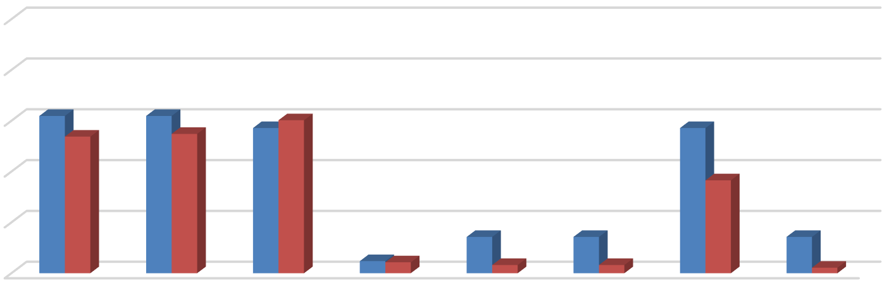
100%
62% 62% 57%
54% 55% 60%
57%
37%
14%
14%
14%
5% 4%
3%
3%
2%
80%
60%
40%
20%




0%
Bed Leases Unit Leases
Source: BAE, 2025.

8 Properties that charge utility fees on a pass-through basis independently meter utility usage by unit and pass on the utility charge to tenants (e.g., Ratio Utility Billing System, or RUBS).

Figure 6 illustrates the types of appliances and other amenities that are provided. Nearly all respondent complexes include a refrigerator, stove/oven, and air conditioning unit at no extra charge. Approximately 90 percent of bed leasing properties and 72 percent of unit lease properties include a dishwasher, while 86 percent of bed lease properties and 54 percent of unit lease properties include a microwave. Roughly half of the bed lease complexes, but only around 25 percent of unit lease complexes, provide in-unit laundry.
Figure 6: Percent of Respondents Including Appliances in Unit by Lease Type

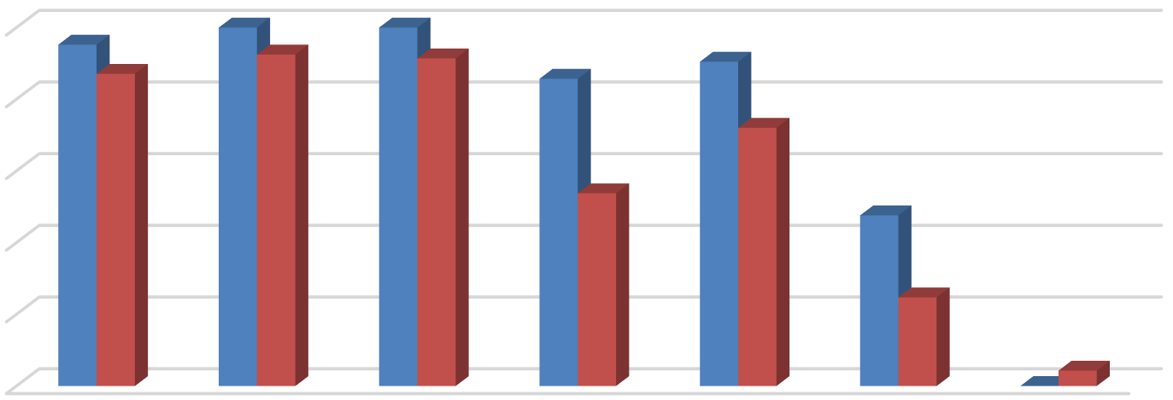
100%
95%
87%
100% 100%
92%
91%
86%
90%
72%
54%
48%
25%
0%4%
80%
60%
40%
20%
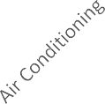



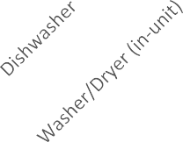

0%
Bed Leases Unit Leases
Source: BAE, 2025.

The 2025 survey also questioned respondents regarding the amenities offered on-site, such as gym or pool facilities, and services provided by the property management staff, such as package service and organized social activities. Figure 7, on the following page, illustrates the prevalence of these amenities, differentiating between complexes that offer unit leases versus bed leases. Overall, respondents that offer unit leases generally tend to offer fewer amenities. For example, 55 percent offer a pool and/or hot tub, while 57 percent offer a picnic or BBQ area, and 43 percent offer on-site gym facilities. The most prevalent amenity offered by unit lease complexes is an on-site laundry facility. Respondents that offer bed leases were more likely to offer a wider assortment of on-site amenities, with most respondents offering multiple types of equipment, facilities, and services. For example, 86 percent include a pool or hot tub and a picnic/BBQ area, 81 percent of complexes include a picnic an onsite gym, and 67 percent include a clubhouse. Of the respondents who offered other additional services, most offer study lounges, pet amenities, and bike parking.

Figure 7: Percent of Respondents Offering Select Amenities by Lease Type

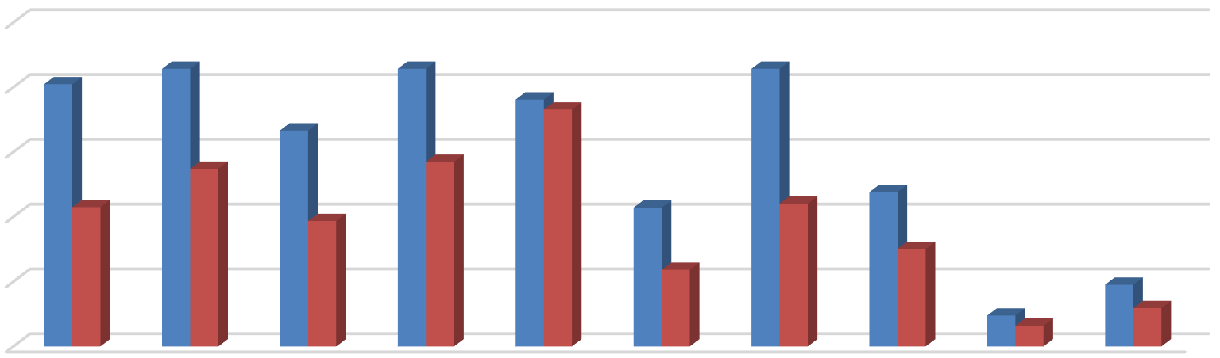
100%
81%
86%
86%
86%
76%
67%
73%
55%
57%
43%
39%
43%
44% 48%
24%
30%
19%
10% 6%
12%
80%
60%
40%
20%
0%

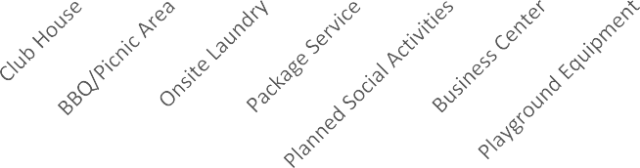


Bed Leases Unit Leases
Source: BAE, 2025.

Furnished and Unfurnished Units
Most of the surveyed properties indicated that they did not offer furnished units in the 2025 leasing season. Figures 8 and 9, on the next page, illustrate the number of respondents that offered furnishings, by unit size. Only 16 properties offered furnished apartments under unit lease arrangements in the 2025 leasing season. Two-bedroom units were the most common unit type offered with furnishings under a unit lease arrangement followed by one-bedroom units. Twelve of the 21 bed lease complexes reported offering furnished units.

Services and Incentives
For a variety of reasons, it is often in a property owner’s best interest to provide certain services and incentives to residents. This often promotes resident recruitment and retention. For properties that offer bed leases, a roommate matching program can often be an important tool. Under such programs, prospective residents fill out applications, stating their interests and preferences for a roommate. The prevalence of roommate matching programs is similar to the 2024 survey period, with a total of 17 properties offering such services, including 14 of the 21 properties that lease apartments on a per bed basis. Fifty-nine apartment complexes reported offering other incentives and move-in specials in the 2025 leasing season to help fill vacancies and attract new residents, which is approximately 35 percent more than the number of properties that offered incentives in the 2024 leasing season, which also found an increase in incentives and move-in specials relative to prior survey periods. Common incentives and specials included free or discounted rent, waived application fees, and gift cards, among other giveaways. The value of these incentives ranged from a $35 gift card to two full months of discounted rent, with the average value equaling roughly $1,600 in incentives, which is well above prior years.

Figure 8: Number of Respondents Offering Furnished Unit Leases by Unit Size

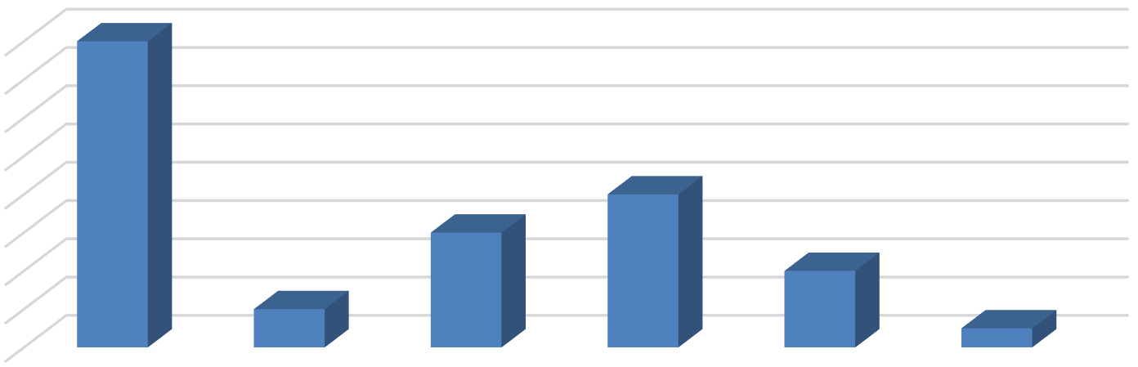
16
16
8
6
4
2
1
14
12
10
8
6
4
2
0

Source: BAE, 2025.

All Unit Sizes

Studio 1 Bedroom 2 Bedroom 3 Bedroom 4+ Bedroom

Figure 9: Number of Respondents Offering Furnished Bed Leases by Unit Size

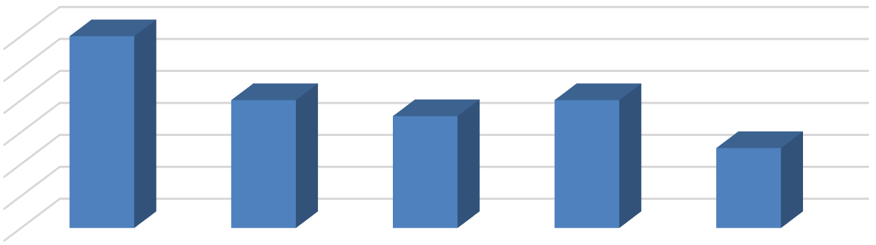
12
12
8
7
8
5
10
8
6
4
2
0

Source: BAE, 2025.

All Unit Sizes Studio & 1
Bedroom

2 Bedroom 3 Bedroom 4+ Bedroom

Planned Renovations
Twenty-five respondents reported having plans to undertake renovations within the next 12 months. Most of those that reported planned renovations conduct periodic updates as units turn over. Other common upgrades include new kitchen and bath facilities, windows, and countertops. Other exterior upgrades typically include new paint or siding, landscaping, and common area improvements.

